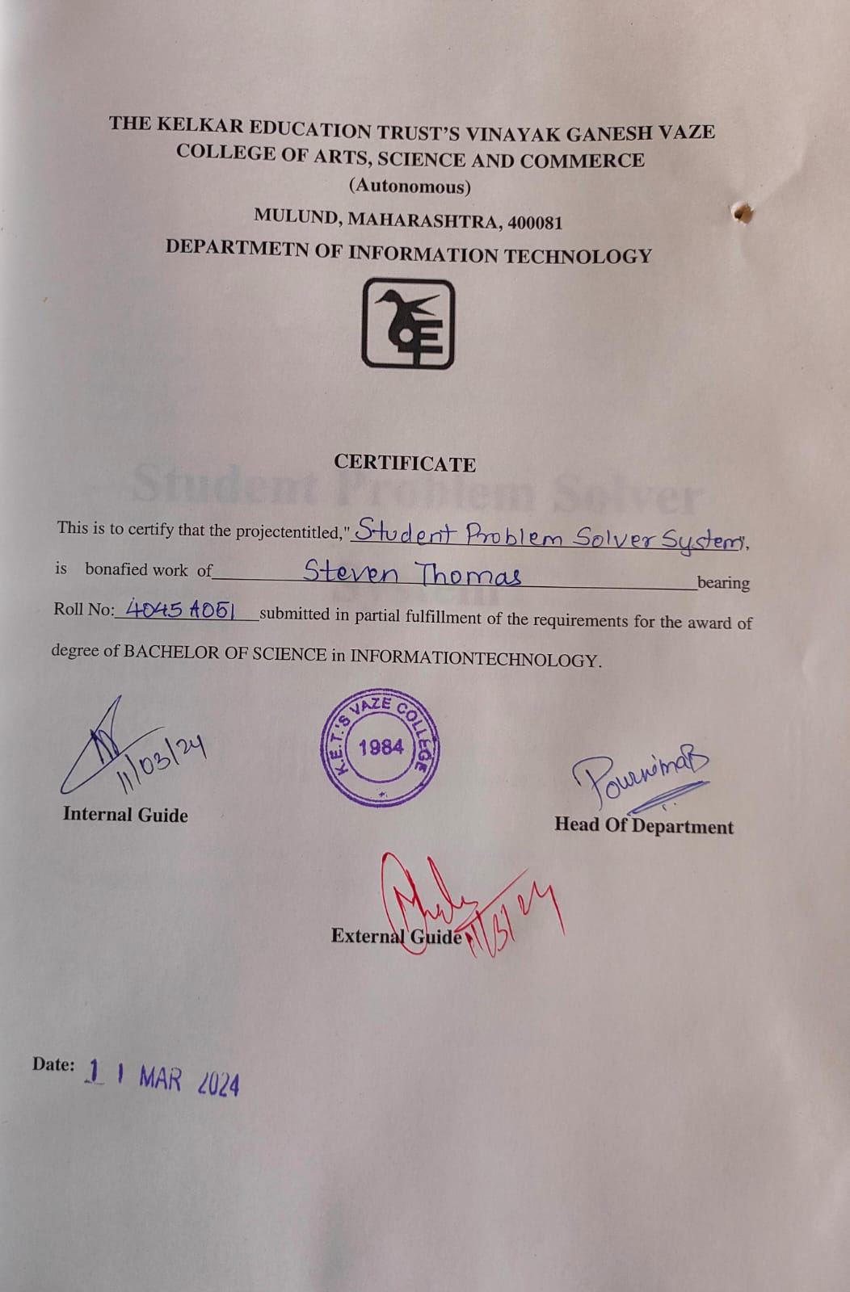

**Student Problem Solver System**

**THE APPROVAL PROJECT PROPOSAL**

|  |  |
| --- | --- |
| Name: | Steven Thomas |
| Title: | Student Problem Solver System |
| Name of Guide: | Mrs. Nanda Rupnar |
| Is this your first submission of project? | Yes |
| Control Id: | 2019060868 |
| Roll no: | 4045A051 |

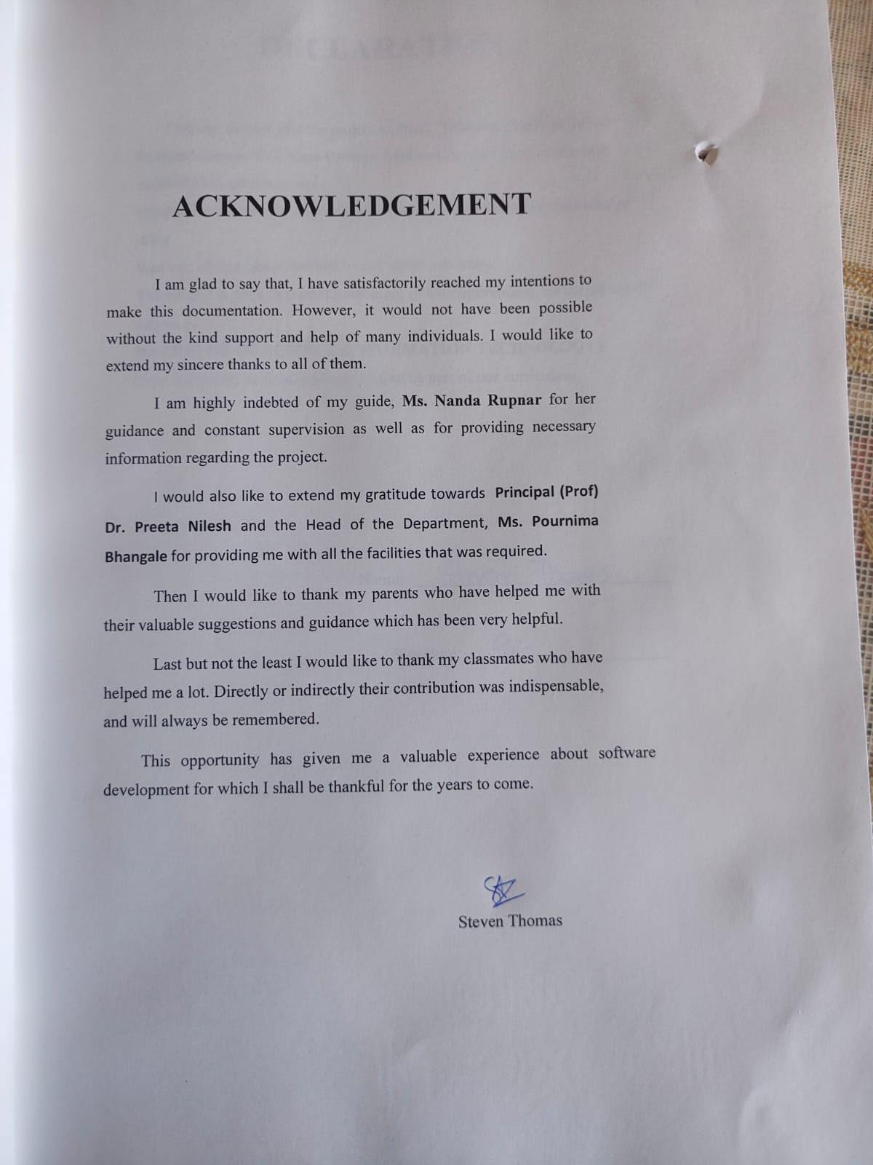

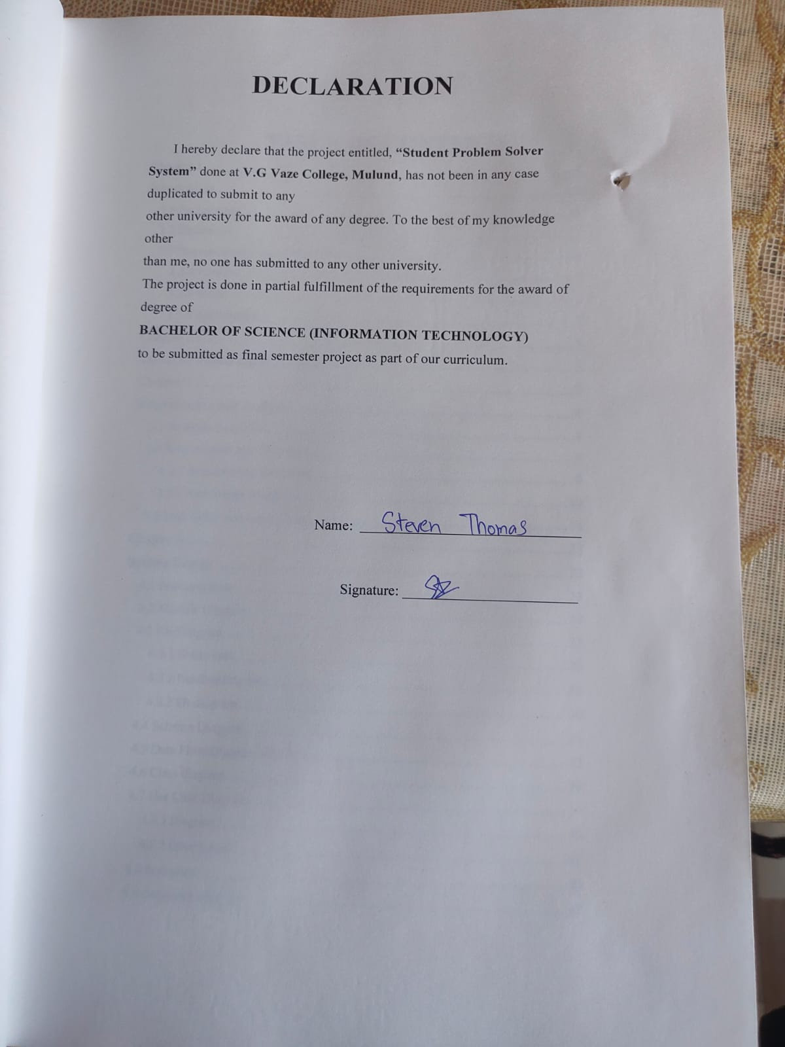

TABLE OF CONTENTS

Chapter 1 1

Introduction 1

1.1 Background 1

1.2 Objectives 1

1.3 Purpose, scope, and applicability 1

1.3.1 Purpose 1

1.3.2 Scope 2

1.3.3 Applicability 2

Chapter 2 3

Survey of Technologies 3

Chapter 3 8

Requirements and Analysis 8

3.1 Problem Definition 8

3.2 Requirement Specifications 8

3.2.1 Requirement Gathering 8

3.2.2 Requirement Analysis 10

3.3 Task Table and Gantt Chart 14

Chapter 4 23

System Design 23

4.1 Business Rule 23

4.2 Module Diagram 24

4.3 ER Diagram 25

4.3.1 Entity sets 26

4.3.2 Relationship Sets 28

4.3.3 ER diagram 30

4.4 Schema Diagram 30

4.5 Data Flow Diagram (DFD) 32

4.6 Class diagram 38

4.7 Use Case Diagram 39

4.7.1 Diagram 40

4.7.2 Description 40

4.8 Scenarios 44

4.9 Sequence diagram 47

4.10 Activity Diagram 53

4.11 State Diagram 56

4.12 User Interface Design 59

4.13 Test Cases 70

Chapter 5: Coding and Implementation 78

5.1 Implementation approaches 78

5.2 Coding and Efficiency 78

5.2.1 Coding: 78

5.2.2 Coding Efficiency 172

5.3 Testing Approaches 172

5.4 Unit Testing 173

5.5 Integration Testing 185

5.6 Modification and Implementation 188

Chapter 6: Results and Discussions 194

6.1 Test Report 194

6.2 User Documentation 194

Chapter 7: Conclusion and Future Work 206

7.1 Conclusion 206

7.2 Limitation 206

7.3 Future Scope 206

References 207

**List Of Tables**

Table 4.3.1: Entity Relationship Diagram symbols 25

Table 4.4.1: Schema Diagram Symbols 31

Table 4.5.1: Data Flow Diagram Symbols 32

Table 4.6.1: Class Diagram Symbols 38

Table 4.7.1: Use Case Diagram Symbols 39

Table 4.9.1: Sequence Diagram Symbols 47

Table 4.10.1: Activity Diagram Symbols 53

Table 4.11.1: State chart Diagram Symbols 56

Table 4.13.1: Login Test Case 70

Table 4.13.2: Edit Profile Test Case 70

Table 4.13.3: Contact Us Test Case 70

Table 4.13.4: Registration Test Case 72

Table 4.13.5: Send Post Test Case 72

Table 4.13.6: Vote Post Test Case 72

Table 4.13.8: Remove Post Test Case 73

Table 4.13.9: Delete Post Test Case 73

Table 4.13.10: Add student account Test Case 74

Table 4.13.11: Edit student account Test Case 75

Table 4.13.12: Add handler Test Case 76

Table 4.13.13: Add Admin Test Case 76

Table 4.13.15: Edit admin Test Case 77

Table 4.13.16: Delete user Test Case 77

Table 5.4.1: Login Test Case 173

Table 5.4.2: Edit Profile Test Case 173

Table 5.4.4: Forgot Password Test Case 174

Table 5.4.5: Registration Test Case 176

Table 5.4.6: Send Post Test Case 177

Table 5.4.7: Vote Post Test Case 178

Table 5.4.8: Verify Post Test Case 178

Table 5.4.9: Search Post Test Case 178

Table 5.4.10: Remove Post Test Case 179

Table 5.4.11: Delete Post Test Case 179

Table 5.4.12: Add student account Test Case 181

Table 5.4.14: Add handler Test Case 182

Table 5.4.15: Add Admin Test Case 183

Table 5.4.16: Edit handler Test Case 183

Table 5.4.17: Edit admin Test Case 184

Table 5.4.18: Delete user Test Case 184

Table 5.5.1: Registration and Profile Integrated Test Case 185

Table 5.5.2: Send Post Integrated Test Case 185

Table 5.5.3: Home(student)Integrated Test Case 185

Table 5.5.4: Verify and Remove Post Integrated Test Case 186

Table 5.5.5: Add, Edit and Delete student account Integrated Test Case 186

Table 5.5.6: Add, Edit and Delete Handler Integrated Test Case 187

Table 5.5.7: Add, Edit and Delete Admin account Integrated Test Case 187

Table 5.6.1: Modification Table for registration(student) and add student of manage users(admin) 188

Table 5.6.2: Registration Test Case 190

Table 5.6.3: Registration and Profile Integrated Test Case 190

Table 5.6.4: Add student account Test Case 192

Table 5.6.5: Add, Edit and Delete student account Integrated Test Case 193

**List Of Figures**

Figure 3.2.1.1: Google Form Result 9

Figure 4.2: Module diagram 24

Figure 4.3.1.1: Student Entity 26

Figure 4.3.1.2: Student_account Entity 27

Figure 4.3.1.3: Post Entity 28

Figure 4.3.2.1: student_account send post 28

Figure 4.3.2.2: student create student_account 29

Figure 4.3.2.3: student_account votes post 29

Figure 4.3.3.1: Entity Relationship Diagram 30

Figure 4.4.1: Schema Diagram 31

Figure 4.5.1: DFD Level 0 33

Figure 4.5.2: DFD Level 1 34

Figure 4.5.3: DFD Level 2 for Login 35

Figure 4.5.4: DFD Level 2 for Registration 35

Figure 4.5.5: DFD Level 2 for Verify Post 36

Figure 4.5.6: DFD Level 2 for Evaluate Post 36

Figure 4.5.7: DFD Level 2 for Remove Post 37

Figure 4.5.8: DFD Level 2 for Manage Users 37

Figure 4.5.9: DFD Level 2 for Manage Profile 38

Figure 4.7.1: Use Case Diagram 40

Figure 4.9.1: Sequence Diagram for User Registration 47

Figure 4.9.2: Sequence Diagram for User Login 48

Figure 4.9.3: Sequence Diagram for Send Post 48

Figure 4.9.4: Sequence Diagram for Evaluate Post 49

Figure 4.9.5: Sequence Diagram for Contact Admin 49

Figure 4.9.6: Sequence Diagram for Manage Profile 50

Figure 4.9.7: Sequence Diagram for Verify Post 50

Figure 4.9.8: Sequence Diagram for View Post [Most voted post chosen] 51

Figure 4.9.9: Sequence Diagram for Remove Post 51

Figure 4.9.10: Sequence Diagram for Manage users 52

Figure 4.10.1: Activity diagram for student 54

Figure 4.10.2: Activity diagram for handler 55

Figure 4.10.3: Activity diagram for admin 55

Figure 4.11.1: State diagram for student 57

Figure 4.11.2: State diagram for handler 58

Figure 4.11.3: State diagram for admin 58

Figure 4.12.1: Home Page UI 59

Figure 4.12.2.1: Register Page 1 UI 59

Figure 4.12.2.3: Register Page 3 UI 60

Figure 4.12.3: Login Page UI 61

Figure 4.12.4: Student Home Page UI 61

Figure 4.12.5: Student Send Post Page UI 62

Figure 4.12.6: Student Profile Page UI 62

Figure 4.12.7: Student Contact Us Page UI 63

Figure 4.12.8: Handler Home Page UI 63

Figure 4.12.9: Handler Post Page UI 64

Figure 4.12.10: Handler Profile Page UI 64

Figure 4.12.11: Admin Home Page UI 65

Figure 4.12.12.1: Admin Post Page 1 UI 65

Figure 4.12.12.2: Admin Post Page 2 UI 66

Figure 4.12.13.1: Admin Update Users Page 1 UI 66

Figure 4.12.13.2: Admin Update Users Page 2 UI 67

Figure 4.12.13.3: Admin Update Users Page 3 UI 67

Figure 4.12.13.4: Admin Update Users Page 4 UI 68

Figure 4.12.13.5: Add user model for student account UI 68

Figure 4.12.13.6: Edit user model for handler UI 69

Figure 4.12.13.7: Edit user model for student database UI 69

Figure 6.2.1: Home Page UI 194

Figure 6.2.2.1: Register Page 1 UI 195

Figure 6.2.2.2: Register Page 2 UI 195

Figure 6.2.2.3: Register Page 3 UI 196

Figure 6.2.3: Login Page UI 196

Figure 6.2.4: Student Home Page UI 197

Figure 6.2.5: Student Send Post Page UI 197

Figure 6.2.6: Student Profile Page UI 198

Figure 6.2.7: Student Contact Us Page UI 199

Figure 6.2.8: Handler Home Page UI 199

Figure 6.2.9: Handler Post Page UI 200

Figure 6.2.10: Handler Profile Page UI 200

Figure 6.2.11: Admin Home Page UI 201

Figure 6.2.12.1: Admin Post Page 1 UI 201

Figure 6.2.12.2: Admin Post Page 2 UI 202

Figure 6.2.13.1: Admin Update Users Page 1 UI 202

Figure 6.2.13.2: Add user model for student account UI 203

Figure 6.2.13.3: Edit user model for student database UI 203

Figure 6.2.13.4: Admin Update Users Page 2 UI 204

Figure 6.2.13.5: Admin Update Users Page 3 UI 204

Figure 6.2.13.6: Admin Update Users Page 4 UI 205

**SYNOPSIS**

**1. Title:** Student Problems management system

**2. Statement about the problem**

Student’s face problems which they cannot complaint or state due to fear of revealing identity. Student can share their problems faced in the college, anonymously in this community where the problems most faced by the students is most visible to the handler who is representing the college.

Thus, making it easy for students for stating their problems and handler to solve the students most facing problems.

**3. Why this topic?**

Internet is providing the channel for students and college representative to communicate through WhatsApp etc. but the core problem of the student is losing their identity.

Thus, this software makes sure the identity of student is not revealed thus the raw problems of students can reach out to the college.

To make sure no invalid post is posted it is verified through the handler before it is posted publicly.

**4. Objective and scope**

* Making it easier for the college to see into student’s most faced problems in the college
* To make sure student’s identity is anonymous
* Giving the handler choice which problems can be solvable and making it priority to solve accordingly
* Scope restricted to a particular college.

**5. Methodology**

To develop this system. I am going to use incremental model. It is used because working on a little new technology so time required to learn and less documentation required in this model.

**6. Proposed Architecture**

To create the system, we will use the two-tier architecture, the client -server architecture. To achieve faster interaction between client and server, as this system involves constant client server interaction.

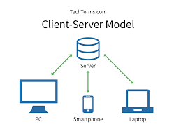

**Fig 1.1 client server model**

**7. Requirement**

**7.1 Software Requirement**

Frontend: HTML5 Javascript CSS

Backend: PHP

Database: MySQL

**7.2 Hardware Requirement**

Processor: 11th Gen Intel(R) Core (TM) i3-1115G4 @ 3.00GHz 3.00 GHz, 64-bit operating system, x64-based processor

Memory: 2 GB or more

Display: FHD display with a resolution of 1920 x 1080

**7.3 Platform**

Platform used is visual studio code for faster development.

**8. Contribution**

This website will be of a great help for the students. Most of the problems would reach out to the college and would be solved, thus making a healthy environment for the students.

Also saves the time and energy of physical meeting or writing a complaint in letter. Thus, making an overall better college experience.

**9. Conclusion**

This system will let the students post their problems without any fear or shyness, due to its anonymity.

It has voting system making the most faced issue reach out.

Reduces the time of the complaint reaching the handler.

Reduces the unnecessary usage of the resources.

Thus, more problems would reach out to the college and more problems would be solved.

# Chapter 1

# Introduction

## 1.1 Background

A student faces many problems in his/her college life. Many problems are not even addresses to the college due to student revealing their identity shyness or the process being tedious. Currently, there is no existing identical system. A similar system would be Reddit. The main goal of reddit is, through the voting system the best content is to be reached to the user. The reddit is for anything (memes, any matter, or problems).

The software being developed would be specifically for the college and students. In the Student Problem Management System, the most faced or critical problem can be addressed and voted by the students which would be taken up by the college handler.

## 1.2 Objectives

**The objectives of the system are as follows:**

* Providing a community where students can address by posting their problems in a quicker way without any shyness and fear of revealing identity.
* Providing a community where students can vote over the most faced or critical problems.
* Providing a community for college where they can view and take up the most faced problems by the students and prioritizing it to solve it accordingly.
* Reducing the time of the problems reaching out to the college thus making it a merit to the college.
* Reducing the resources usage in the usual physical process.

## 1.3 **Purpose, scope, and applicability**

### 1.3.1 Purpose

Providing a community where students can address by posting their problems in a quicker way without any shyness and fear of revealing identity and where the college they can view and take up the most faced problems by the students and prioritizing it to solve it accordingly.

### 

### 1.3.2 Scope

Making students of a college address by posting their problems at this software. Thus, the scope of this software to work efficiently is for a particular college.

It consists of some limitations for user like notifications which can be upgraded in future.

### 1.3.3 Applicability

* This software is for the students of a college to help them address their problems withoutany shyness and fear of revealing identity.
* This software is for the college to take up the problems faced by the students and try to provide solutions to solvable problems in a swift way.
* Thus, a software for a college which consists of students posting their problems and handler (college representative) taking up the problems, which will reduce the overall time and resources used in its usual manual process.

# Chapter 2

# Survey of Technologies

1. **HTML**

HTML is a markup language. It provides the structures of a website so that the web browser knows what to show.

1. **CSS**

CSS (Cascading Style Sheets) is a simple design language used to stylize elements written in a markup language such as HTML. It simplifies the process of making web pages presentable by handling the look and feel part of a web page and allowing users to control multiple web pages all at once.

1. **Programming Languages**

**• JavaScript**

JavaScript is a lightweight, interpreted, or just in time compiled programming language with first class function. While it is most well-known as the scripting language for webpages, many web browsers environments also use it, such as Node.js, Apache CouchDB, and adobe acrobat. JavaScript is a prototype based, multi-paradigm, single threaded, dynamic language, supporting object oriented, imperative, and declarative(e.g., functional programming) styles. It is used by all web browsers, meteor, and lots of other frameworks. Jquery an popular part of the JavaScript library that simplifies and enhances web development by providing a concise and efficient way to manipulate HTML documents, handle events, create animations, and interact with web services. It is designed to make JavaScript coding more accessible and cross-browser compatible.

**• Coffee Script**

It is a kind of “dialect” of java script. It is viewed as simpler and easier on your eyes as a developer but it compiles or converts back into java script. Coffee script is an attempt to expose the good part of java script in a simple way. The code compiles one to one into equivalent JS and there is no interpretation at the runtime. You can use any existing java script library seamlessly from coffee script and vice-versa. The compiled output is readable, pretty-printed and tends to run as fast or faster than the equivalent handwritten java script.

**• Python**

It is one of the highly used programming languages. It is used by the Django framework and used in a lot of mathematical calculations.

**• Ruby**

Used by the ruby or rails framework. It is a dynamic, open-source programming languages with a focus on simplicity and productivity. It has an elegant syntax that is natural to read and easy to understand.

• **PHP**

PHP is a popular general-purpose scripting language that is especially suited to web development. Fast, flexible, and pragmatic, PHP powers everything from your blog to most popular websites in the world.

**• Java**

Used by android(Google) and a lot of desktop applications. Java is a commonly used language for the web development, especially on the server-side. Java web applications are distributed applications that run on the internet. Web applications that run on the internet. Web development with java allows us to create dynamic web pages where user can interact with the interface.

1. **Frameworks**

• **Node.js**

It is a server-side java script framework. It is a JavaScript runtime built on chrome’s V8 JavaScript engine. As an asynchronous event-driven java script runtime, Node.js is designed to build scalable network applications.

• **Django**

Django is a high-level python web framework that encounters rapid development and clean, pragmatic design. Built by experienced developers, it takes cares of much of the hassle of web development, so you can focus on writing your app without needing to reinvent the wheel. It is free and open source.

• **Bootstrap**

A UI(user interface) framework for building with HTML/CSS/JavaScript.

**• Foundation**

A UI(user interface) framework for building with HTML/CSS/JavaScript.

• **WordPress**

A CMS(content management system) built on php. Currently, about 20% of all websites run on this framework.

**• .NET**

It is a full-stack framework built by Microsoft. It includes a large class library called Framework class library and provides language interoperability across several programming languages.

• **Angular.js**

It is a front-end java script framework. AngularJS lets you extend HTML vocabulary for your applications. The resulting environment is extraordinary expressive, readable, and quick to develop.

1. **Databases**

**• MongoDB**

It is an open-sourced NoSQL database and is currently the only database supported by Meteor. It is document data model naturally supports JSON and its expressive query language is simpler for developers to learn and use. Functionality such as automatic failover, horizontal scaling, and the ability to assign data to a location are built-in.

**• Redis**

It is the most popular key-value store. It is lighting fast for retrieving data but does not allow for much depth in the data storage. It has built in replication, Lua scripting, LRU eviction, transactions, and different levels of on disk persistence, and provides high availability via Redis Sentinel and automatic partitioning with Redis Cluster.

**• MySQL**

MySQL server is an open-source relational database management system which is a major support for web-based applications. MySQL server is used for data operations like querying, sorting, filtering, grouping, modifying, and joining the tables.

**• SQL server**

Microsoft SQL Server or MS SQL Server for short is the query language provided for data definition and manipulation. SQL Server is a Relational Database Management Systems which was developed and marketed by the Microsoft company. SQL and SQL servers are built as two layers where the SQL server is on the top for interacting with the relational databases.

1. **Data Formats**

It is the structure of how the data is stored.

**• JSON:**

It is quickly becoming the most popular data format. It is a lightweight data interchange format. It is easy for humans to read and write. It is easy for machines to parse and generate.

**• XML:**

It was the main data format early in the web days and predominantly used by Microsoft systems.

**• CSV:**

Its data is formatted with commas. Excel data is typically formatted this way.

**The technologies/system which will be used for the creation of the systems are:**

**1) HTML5 –** as it is short and crisp syntax hence it became very easy to write and manage HTML5 code. It will be used make user-friendly front-end.

**2) CSS -**it will be used to make the website presentable and the style applied is consistency visible across variety of sites.

**3) JAVASCRIPT-**it will be used to validate, manipulate, and compute data and as it could support all modern browser and produce an equivalent result. It simplifies and enhances web development by providing a concise and efficient way to manipulate HTML documents, handle events, create animations, and interact with web services. It is designed to make JavaScript coding more accessible and cross-browser compatible.

**4)PHP-**as it is open source and adaptable at multiple platforms. PHP has a relatively simple and intuitive syntax, making it easy to learn for beginners. It also integrates seamlessly with HTML and MySQL, allowing developers seamlessly with HTML, allowing developers to embed code within webpages.

**5)MySQL-**as easy to use and higher efficiency. It is easy to learn and used for storing data in database server and retrieve and modify according to the functionality of the software. This language helps to add, delete, and update data making it easy to use.

**6)JSON-**used for proper access of data as it is lightweight and easy to use.

# Chapter 3

# Requirements and Analysis

## 3.1 Problem Definition

The system is built so that students could state their problems in this software without revealing their identity in less tedious manner. The student could post their problems and could vote on the problems they find mutual or which they find right. The handler first verifies the posts before being posted to be voted and can take up the most faced problems and coordinate to the college management to solve it.

## 3.2 Requirement Specifications

### 3.2.1 Requirement Gathering

Various ways to gather requirement:

**1. Interview and surveys:** Conducting interview and surveys with users to gather their preferences and requirements for the software.

**2. User stories:** Utilize user stories, which are concise descriptions of a specific user’s requirement or need, to capture functional and non-functional requirements from the user’s perspective.

**3. Prototyping and Mock-ups:** Create protypes or mock-ups of the software to allow users to visualize and interact with the proposed solution. Their feedback can help refine and clarify requirements.

I have used the survey, and user-story method.

The information on requirement was gathered by asking some questions and taking some opinions of students and mentors of college. The questionnaire was prepared and passed by using Google forms, the link of the form is:

1. Student form: [Software Requirement Form-Student (google.com)](https://docs.google.com/forms/d/e/1FAIpQLSew9o-bxpzsR2etwM4qYKmhdRS0ZpkSE82din4NwQSeLhVDxQ/viewform)( https://forms.gle/imxrodxJzd6VsadeA)

The questions that were asked to students are as follows:

1.Does your problems faced in college get resolved?

2.Do you find it difficult to address the problems to the college?

3.Does it take long time from the problem being identified and getting resolved?

4.Reasons of not telling problems faced in the college to the college:

5.In which mode would u prefer to address the problem to college

6.Would it become easier if a software is provided in which your identity is not revealed and the above reasons are resolved and you can state your problem to your college?

7. Whether students should be able to vote on the problems and based on votes, can decide the priority of which problems is to be taken up without revealing any identity.

Based on these above questions the responses of the students who filled the form was recorded and they are all shown below:

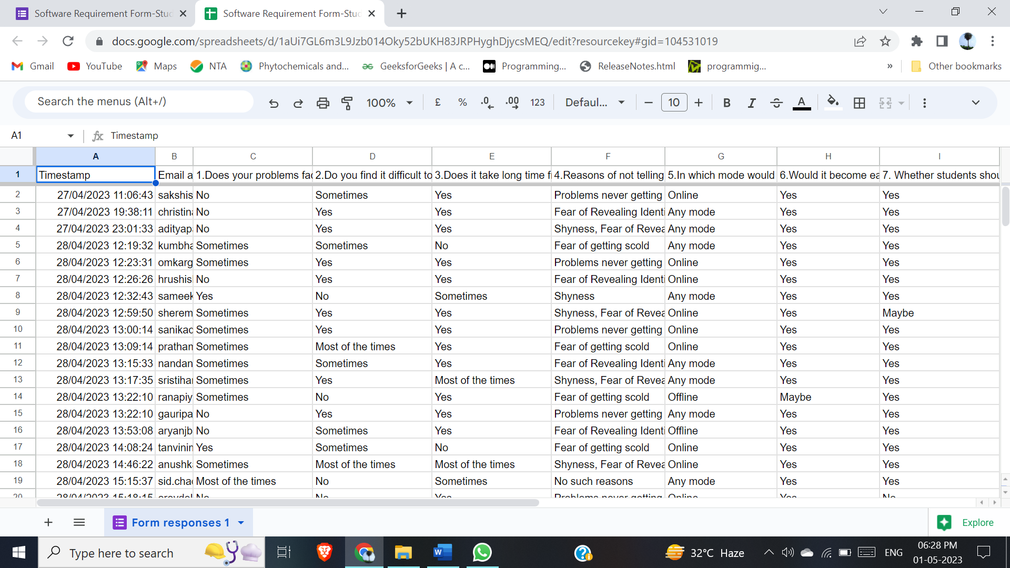

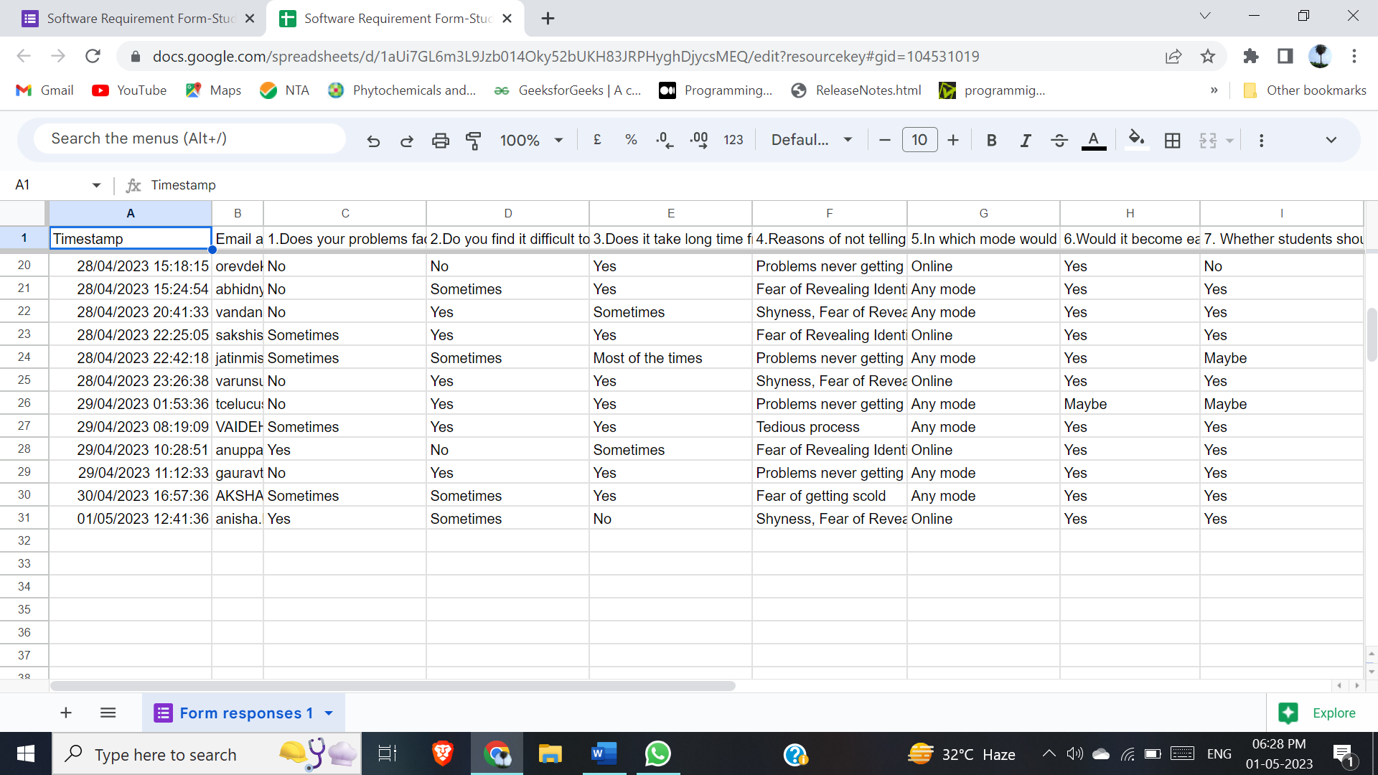

Figure 3.2.1.1: Google Form Result

The response to the problems that they normally seek (with the percentage according to survey):

1.The problems faced by the student doesn’t get solved (42.4%) or get solved sometimes (42.4%)

2.The problems faced by the students are difficult to address for 45.5% and sometimes difficult for 33.3%.

3.The problems faced in the college takes long time from being identified and getting resolved is found to be true to 66.7% students

4.The top 4 reasons of not telling the problems faced in college by the students were-

i. Fear of getting scold (51.8%)

ii. Problems never getting solved (45.5%)

iii. Fear of Revealing Identity (42.4%)

iv. Tedious process (30.3%)

v. 51.5% students are comfortable addressing their problems online.

vi.93.9% students are in favourable of wanting this software.

vii.87.9% students wanted the voting feature to the problems they face.

The response about any features that they wished there was in the website are as follows:

1. only one vote per student

2. Identity of any person should not be revealed to teachers

3.Information about the previous problems which were solved

4.History of the post posted to be provided to the student’s profile.

5.Categorization of the problems.

### 3.2.2 Requirement Analysis

**3.2.2.1 Functional Requirements**

1.Identity of Student to be anonymous

2.Problems could be posted and managed.

3.Problems could be viewed and voted.

4.View profile and recent posted.

5.Handler can verify and remove posts sent to verification

6.Admin can manage(add,delete,edit) details of all the users.

7.Admin can manage(add,delete) the posts.

8.Support page through which any issues can be communicated to admin directly.

**3.2.2.2 Non-Functional Requirements**

**1. Security**

It is achieved in login page by validating through username and password. In the registration page first the student’s control-id is validated then the email is authorised by through OTP verification.

**2. Availability**

It is achieved by creating backup database in case of any corruption or damage to the database. Regular backup and monitoring of database are to be done.

**3. User-feedback**

Any issues faced by the user will be handle through the contact us page or just mailing us the issue through the mail button set in every page footer.

**4. Efficiency**

It is achieved by using lightweight data format-JSON while fetching data through the ajax in the jQuery. And MySQL and PHP are used for the efficient server interaction.

**5. Reliability**

By making the software available and efficient it becomes reliable to the users to use whenever required. Every action is given an alert (user message) thus making every action user friendly. Thus, making the software reliable.

**3.2.2.3 System Requirements**

**1. Registration**

The student-user must first register its account in order to use the site. Without registering the user will be able to use the website.

* Input: User Details (controlid, rollno, email, otp (to the email), username, password)
* Output: Registration successful (redirect to the main page (index page))
* Pre-Condition: No existing user with same credentials and it should correspond to the details of the college student data table.
* Post-Condition: User able to login in with his/her account

**2. Login**

After registering the student-user will have to login in the system by the username/id and the password and after the credentials is verified the user will be logged in the system. For handler and admin, they would be given their username and password before only, registration not required.

* Input: username and password
* Output: successful login
* Pre-Condition: user should be registered (for the students). For handler and admin, they should be added to database through either admin page or manually added to database.
* Post-Condition: moved to user home page

**3. Post**

After login the student-user can post problems faced by them through the menu post tab.

* Input: post tab
* Output: show the posting page
* Pre-Condition: valid data should be entered
* Post-Condition: post is sent to handler for verification.

For Handler, in this tab they can verify or remove the post to be verified.

For Admin, they can verify or delete the removed post and remove the to be verified post

**4. View and Vote**

After login the student-user can view and vote the posts according to their opinions.

* Input: home tab or login
* Output: show the home page
* Pre-Condition: user must be logged in
* Post-Condition: post is sent to handler for verification.

For Handler, in this tab they can only view the voting done by the other student users and take up the problem and try to solve it by taking required actions.

For Admin, they can remove the verified post.

**5. Profile**

After login the all the user can view their profile in which they can view their details. And can edit details.

* Input: profile tab
* Output: show the profile page and option to edit details
* Pre-Condition: user must be logged in
* Post-Condition: all profile details are shown

**6. Support Page**

After login the all the user can navigate to contact us to state the software related issues.

* Input: contact us tab
* Output: show the contact us page
* Pre-Condition: user must be logged in
* Post-Condition: contact us form through which mail could be sent.

**6. User Update Page**

After login the only the admin can navigate to this page where he can manage (add,delete and edit) the users-student, handler and admin.

* Input: User Updater
* Output: show the User Update page
* Pre-Condition: user must be logged in.
* Post-Condition: user-specific tab to be selected according to which users can managed.

**3.3 Task Table and Gantt Chart**

|  |  |  |  |  |  |  |
| --- | --- | --- | --- | --- | --- | --- |
| Task No. | Task name | Starting date | Ending date | | Actual Starting date | Actual Ending Date |
| T1 | Synopsis | 1-April-23 | 15-April-23 | | 1-April-23 | 12-Apr-23 |
| T2 | Approval | 1-April-23 | 15-April-23 | | 3-April-23 | 12-April-23 |
| T3 | Chapter-1 Introduction | 17-April-23 | 24-April-23 | | 19-April-23 | 20-April-23 |
| T4 | Chapter-2  Survey of Technologies | 13-June -23 | 19-June-23 | | 17-June-23 | 19-June-23 |
| T5 | Chapter-3  Requirement and Analysis  3.1 Problem Definition  3.2 Requirement Specification | 13-June-23 | 19-June-23 | | 17-June-23 | 19-June-23 |
| T6 | Task Table and Gnat chart | 1-July-23 | 6-October-23 | | 1-July-23 | 6-October-23 |
| T7 | Chapter -4  System Design  4.1 Business Rule  4.2 Module Diagram  4.3 ER diagram | 14-July-23 | 18-August-23 | | 17-July-23 | 10-August |
| T8 | 4.4 Schema | 1-August-23 | 10-August-23 | | 3-August-23 | 5-August-23 |
| T9 | 4.5 Data Flow Diagram | 10-August-23 | 31-August-23 | | 12-August-23 | 31-August-23 |
| T10 | | 4.6 Class Diagram | 10-August-23 | 31-August-23 | | 12-August-23 | 31-August-23 |
| T11 | | 4.7 Use case and Scenario | 28-August-23 | 13-September-23 | | 28-August-23 | 9-September-23 |
| T12 | | 4.8 Sequence Diagram | 13-September-23 | 15-September-23 | | 13-September-23 | 15-September-23 |
| T13 | | 4.9 Activity Diagram | 16-September-23 | 03-October-23 | | 17-September-23 | 03-October-23 |
| T14 | | 4.10 State Chart Diagram | 16-September-23 | 03-October-23 | | 18-September-23 | 03-October-23 |
| T15 | | 4.11 UI Design | 16-September-23 | 03-October-23 | | 19-September-23 | 03-October-23 |
| T16 | | 4.12 Test Cases | 01-October-23 | 05-October-23 | | 04-October-23 | 05-October-23 |
| T17 | | **Re-engineering**  Chapter 1 | 1-November-23 | 4-November-23 | | 1-November-23 | 1-November-23 |
| T18 | | Chapter 2 | 1-November-23 | 4-November-23 | | 1-November-23 | 1-November-23 |
| T29 | | Chapter 3 | 1-November-23 | 4-November-23 | | 1-November-23 | 1-November-23 |
| T20 | | Chapter 4 | 1-November-23 | 4-November-23 | | 1-November-23 | 1-November-23 |
| T21 | | **Unit 1: Home & Registration & Login Page**  Design Module Home | 10-November-23 | 11-November-23 | | 10-November-23 | 11-November-23 |
| T22 | | Debugging Module Home | 10-November-23 | 11-November-23 | | 10-November-23 | 11-November-23 |
| T23 | | Testing Module Home | 11-November-23 | 11-November-23 | | 11-November-23 | 11-November-23 |
| T24 | | Design Module Register | 11-November-23 | 12-November-23 | | 11-November-23 | 12-November-23 |
| T25 | | Debugging Module Register | 12-November-23 | 12-November-23 | | 12-November-23 | 13-November-23 |
| T26 | | Testing Module Register | 12-November-23 | 13-November-23 | | 13-November-23 | 14-November-23 |
| T27 | Design Module Login | 13-November-23 | 13-November-23 | | 14-November-23 | 14-November-23 |
| T28 | Debugging Module Login | 14-November-23 | 15-November-23 | | 15-November-23 | 16-November-23 |
| T29 | Testing Module Login | 14-November-23 | 15-November-23 | | 15-November-23 | 16-November-23 |
| T30 | Integrating All completed Unit | 15-November-23 | 16-November-23 | | 16-November-23 | 17-November-23 |
| T31 | Debugging | 16-November-23 | 16-November-23 | | 17-November-23 | 17-November-23 |
| T32 | Testing | 16-November-23 | 16-November-23 | | 17-November-23 | 17-November-23 |
| T33 | **Unit 2: Student Home Page (View and Vote Post)**  Design Student Home Page | 17-November-23 | 18-November-23 | | 18-November-23 | 19-November-23 |
| T34 | Debugging Student Home Page | 18-November-23 | 18-November-23 | | 19-November-23 | 19-November-23 |
| T35 | Testing Student Home Page | 18-November-23 | 18-November-23 | | 19-November-23 | 19-November-23 |
| T36 | Integrating All completed Unit | 19-November-23 | 20-November-23 | | 20-November-23 | 21-November-23 |
| T37 | Debugging | 20-November-23 | | 20-November-23 | 21-November-23 | 21-November-23 |
| T38 | Testing | 20-November-23 | 20-November-23 | | 21-November-23 | 21-November-23 |
| T39 | **Unit 3: Send Post**  Design Send Post | 21-November-23 | 22-November-23 | | 22-November-23 | 23-November-23 |
| T40 | Debugging Send Post | 22-November-23 | 22-November-23 | | 23-November-23 | 23-November-23 |
| T41 | Testing Send Post | 22-November-23 | 22-November-23 | | 23-November-23 | 23-November-23 |
| T42 | Integrating All completed Unit | 23-November-23 | 24-November-23 | | 24-November-23 | 25-November-23 |
| T43 | Debugging | 24-November-23 | 24-November-23 | | 25-November-23 | 25-November-23 |
| T44 | Testing | 24-November-23 | 24-November-23 | | 25-November-23 | 25-November-23 |
| T45 | **Unit 4: Profile Page**  Design Profile Page | 25-November-23 | 26-November-23 | | 26-November-23 | 27-November-23 |
| T46 | Debugging Profile Page | 26-November-23 | 26-November-23 | | 27-November-23 | 27-November-23 |
| T47 | Testing Profile Page | 26-November-23 | 26-November-23 | | 27-November-23 | 27-November-23 |
| T48 | Integrating All completed Unit | 27-November-23 | 28-November-23 | | 28-November-23 | 29-November-23 |
| T49 | Debugging | 28-November-23 | 28-November-23 | | 29-November-23 | 29-November-23 |
| T50 | Testing | 28-November-23 | 28-November-23 | | 29-November-23 | 29-November-23 |
| T51 | **Unit 5: Contact Us**  Design Contact Us Page | 29-November-23 | 30-November-23 | | 30-November-23 | 1-December-23 |
| T52 | Debugging Contact Us Page | 30-November-23 | 30-November-23 | | 1-December-23 | 1-December-23 |
| T53 | Testing Contact Us Page | 30-November-23 | 30-November-23 | | 1-December-23 | 1-December-23 |
| T54 | Integrating All completed Unit | 1-December-23 | 2-December-23 | | 2-December-23 | 3-December-23 |
| T55 | Debugging | 2-December-23 | 2-December-23 | | 3-December-23 | 3-December-23 |
| T56 | Testing | 2-December-23 | 2-December-23 | | 3-December-23 | 3-December-23 |
| T57 | **Unit 6: Handler Home Page (View Post)**  Design Handler Home Page | 3-December-23 | 4-December-23 | | 4-December-23 | 5-December-23 |
| T58 | Debugging Handler Home Page | 4-December-23 | 4-December-23 | | 5-December-23 | 5-December-23 |
| T59 | Testing Handler Home Page | 4-December-23 | 4-December-23 | | 5-December-23 | 5-December-23 |
| T60 | Integrating All completed Unit | 5-December-23 | 6-December-23 | | 6-December-23 | 7-December-23 |
| T61 | Debugging | 6-December-23 | 6-December-23 | | 7-December-23 | 7-December-23 |
| T70 | Testing | 6-December-23 | 6-December-23 | | 7-December-23 | 8-December-23 |
| T71 | **Unit 7: Verify and Remove Post Page**  Design Verify and Remove Post | 7-December-23 | 8-December-23 | | 9-December-23 | 10-December-23 |
| T72 | Debugging Verify and Remove Post | 8-December-23 | 8-December-23 | | 10-Decemeber-23 | 10-Decemeber-23 |
| T73 | Testing Verify and Remove Post | 8-December-23 | 8-December-23 | | 10-Decemeber-23 | 10-Decemeber-23 |
| T74 | Integrating All completed Unit | 9-December-23 | 10-December-23 | | 11-Decemeber-23 | 12-Decemeber-23 |
| T75 | Debugging | 10-December-23 | 10-December-23 | | 12-Decemeber-23 | 12-Decemeber-23 |
| T76 | Testing | 10-December-23 | 10-December-23 | | 12-Decemeber-23 | 12-Decemeber-23 |
| T77 | **Unit 8: Admin Home Page (View and Remove Post)**  Design Admin Home Page | 11-December-23 | 12-December-23 | | 13-Decemeber-23 | 14-Decemeber-23 |
| T78 | Debugging Admin Home Page | 12-December-23 | 12-December-23 | | 14-Decemeber-23 | 14-Decemeber-23 |
| T79 | Testing Admin Home Page | 12-December-23 | 12-December-23 | | 14-Decemeber-23 | 14-Decemeber-23 |
| T80 | Integrating All completed Unit | 13-December-23 | 14-December-23 | | 15-Decemeber-23 | 16-Decemeber-23 |
| T81 | Debugging | 14-December-23 | 14-December-23 | | 16-Decemeber-23 | 16-Decemeber-23 |
| T82 | Testing | 14-December-23 | 14-December-23 | | 16-Decemeber-23 | 16-Decemeber-23 |
| T83 | **Unit 9: Verify, Remove and Delete Post Page**  Design Verify and Remove Post | 15-December-23 | 16-December-23 | | 17-Decemeber-23 | 18-Decemeber-23 |
| T84 | Debugging Verify and Remove Post | 16-December-23 | 16-December-23 | | 18-Decemeber-23 | 18-Decemeber-23 |
| T85 | Testing Verify and Remove Post | 16-December-23 | 16-December-23 | | 18-Decemeber-23 | 18-Decemeber-23 |
| T86 | Integrating All completed Unit | 17-December-23 | 18-December-23 | | 19-Decemeber-23 | 20-Decemeber-23 |
| T87 | Debugging | 18-December-23 | 18-December-23 | | 20-Decemeber-23 | 20-Decemeber-23 |
| T88 | Testing | 18-December-23 | 18-December-23 | | 20-Decemeber-23 | 20-Decemeber-23 |
| T89 | **Unit 10: Manage User Page (View and Remove Post)**  Design Manage User Page | 19-December-23 | 20-December-23 | | 21-Decemeber-23 | 22-Decemeber-23 |
| T91 | Debugging Manage User Page | 20-December-23 | 20-December-23 | | 22-Decemeber-23 | 22-Decemeber-23 |
| T92 | Testing Manage User Page | 20-December-23 | 20-December-23 | | 22-Decemeber-23 | 22-Decemeber-23 |
| T93 | Integrating All completed Unit | 21-December-23 | 21-December-23 | | 23-Decemeber-23 | 23-Decemeber-23 |
| T94 | Debugging | 21-December-23 | 21-December-23 | | 23-Decemeber-23 | 23-Decemeber-23 |
| T95 | Testing | 22-December-23 | 22-December-23 | | 24-Decemeber-23 | 24-Decemeber-23 |

*Table 3.3.1: Task Table*

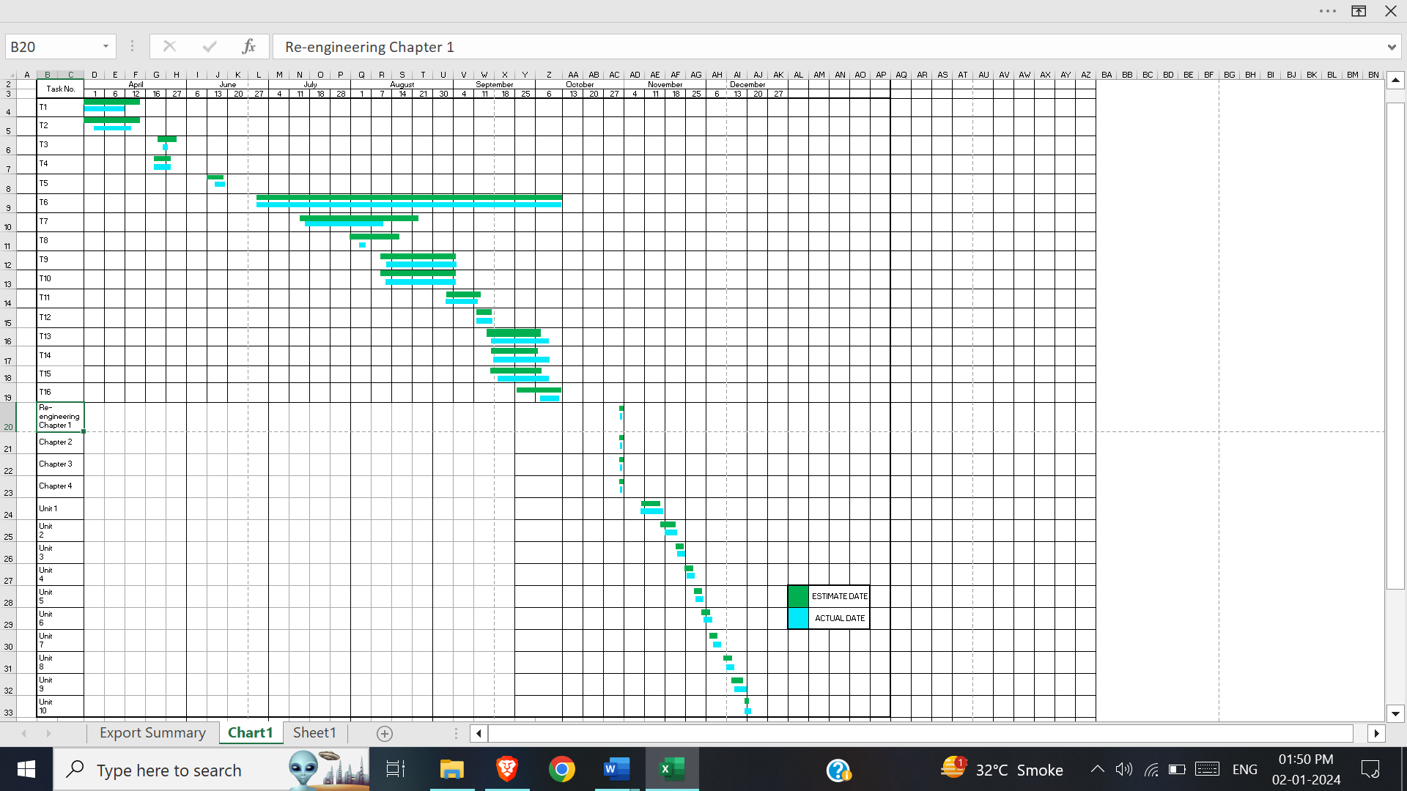

*Figure 3.3.1: Gantt Chart*

# Chapter 4

# System Design

## 4.1 Business Rule

* When the web application is opened the user can either sign in if they have already registered or must sign up.
* To sign up the user must be a student of college having a valid control id, roll no and email given to college. Roll no and email should match with the control id. Control id should be a 10-digit number while roll no should be 8 digit alpha numeric. An OTP would be sent while registering for authentication of mail.
* While registering the user will have to create username and its length would be between 8 and 20 and minimum 1 letter, 1 number required and other than underscore (_) no special character is allowed and password which will be composed of minimum 1 capital letter, 1 number, 1 special character, and the length of the password should be greater than 8.
* If user have already registered (for students) or have credentials (admin, handler) can login by entering their username and password. The admin and handler would be given credentials in hand (no registration required).
* After login the respective users would get their functionality according to their designation (student, handler, and admin).

Student is allowed to view, vote and post problems. View profile and Contact admin and Logout.

Handler is allowed to view, verify, and remove problems. View profile and Contact admin and Logout.

Admin is allowed to view, verify, remove, and delete problems and can manage users (create, view update, and delete). View profile and Contact admin and Logout.

## 4.2 Module Diagram

Module diagram is a diagram which is used for showing the allocation of classes and objects to module in the physical design of a system. Module Diagram indicates the partitioning of the system architecture. Through this diagram, it is possible to understand the general physical architecture of a system. The two essential elements of a module diagram are modules and their dependencies.

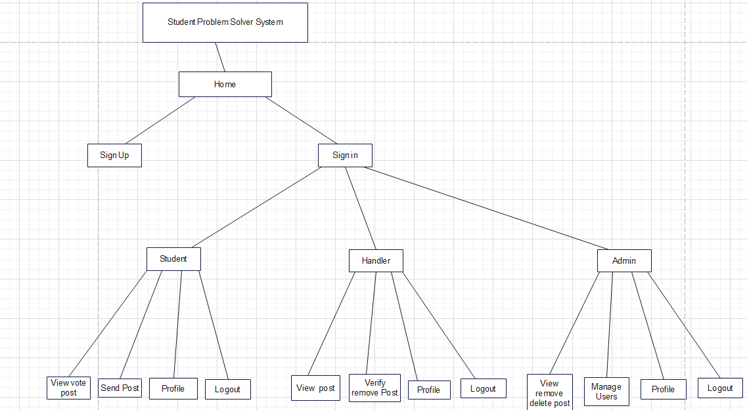

Figure 4.2: Module diagram

## 4.3 ER Diagram

An Entity-Relationship (ER) diagram is a visual representation used to model the relationships between various entities (objects, concepts, or things) within a system or database. It depicts how these entities are related to each other and helps to define the structure of the data and the way data is stored and retrieved. ER diagrams use symbols such as rectangles for entities, diamonds for relationships, and lines to connect them, allowing for a clear visualization of data relationships and dependencies.

**Symbols:**

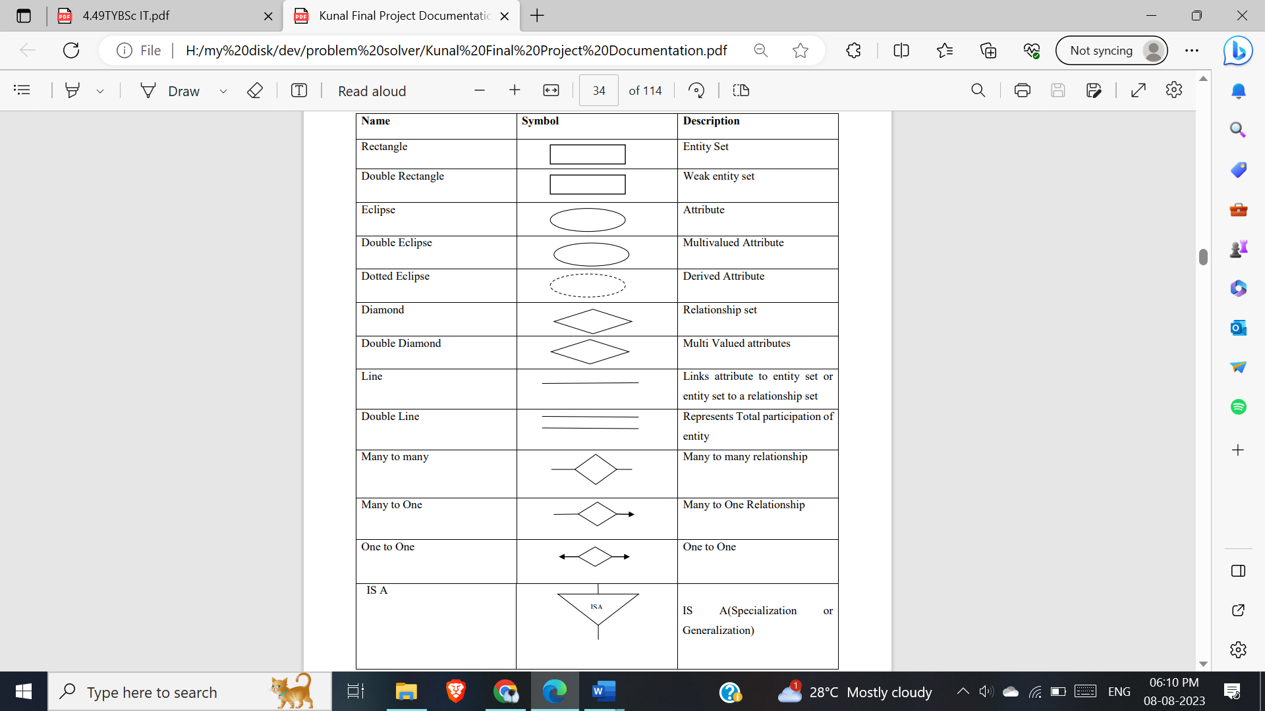

Table 4.3.1: Entity Relationship Diagram symbols

### 4.3.1 Entity sets

**1.Students**

**This Entity represent the students in the college.**

Attributes:

1.Control id(int)-pk

Represent the control id of the student

2.roll no(varchar)

Represent the roll-no of the student

3.email(varchar)

Represent the email of the student

4.registered_no(int)

It Represent whether a student is registered or not.

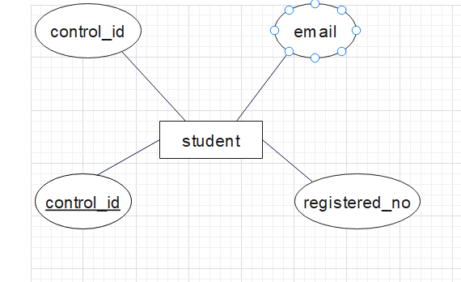

Figure 4.3.1.1: Student Entity

**2.Stud_Account**

**This Entity represent the students who have registered to the website.**

Attributes:

1.Stu_username(varchar)-ck,pk

Represent the username of the student who registered.

2.password(varchar)

Represent the password of the student who registered.

3.public_username(varchar)

Represent the public username of the student who registered.

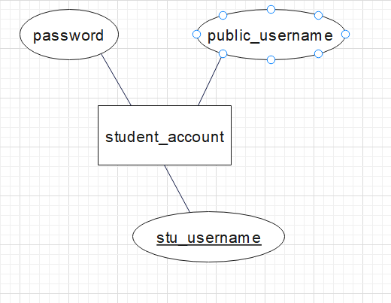

Figure 4.3.1.2: Student_account Entity

**3.Post**

**This entity represents the Post that is posted by the student**

Attributes:

1. post_id(int)-pk

Represent the an unique id given to each post

2.post_votes(int)

Represent the number of votes given to a post

3.post_status(varchar)

Represent the status of a post. Whether it is to be verified, verified, or removed.

4.post_title(varchar)

Represent the title given to a post.

5.post_desc(varchar)

Represent the description given to a post.

6.post_date(date)

Represent the date at which the post was send to be verified by the handler.

7.verified_date(date)

Represent the date at which the post was verified by the handler. And date at which it is available to the student to be viewed publicly and voted.

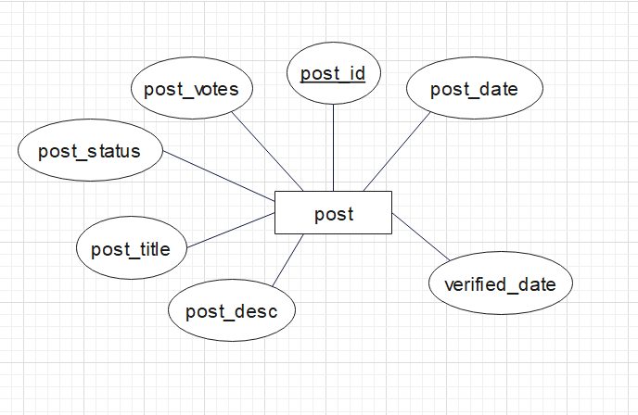

Figure 4.3.1.3: Post Entity

### 4.3.2 Relationship Sets

1.stud_account send post

Mapping constraint: many to many

Participation: partial (from student) total(from post)

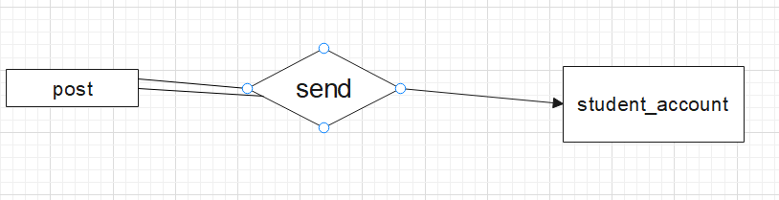

Figure 4.3.2.1: student_account send post

2.student create stud_account

Mapping constraint: one to one

Participation: partial (from student) total(from stud_account)

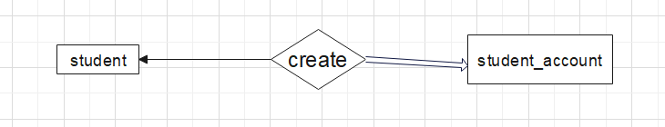

Figure 4.3.2.2: student create student_account

3.student_account votes post

Mapping constraint: many to many

Participation: partial (from student) partial(from post)

Vote have its own attribute called vote_id

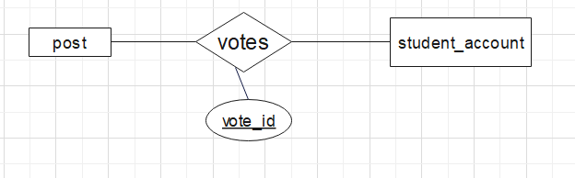

Figure 4.3.2.3: student_account votes post

### 4.3.3 ER diagram

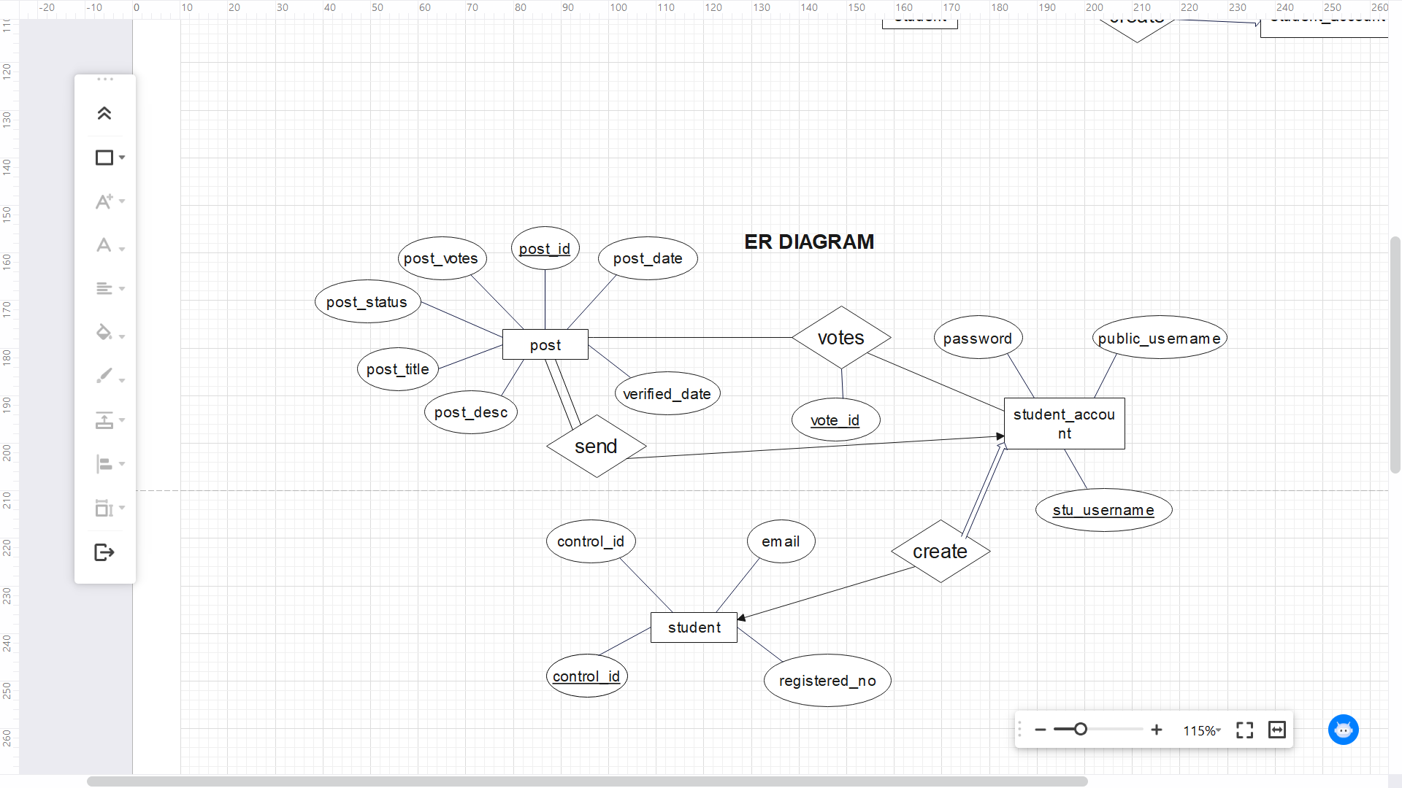

Figure 4.3.3.1: Entity Relationship Diagram

## 4.4 Schema Diagram

A database schema is the skeleton structure that represents the logical view of the entire database. It defines how the data is organized and how the relations among them are associated. It formulates all the constraints that are to be applied on the data.

**Symbols:**

|  |  |  |
| --- | --- | --- |
| **Name** | **Symbol** | **Description** |
| Table |  | A table is a collection of related table held in table format within a database. |
| Relational |  | In a relational database system, a on-to-one table relationship links two tables based on a Primary Key column in the child which is also a Foreign Key referencing the Primary Key of the parent table row. Therefore, we can say that the child table share the Primary Key with the parent table. |

Table 4.4.1: Schema Diagram Symbols

**Schema Diagram:**

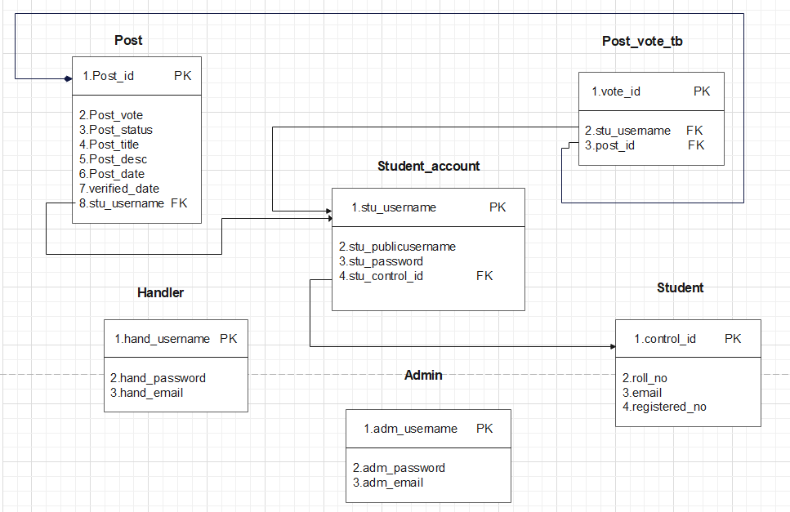

Figure 4.4.1: Schema Diagram

## 4.5 Data Flow Diagram (DFD)

A data-flow diagram is a way of representing a flow of data through a process or a system (usually an information system). The DFD also provides information about the outputs and inputs of each entity and the process itself. A data-flow diagram has no control flow — there are no decision rules and no loops. Specific operations based on the data can be represented by a flowchart.

**Symbols:**

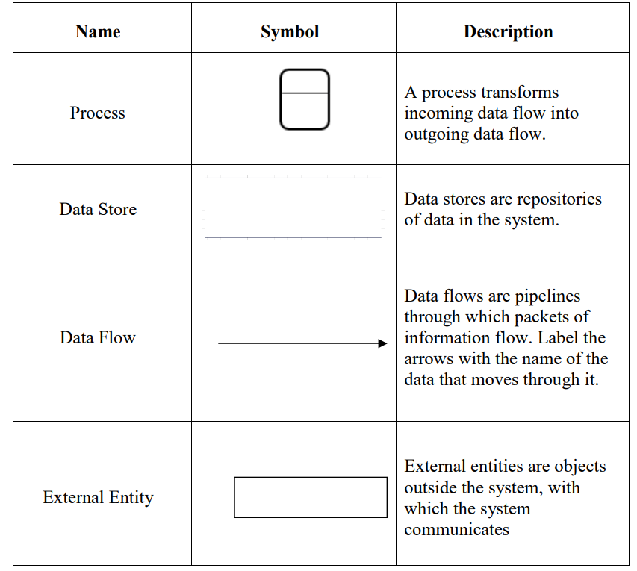

Table 4.5.1: Data Flow Diagram Symbols

**Level 0(Context level DFD):**

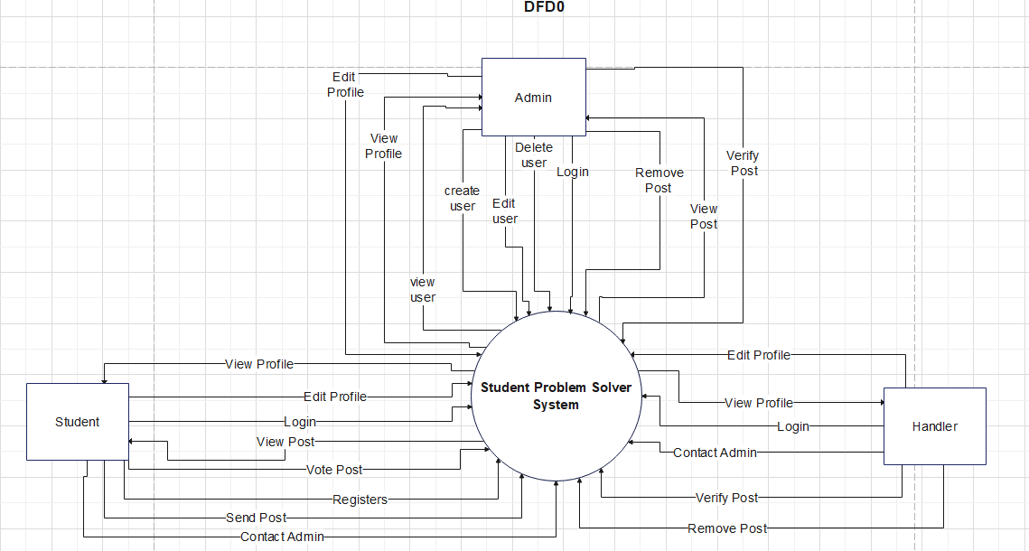

Figure 4.5.1: DFD Level 0

**Level 1 DFD:**

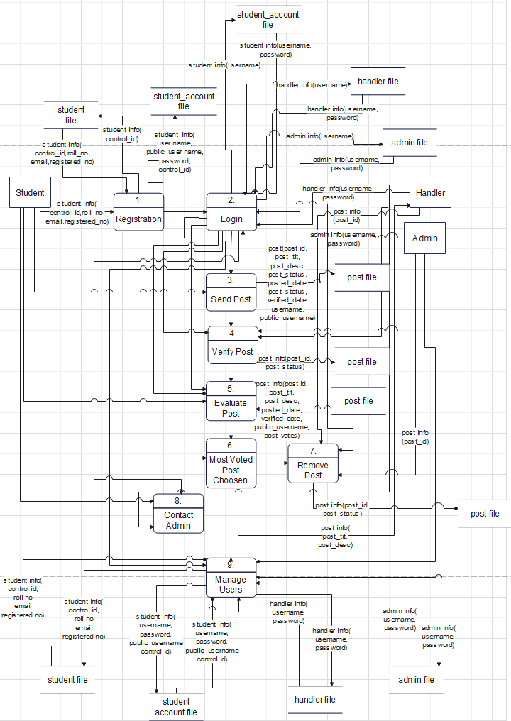

Figure 4.5.2: DFD Level 1

**Level 2 DFD for Login:**

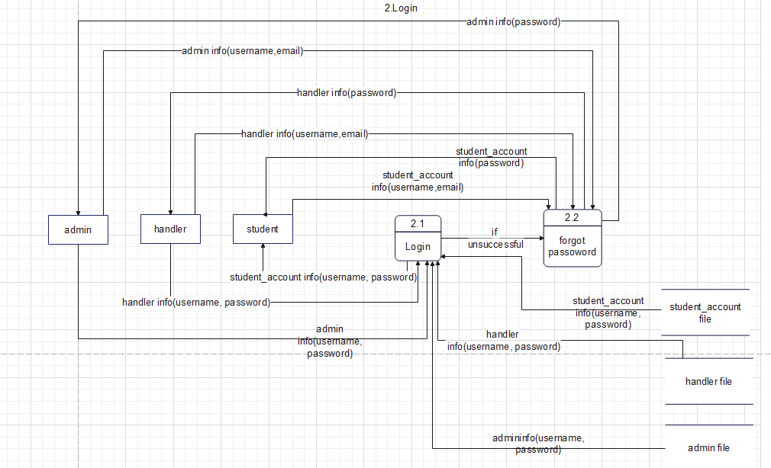

Figure 4.5.3: DFD Level 2 for Login

**Level 2 DFD for Registration:**

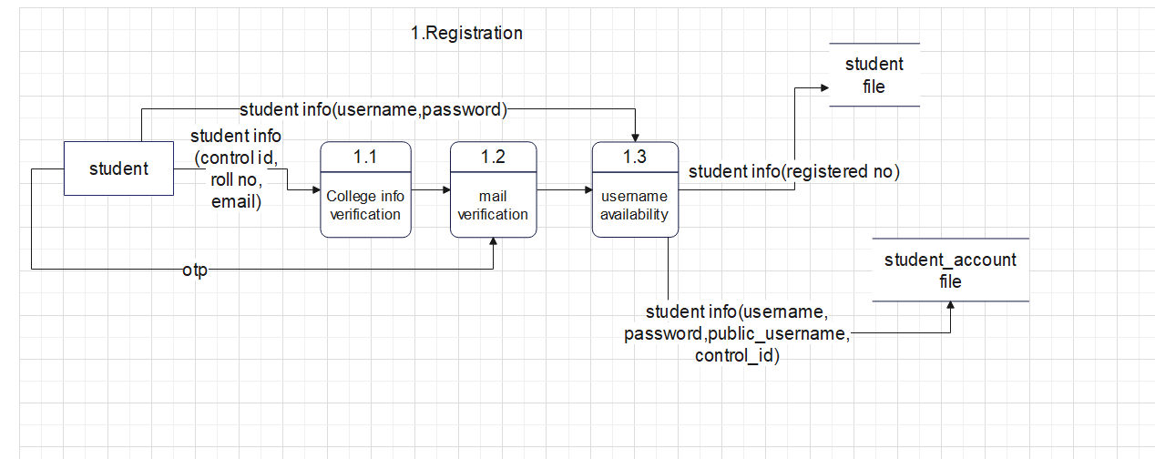

Figure 4.5.4: DFD Level 2 for Registration

**Level 2 DFD for Verify Post:**

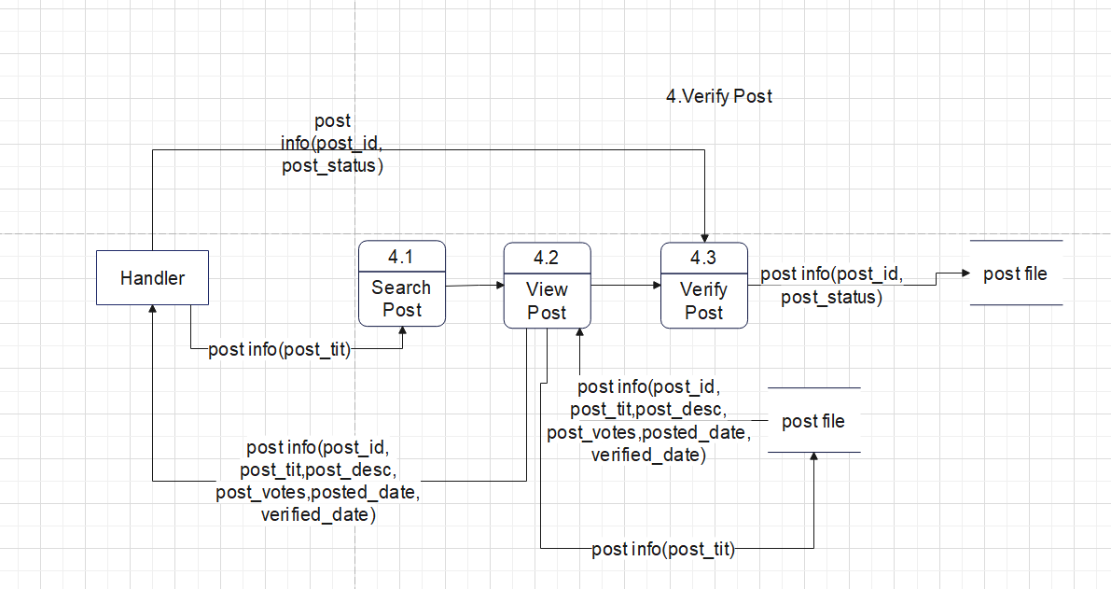

Figure 4.5.5: DFD Level 2 for Verify Post

**Level 2 DFD for Evaluate Post:**

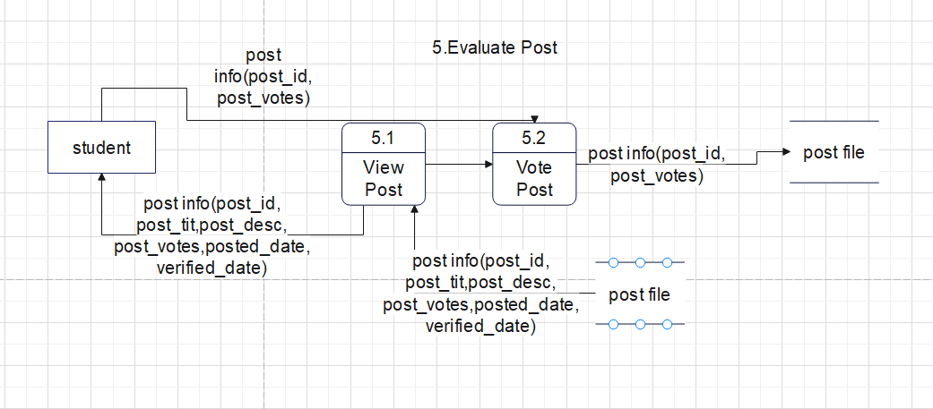

Figure 4.5.6: DFD Level 2 for Evaluate Post

**Level 2 DFD for Remove Post:**

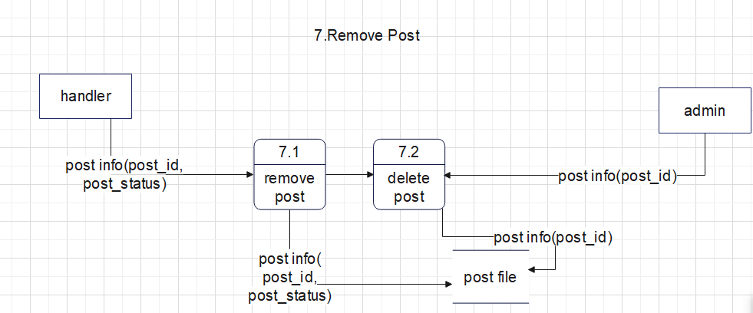

Figure 4.5.7: DFD Level 2 for Remove Post

**Level 2 DFD for Manage Users:**

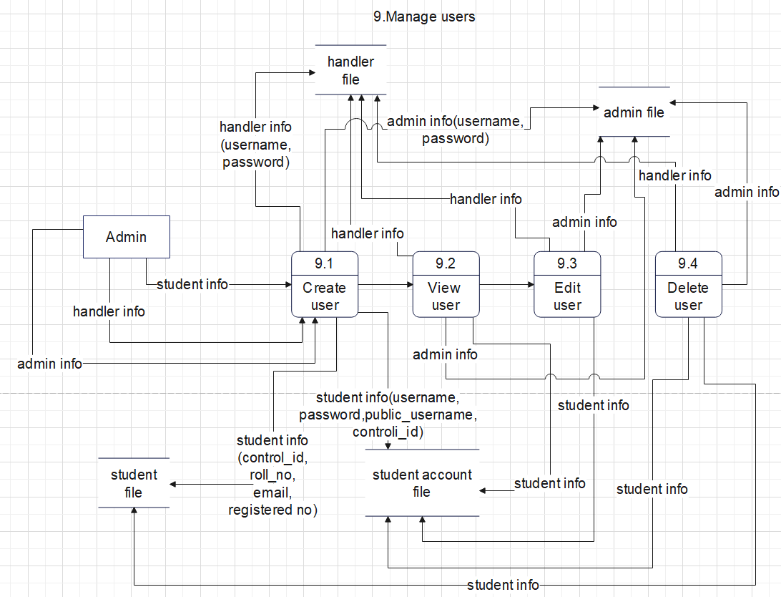

Figure 4.5.8: DFD Level 2 for Manage Users

**Level 2 DFD for Manage Profile:**

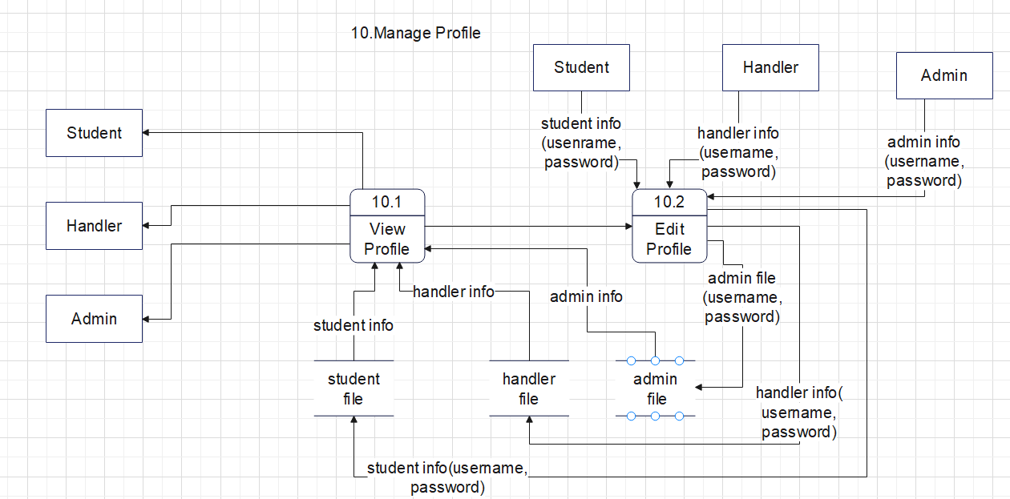

Figure 4.5.9: DFD Level 2 for Manage Profile

## 4.6 Class diagram

Class diagram is a static diagram. It represents the static view of an application. Class diagram is not only used for visualizing, describing, and documenting different aspects of a system but also for constructing executable code of the software application. Class diagram describes the attributes and operations of a class and the constraints imposed on the system. The class diagrams are widely used in the modelling of object-oriented systems because they are the only UML diagrams, which can be mapped directly with object-oriented languages.

**Symbols:**

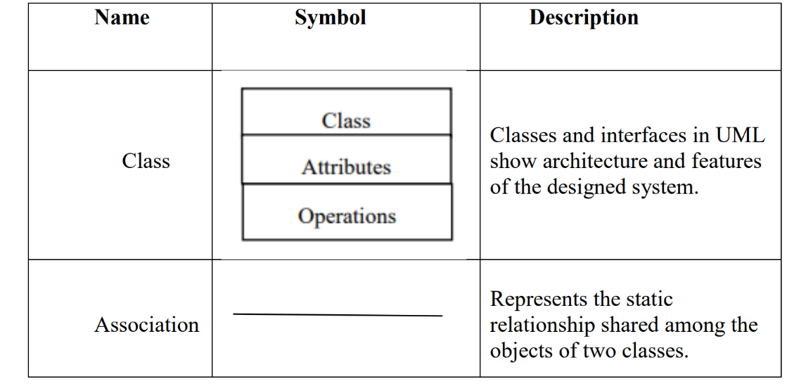

Table 4.6.1: Class Diagram Symbols

**Class Diagram not applicable to this system**

## 4.7 Use Case Diagram

A use case diagram at its simplest is a representation of a user's interaction with the system that shows the relationship between the user and the different use cases in which the user is involved. A use case diagram can identify the different types of users of a system and the different use cases and will often be accompanied by other types of diagrams as well. The use cases are represented by either circles or ellipses.

**Symbols:**

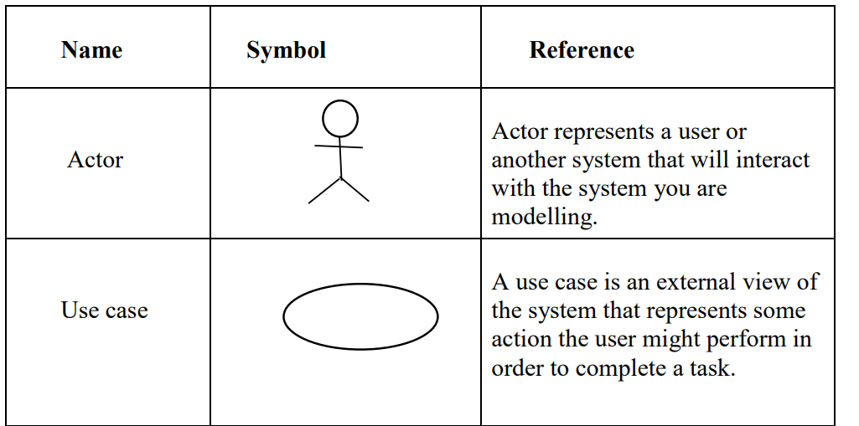

Table 4.7.1: Use Case Diagram Symbols

### 4.7.1 Diagram

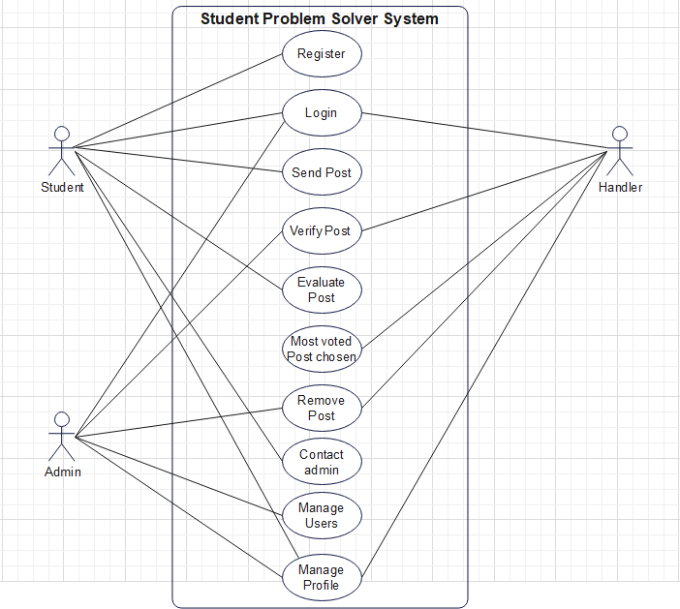

Figure 4.7.1: Use Case Diagram

### 4.7.2 Description

**1.Use Case**: Registration

* **Description**: The user(student) needs to register their account. To register, users will be given a form webpage in which they will have to fill in their personal details like control id, roll no, email, username, and password.
* **Actors**: Student
* **Pre-Condition**: Users(students) need to fill all the details asked in the form in the correct format.
* **Exception**: If the format of any detail is incorrect or any required field is kept empty, registration will not be successful. The control id, roll no, email should be matching to what was given to college during and after the admission process. If any mistake occurs it will lead to improper filling of details.
* **Post-Condition**: Registered successfully. Can proceed to login.

**2.Use Case**: Login

* **Description**: This use case describes the login process where the user needs to login to the system after creating an account, with username and password.
* **Actors**: Student, Handler, Admin
* **Pre-Condition**: The student/admin/handler needs to provide the correct login and password to login to the system.
* **Exception**: If any detail is not correct, the student/admin/handler cannot login to the system and must try again.
* **Post-Condition**: Provided all the details are correct, the student/admin/handler will get logged in to the system, to their respective account.

**3.Use Case**: Send Post

* **Description**: This use case describes the Post sending process by a student
* **Actors**: Student
* **Pre-Condition**: The student must be logged into the system with correct details.
* **Exception**: If login details are incorrect, the student cannot login to the system and send a post. And more than the 3 posts cannot be sent per week unless removed or deleted.
* **Post-Condition**: The post is sent to the handler for verification before being posted or removed.

**4.Use Case**: Verify Post

* **Description**: This use case describes the Post being verified by a Handler and in case of some issues admin too.
* **Actors**: Handler, Admin
* **Pre-Condition**: The Handler/ Admin must be logged into the system with correct details and posts must be sent by students to be verified.
* **Exception**: If login details are incorrect, the Handler/ Admin cannot login to the system and verify the post.
* **Post-Condition**: The post is verified and is posted for voting for students or is removed.

**5.Use Case**: Evaluate Post

* **Description**: This use case describes the Post which was verified, are being evaluated by students such that they view and vote the posts.
* **Actors**: Student
* **Pre-Condition**: The student must be logged into the system with correct details and post must be verified to be available for voting.
* **Exception**: If login details are incorrect, the student cannot login to the system and view and vote post.
* **Post-Condition**: The posts are voted by the students and most voted posts are sorted at the top which would be selected by the handler accordingly.

**6.Use Case**: Most voted post chosen

* **Description**: This use case describes the process in which the Posts with most votes are prioritised and chosen by the handler to be solved.
* **Actors**: Handler
* **Pre-Condition**: The Handler must be logged into the system with correct details and post must be present to be voted by students.
* **Exception**: If login details are incorrect, the Handler cannot login to the system and select the most voted posts.
* **Post-Condition**: The most voted post is selected and the post is removed as its purpose is completed.

**7.Use Case**: Remove post

* **Description**: This use case describes the Post being removed by Handler and in case of issue admin can do this functionality.
* **Actors**: Handler, Admin
* **Pre-Condition**: The Handler/ Admin must be logged into the system with correct details and post must be present to be removed.
* **Exception**: If login details are incorrect, the Handler/ Admin cannot login to the system and remove the post.
* **Post-Condition**: The post is removed and can be deleted later by admin.

**8.Use Case**: Contact admin

* **Description**: This use case describes the process of a student or handler contacting the admin through the contact us page in case of any issue.
* **Actors**: Student, Handler
* **Pre-Condition**: The Student/ Handler must be logged into the system with correct details.
* **Exception**: If login details are incorrect, the Student/ Handler cannot login to the system and contact Admin.
* **Post-Condition**: The admin would respond to the request made by Student/ Handler

**9.Use Case**: Manage users

* **Description**: This use case describes the process of managing users(create,view,edit,delete) by the Admin
* **Actors**: Admin
* **Pre-Condition**: The Admin must be logged into the system with correct details.
* **Exception**: If login details are incorrect, the Admin cannot login to the system and manage users.
* **Post-Condition**: The changes of create, edit delete by admin would be reflected on the system.

**10.Use Case**: Manage profile

* **Description**: This use case describes the process of managing profile(view and edit) of Student/Handler/Admin
* **Actors**: Student, Handler, Admin
* **Pre-Condition**: The Student/Handler/Admin must be logged into the system with correct details.
* **Exception**: If login details are incorrect, the Student/Handler/Admin cannot login to the system and manage profile.
* **Post-Condition**: The changes of edit by Student/Handler/Admin would be reflected on the system.

## 4.8 Scenarios

**1. Registration**

1. The user inputs the required details (control id, roll no, email)

2. The system requests for details of the user from database

3.The system verifies these details

4.The system then sends an otp to the respective mail given and tells the user to enter otp through a modal.

5.The system authenticate the otp and proceed to take the input of username and password.

6.The system check the username availability and check for validation.

7. On successfully passing the check constraints, the details are stored in the database and if successfully registered redirected to the home page

**2. Login**

1. The user inputs the required details (username and password)

2. The system requests for details of the user from database

3.The system verifies these details

4.If verification is successful, and the user is redirected to the home page

**3. Evaluate Post-View and Vote Post**

1.All posts who have its attribute post_status set to "verified " are loaded to the user in a sorted manner of highest to lowest votes from the database, after login. They can view the post posted.

2.The appropriate posts are voted.

3.When a post is voted on. It is sorted again according to the current order of the post's vote.

4.The post vote count is incremented by one and updated in the database.

5.On refreshing it is loaded with the new order with the updated post vote.

**4. Send Post**

1.After selecting the post tab, the user is redirected to the posting page.

2.The user can fill the details of the post and send the post.

3.The details are sent and stored into the database and an attribute of the post, post_status is set to "to be verified"

4. A message "Post will be posted after verification " is shown to the user. A maximum of three votes are allowed to be posted by a user per week unless removed.

**5. Manage Profile**

1.After selecting the profile tab, the user is redirected to the profile page.

2.Data is loaded from the database and profile details are displayed.

3.If it is edited, only the password could be changed by clicking the edit button.

4.On clicking edit, a modal appears where details could be changed.

5.After changing details by clicking on the edit of the modal, the new data is sent to the database and updated.

6.The page gets refreshed automatically and new data is visible in the profile page.

**6. Contact us**

1.After selecting the contact us tab, the user is redirected to the contact us page.

2.Details are to be filled by the user.

3.On submitting the form is sent to the email of admin where he can view the form details.

**7. Verify Post**

1.All posts are loaded to the Handler from the database, after logging in and selecting the post tab. Handler can view and verify the posts.

2.The appropriate posts are verified.

3.After verify button is clicked to a post, the attribute of the post, post_status is set to "verified" and the button text is changed to verified.

4.Admin can verify a removed post in post tab section, which has a similar functioning.

**8. Remove Post**

1.A remove button is present beside the verify button, which can be clicked to remove the post.

2.After clicking, a confirmation message is displayed “Are you sure you want to remove the post?” in which on confirming, the post status of the post is set to "removed" in database.

3.After 3 days of a post its post status is automatically set to "removed"

4.Admin can remove a verified post in home tab section, which has a similar functioning.

5.Further the removed post can be deleted by the admin

6.By clicking the delete button it is deleted from the database.

**9. Manage Users**

1.After login the admin can select the manage user tab, to redirect to the manage user tab.

2.Here four tabs are available to manage which are student, student_acc, handler and admin.

3.On clicking any of the tabs the data is loaded from the database accordingly i.e.if student_acc is selected then the student account data is loaded to admin.

4. Options(buttons) are available to manage which are- create, edit, and delete options. On clicking create or edit a modal appears where data is to be entered and then on confirming the data is updated to the database. On clicking delete the respective data is deleted from the database.

## 4.9 Sequence diagram

A sequence diagram in a Unified Modelling Language (UML) is a kind of interaction diagram that shows how processes operate with one another and in what order. A sequence diagram shows object interactions arranged in time sequence. It depicts the objects and classes involved in the scenario and the sequence of messages exchanged between the objects needed to carry out the functionality of the scenario. Sequence diagrams typically are associated with use case realizations in the Logical View of the system under development.

**Symbols:**

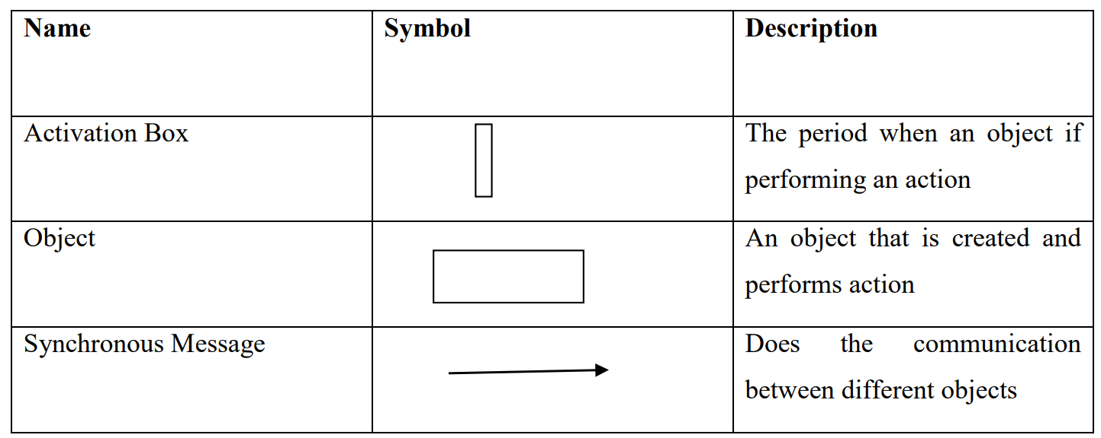

Table 4.9.1: Sequence Diagram Symbols

**Sequence Diagram for User Registration:**

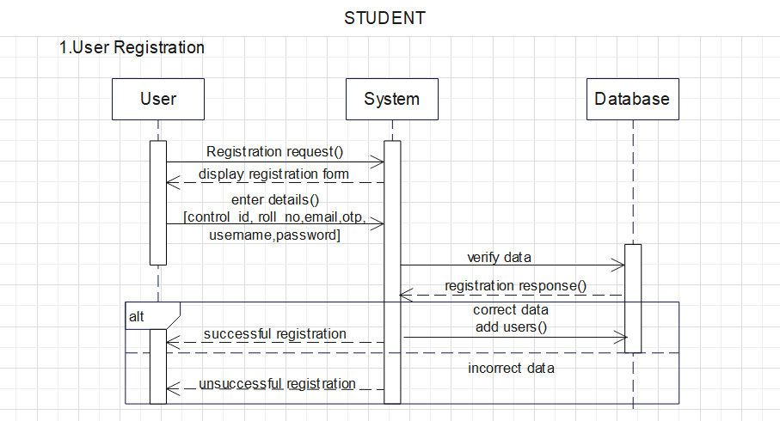

Figure 4.9.1: Sequence Diagram for User Registration

**Sequence Diagram for User Login:**

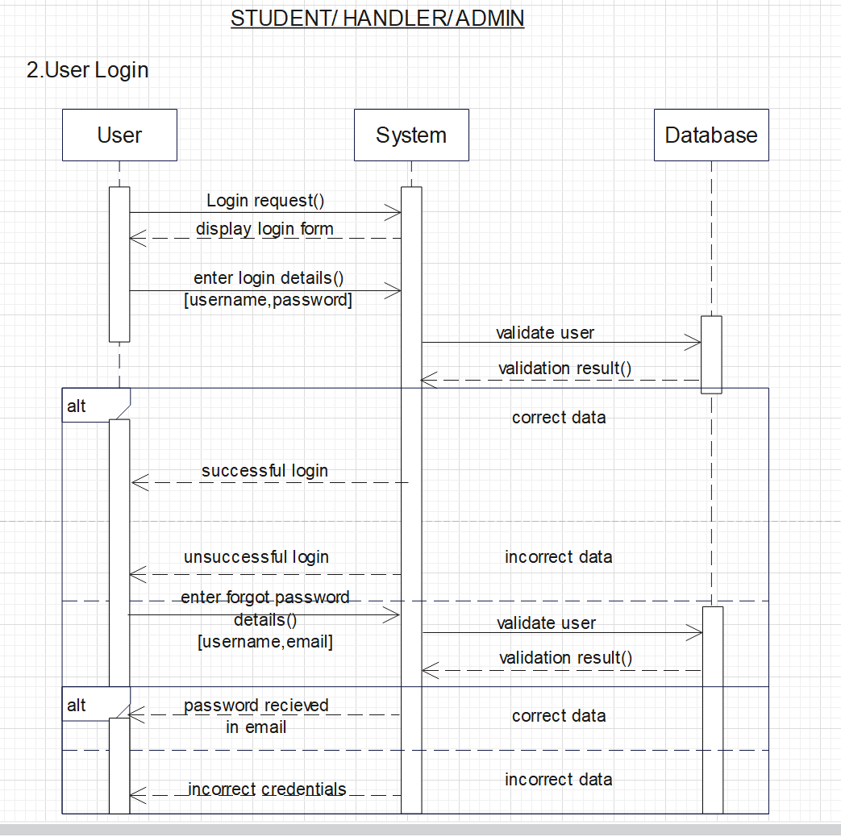

Figure 4.9.2: Sequence Diagram for User Login

**Sequence Diagram for Send Post:**

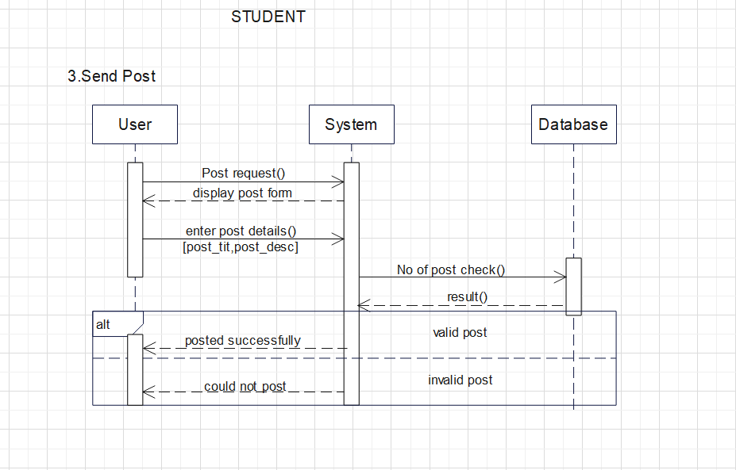

Figure 4.9.3: Sequence Diagram for Send Post

**Sequence Diagram for Evaluate Post:**

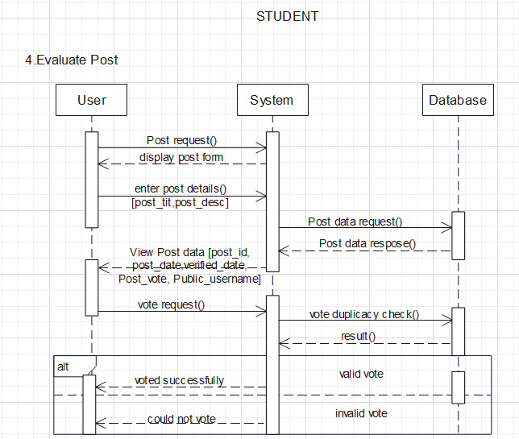

Figure 4.9.4: Sequence Diagram for Evaluate Post

**Sequence Diagram for Contact Admin:**

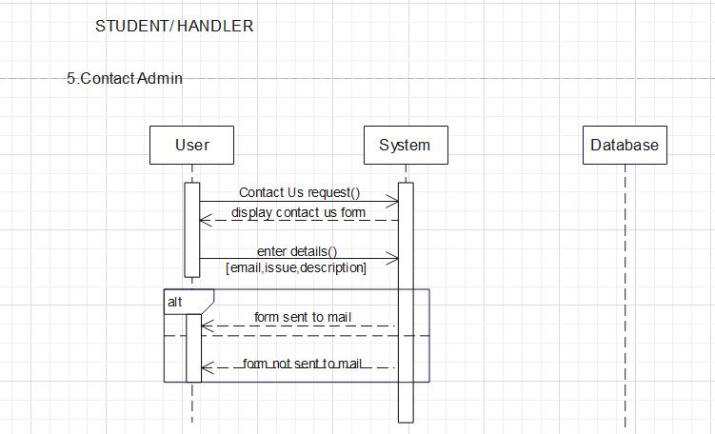

Figure 4.9.5: Sequence Diagram for Contact Admin

**Sequence Diagram for Manage Profile:**

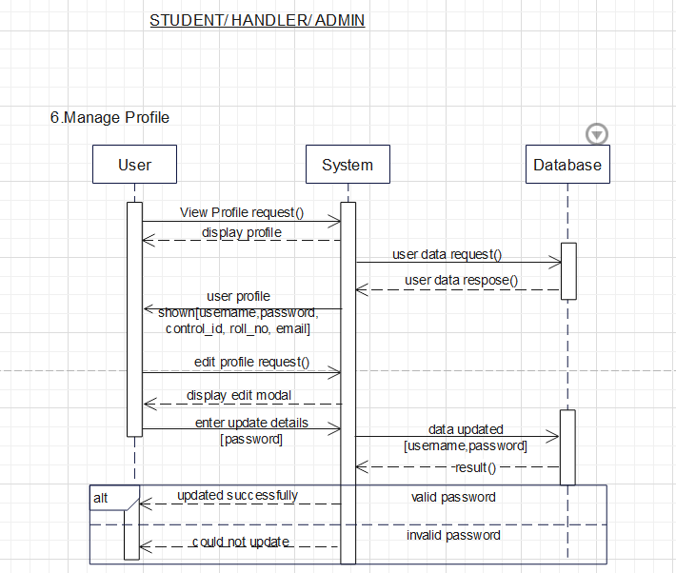

Figure 4.9.6: Sequence Diagram for Manage Profile

**Sequence Diagram for Verify Post:**

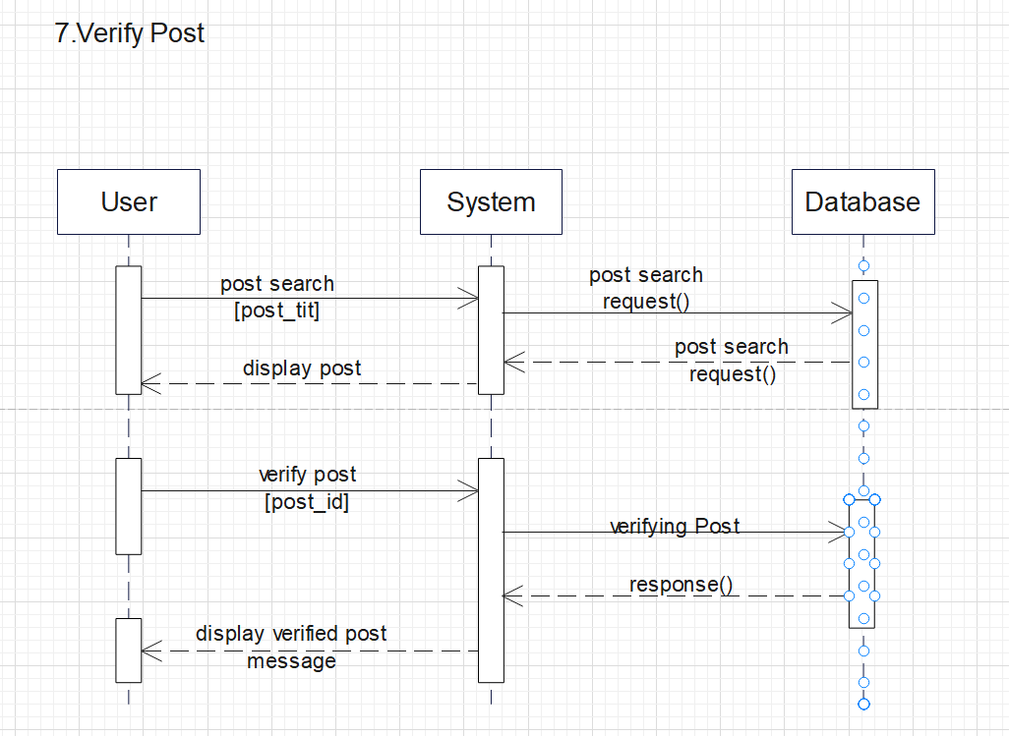

Figure 4.9.7: Sequence Diagram for Verify Post

**Sequence Diagram for View Post [Most voted post chosen]:**

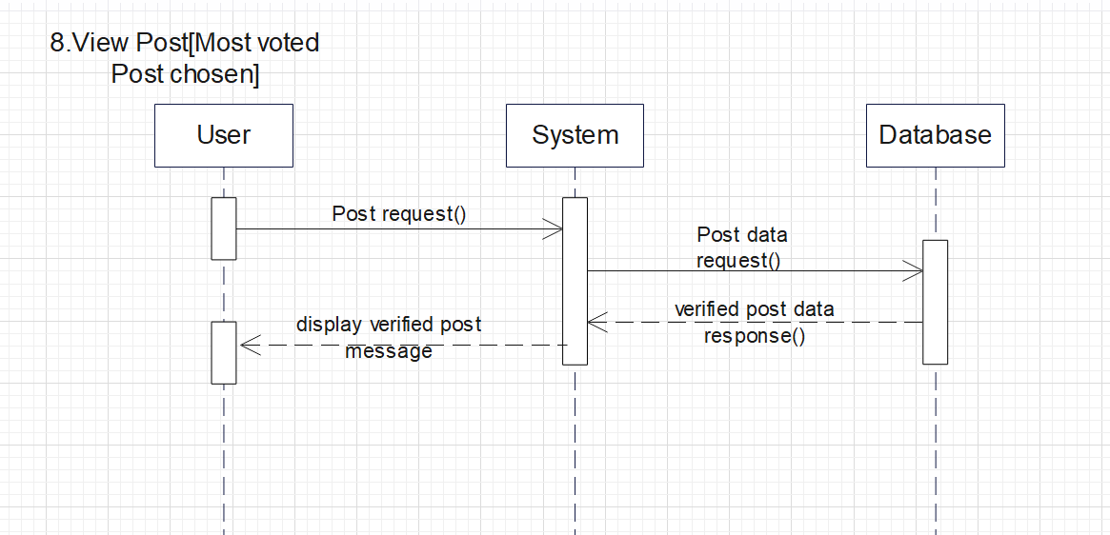

Figure 4.9.8: Sequence Diagram for View Post [Most voted post chosen]

**Sequence Diagram for Remove Post:**

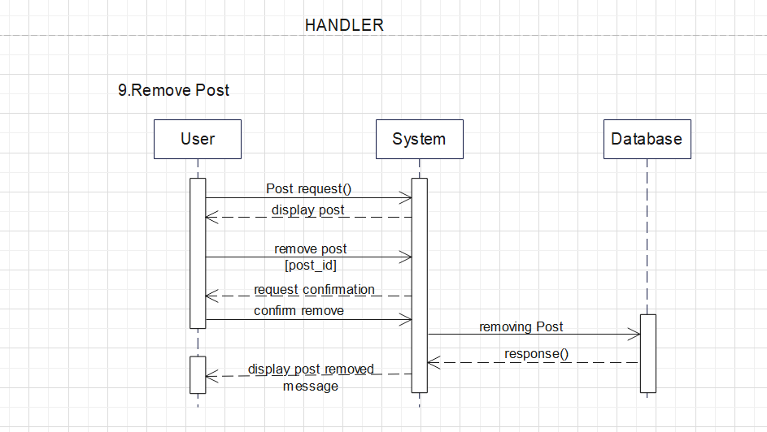

Figure 4.9.9: Sequence Diagram for Remove Post

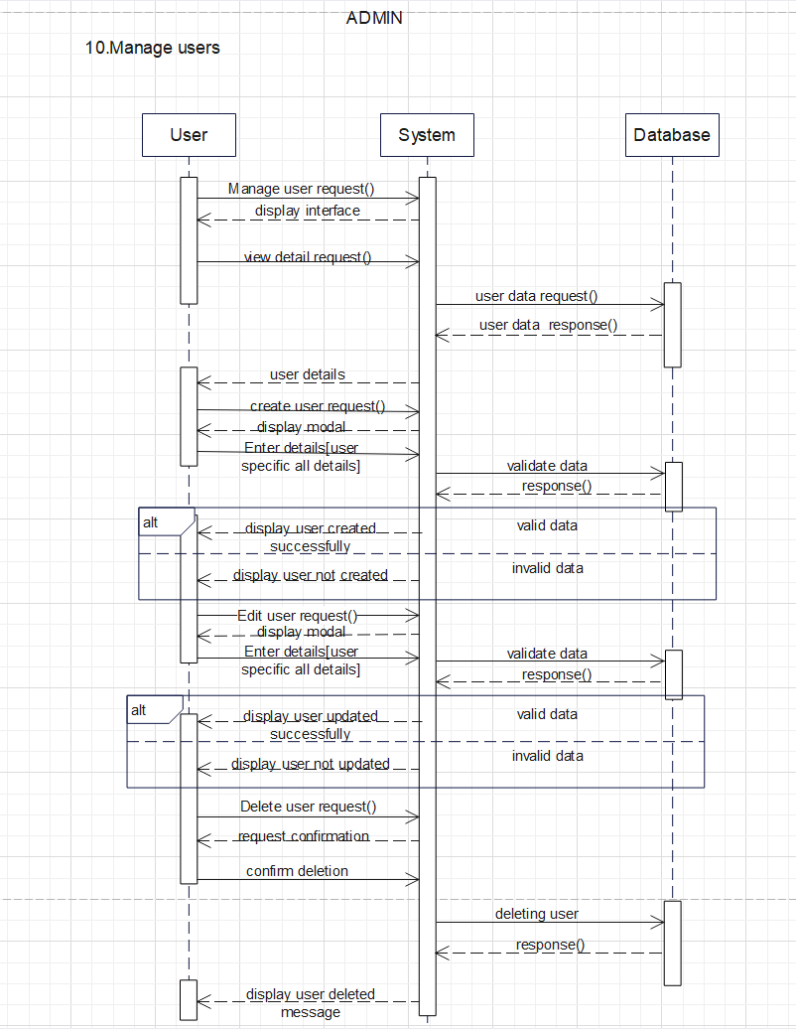

Figure 4.9.10: Sequence Diagram for Manage users

## 4.10 Activity Diagram

Activity diagram is another important diagram in UML to describe the dynamic aspects of the system. Activity diagram is basically a flowchart to represent the flow from one activity to another activity. The activity can be described as an operation of the system. The control flow is drawn from one operation to another. This flow can be sequential, branched, or concurrent. Activity diagrams deal with all type of flow control by using different elements such as fork, join, etc.

**Symbols:**

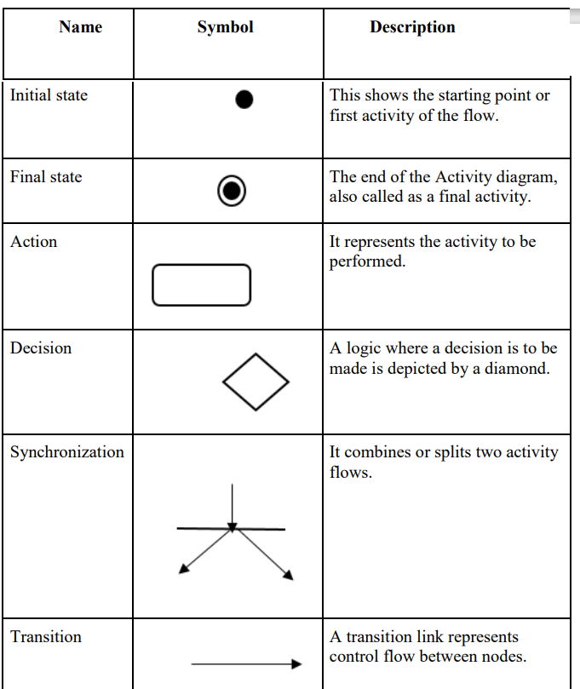

Table 4.10.1: Activity Diagram Symbols

**Activity diagram for student:**

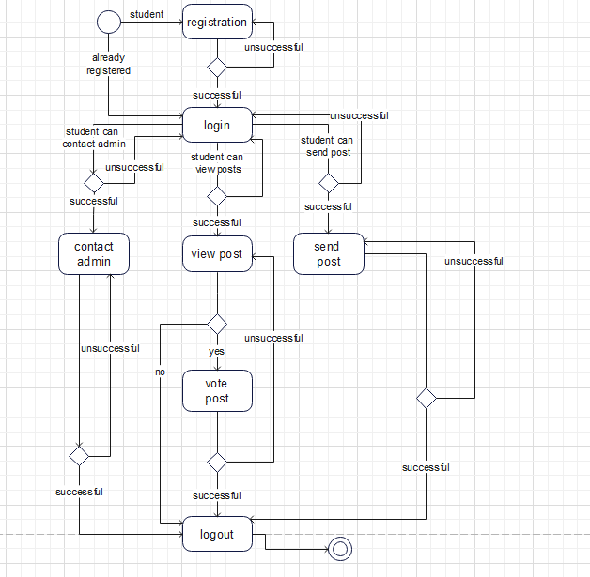

Figure 4.10.1: Activity diagram for student

**Activity diagram for handler:**

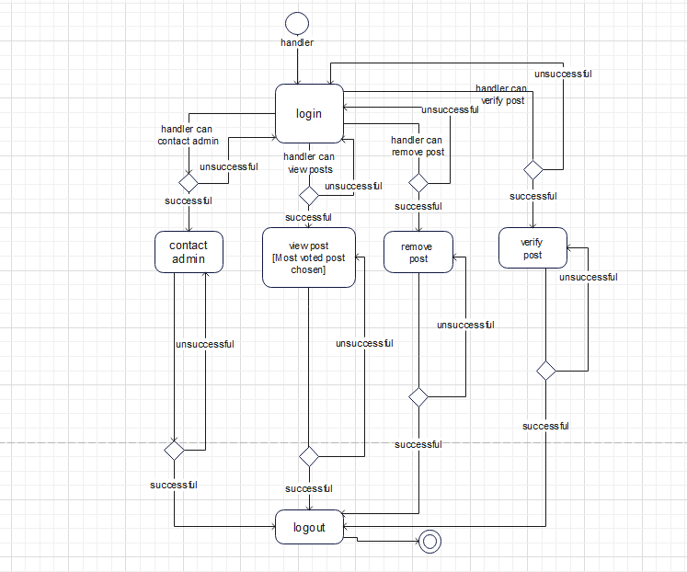

Figure 4.10.2: Activity diagram for handler

**Activity diagram for admin:**

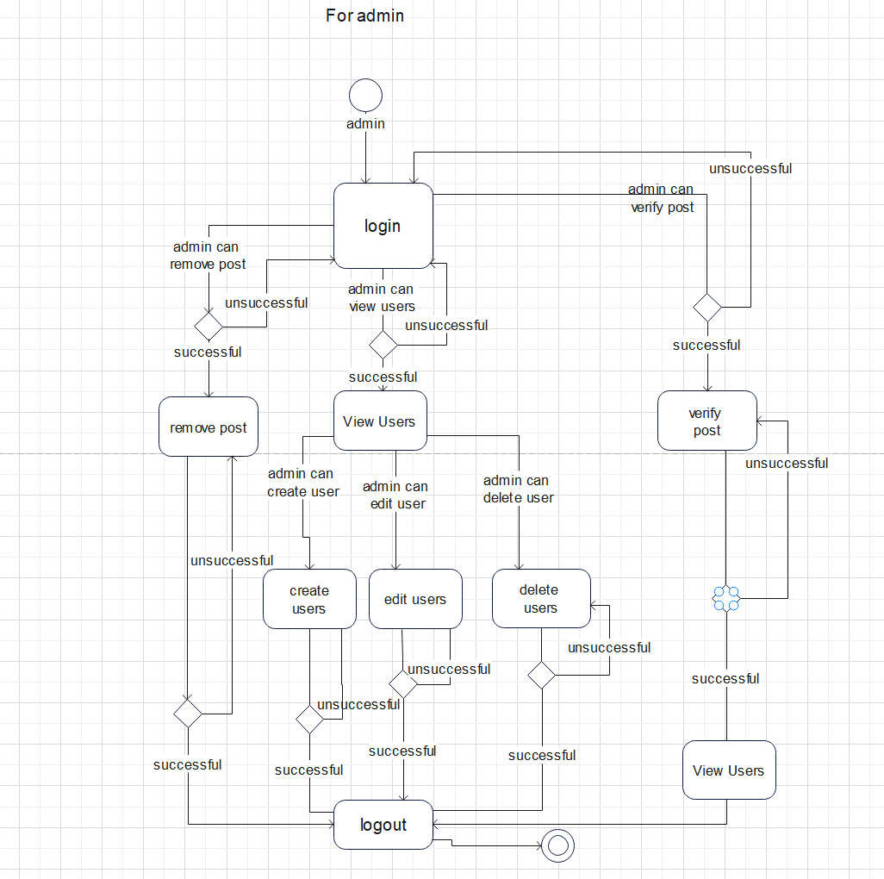

Figure 4.10.3: Activity diagram for admin

## 4.11 State Diagram

A state diagram is a type of diagram used in computer science and related fields to describe the behaviour of systems. State diagrams require that the system described is composed of a finite number of states; sometimes, this is indeed the case, while at other times this is a reasonable abstraction.

**Symbols:**

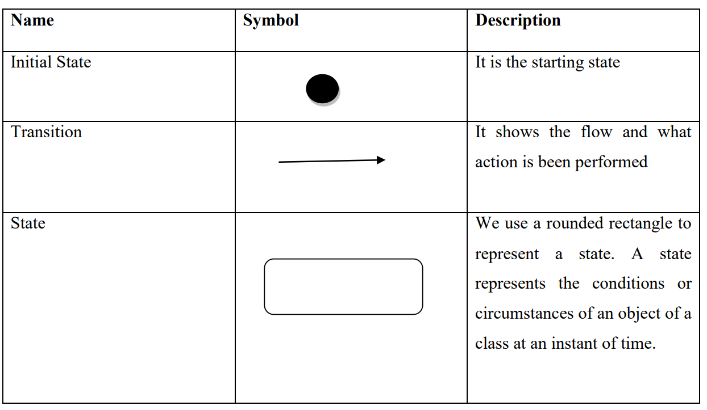

Table 4.11.1: State chart Diagram Symbols

**State diagram for student:**

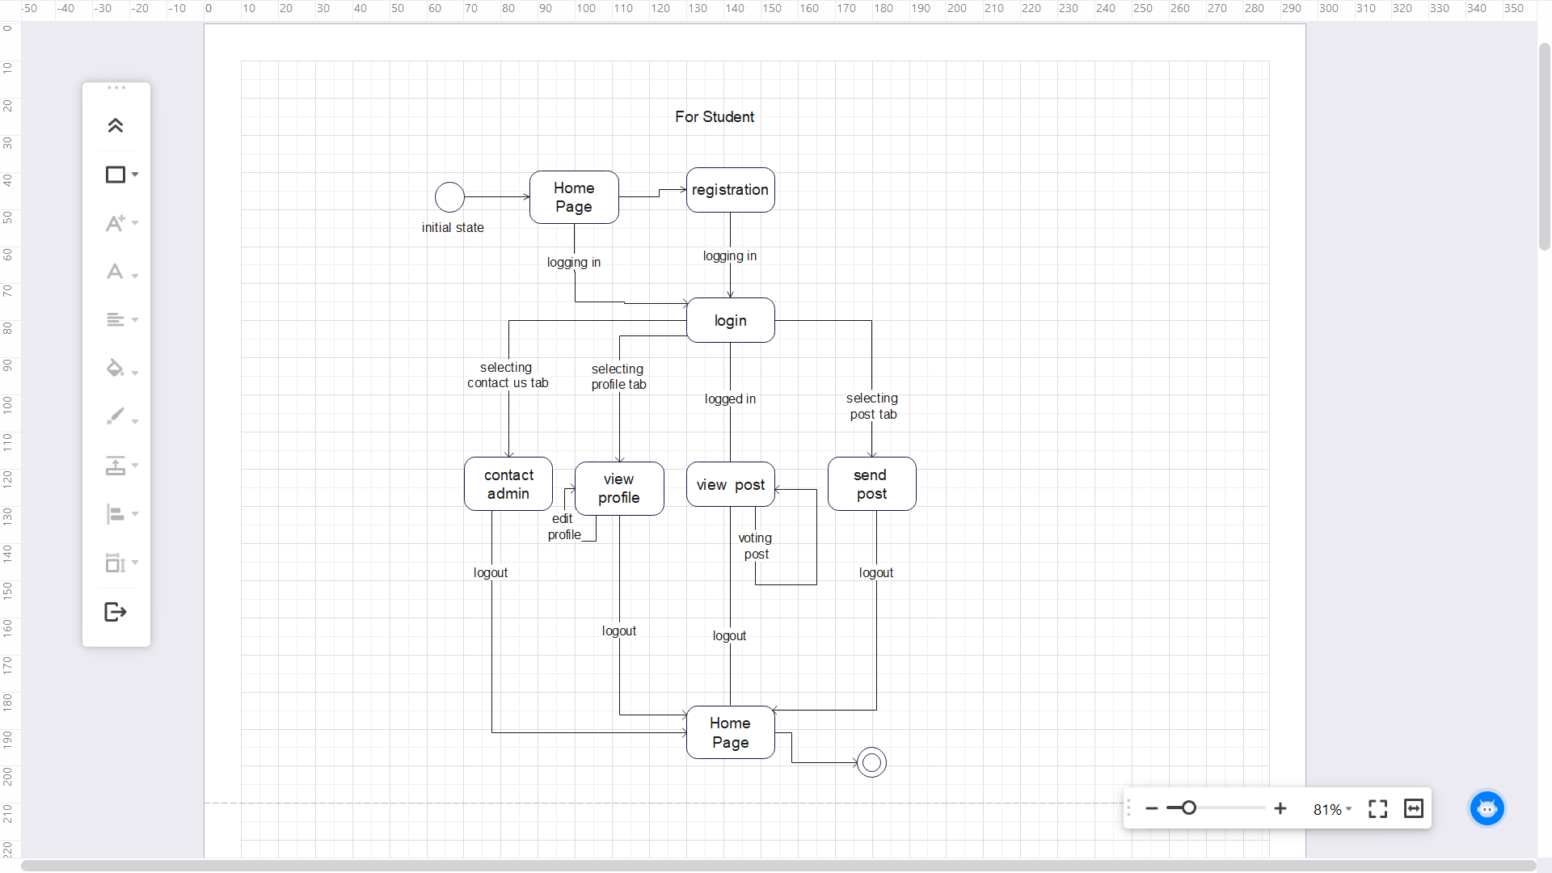

Figure 4.11.1: State diagram for student

**State diagram for student:**

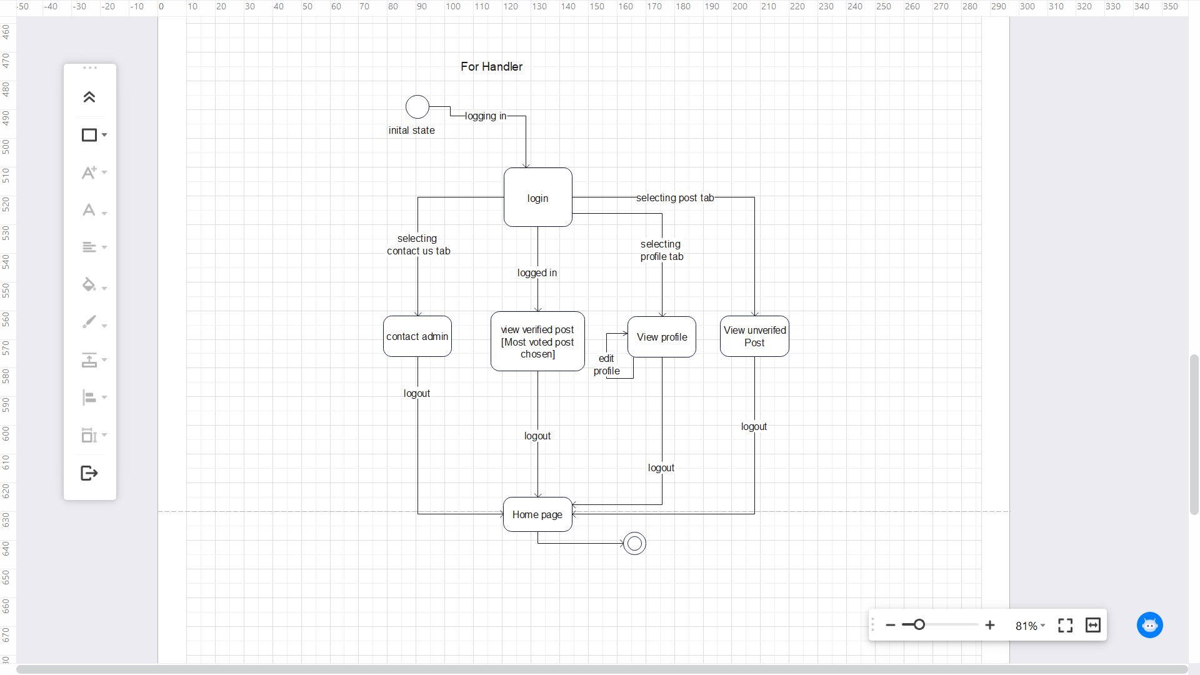

Figure 4.11.2: State diagram for handler

**State diagram for student:**

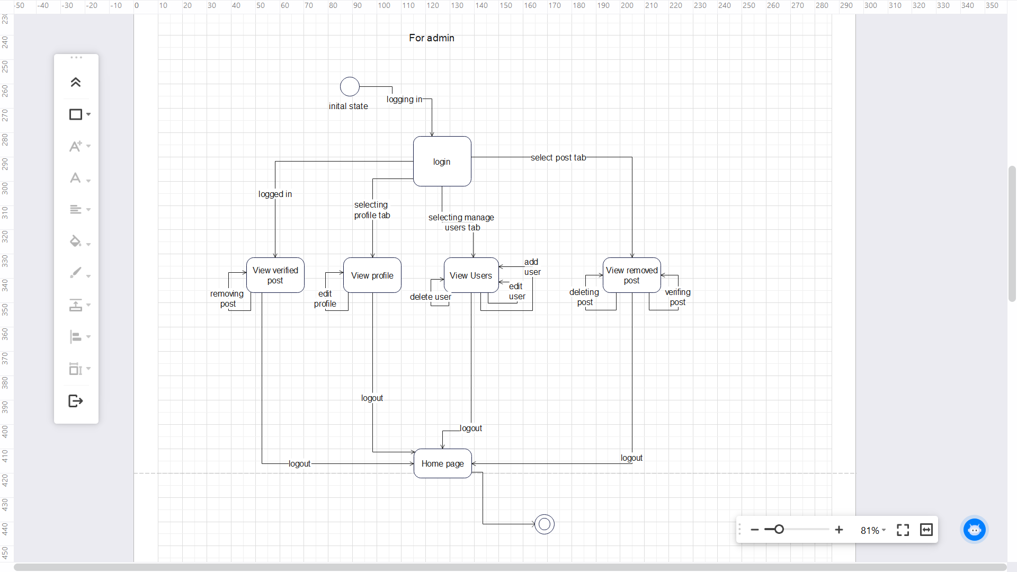

Figure 4.11.3: State diagram for admin

## 4.12 User Interface Design

**Home Page:**

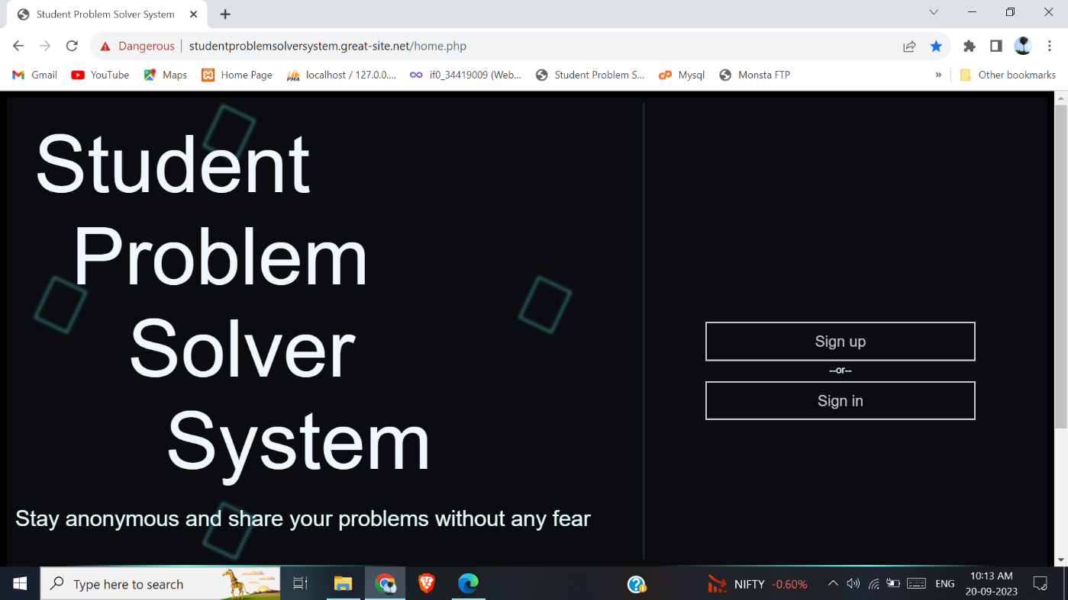

Figure 4.12.1: Home Page UI

**Registration:**

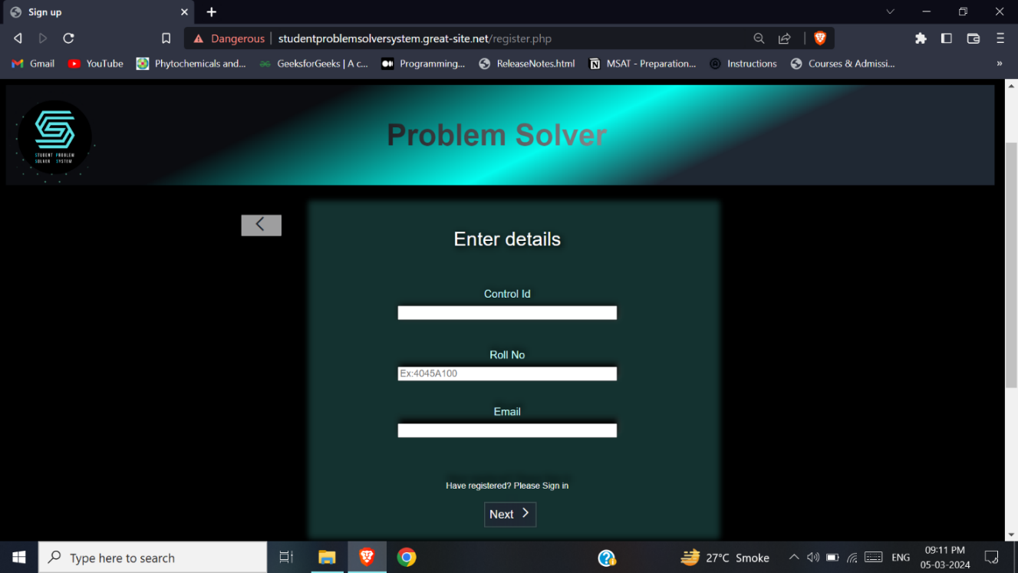

Figure 4.12.2.1: Register Page 1 UI

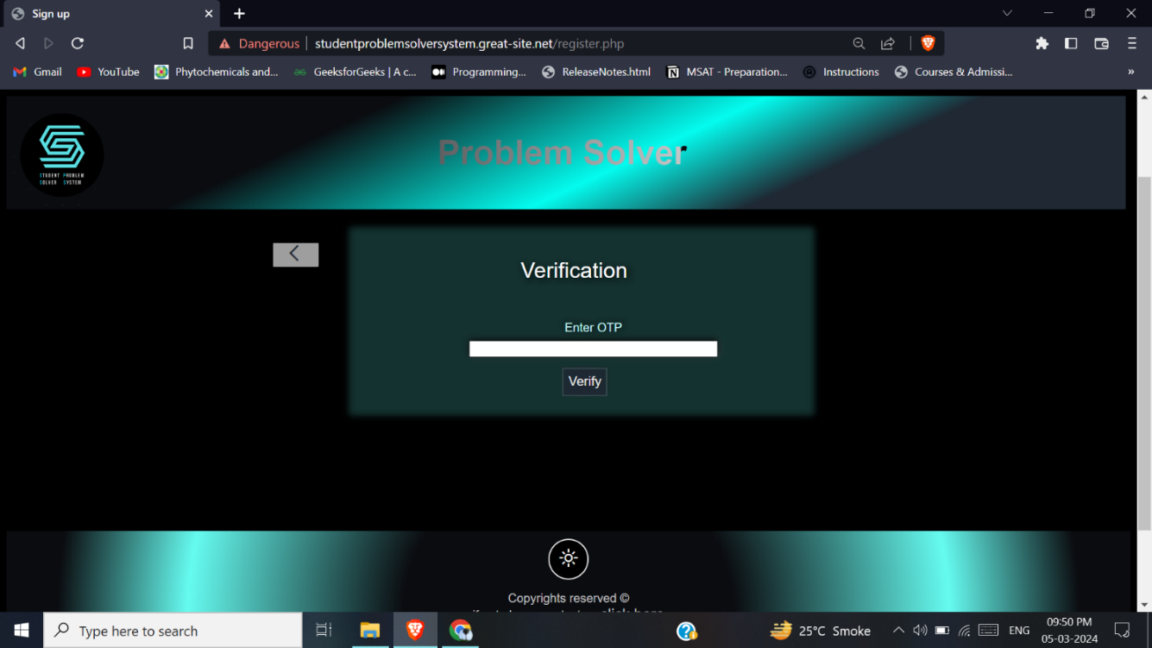

*Figure 4.12.2.2: Register Page 2 UI*

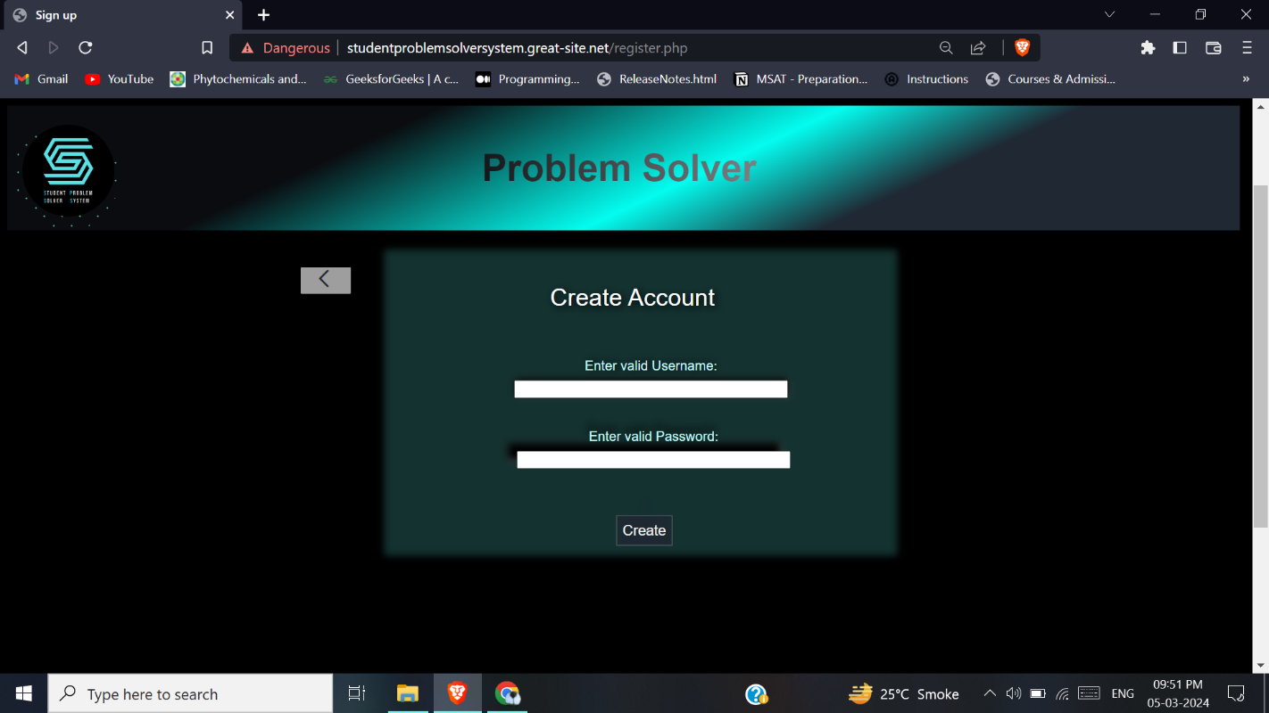

Figure 4.12.2.3: Register Page 3 UI

**Login:**

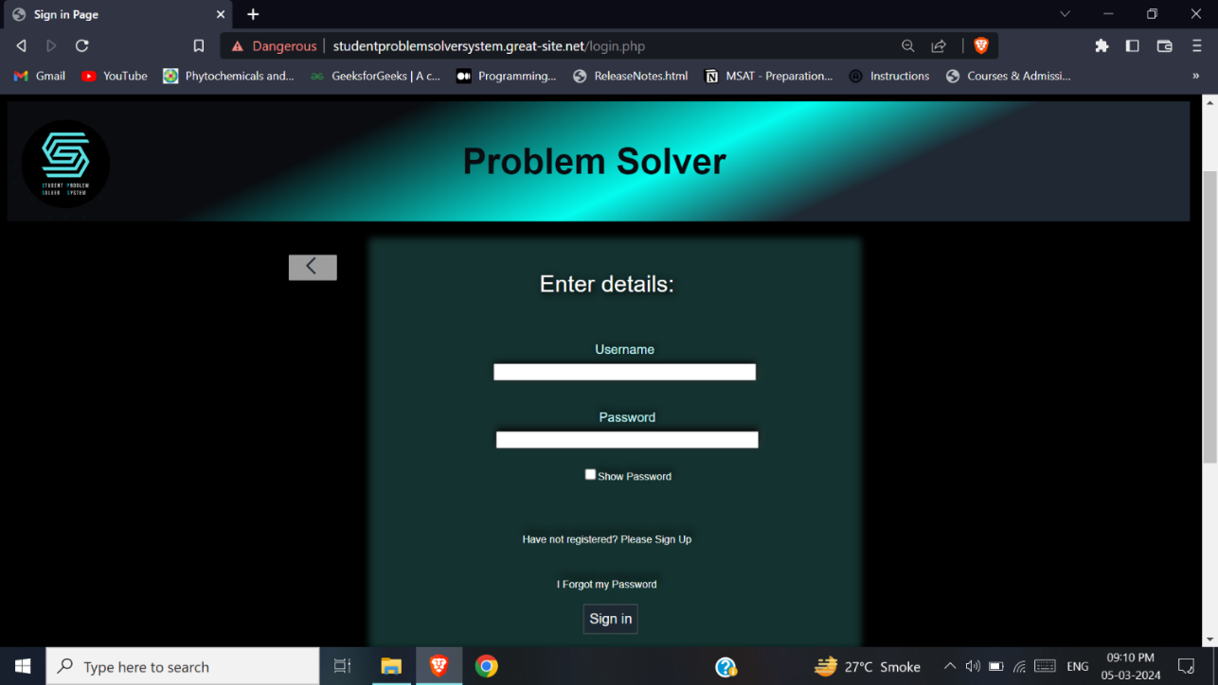

Figure 4.12.3: Login Page UI

**View and Vote Post:**

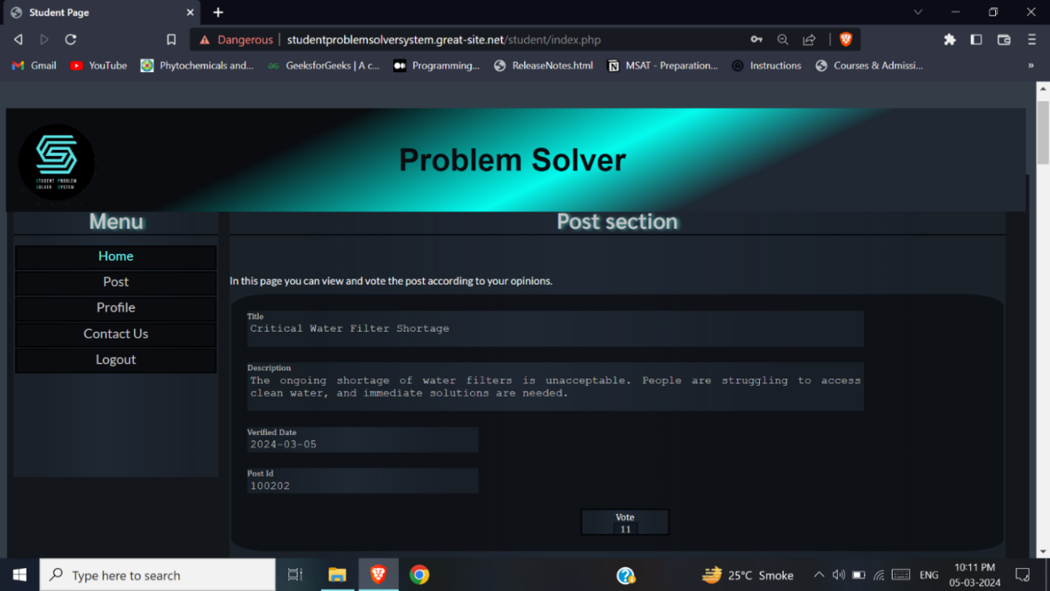

Figure 4.12.4: Student Home Page UI

**Send Post:**

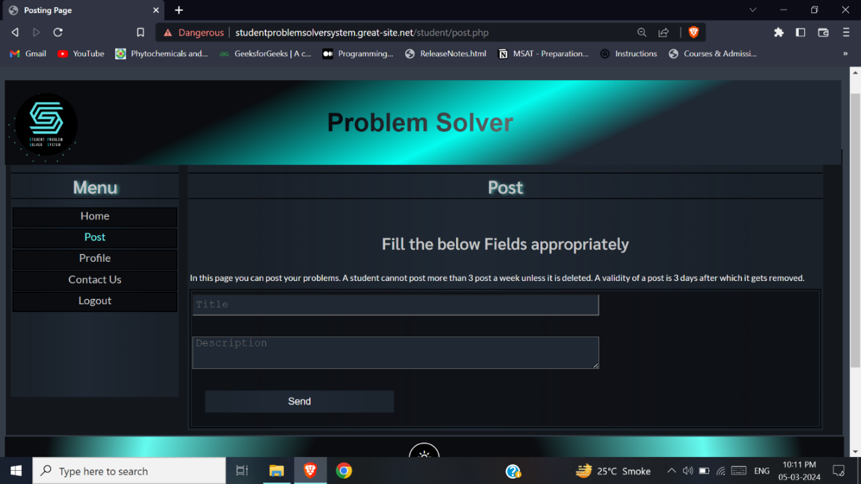

Figure 4.12.5: Student Send Post Page UI

**View and Edit Profile:**

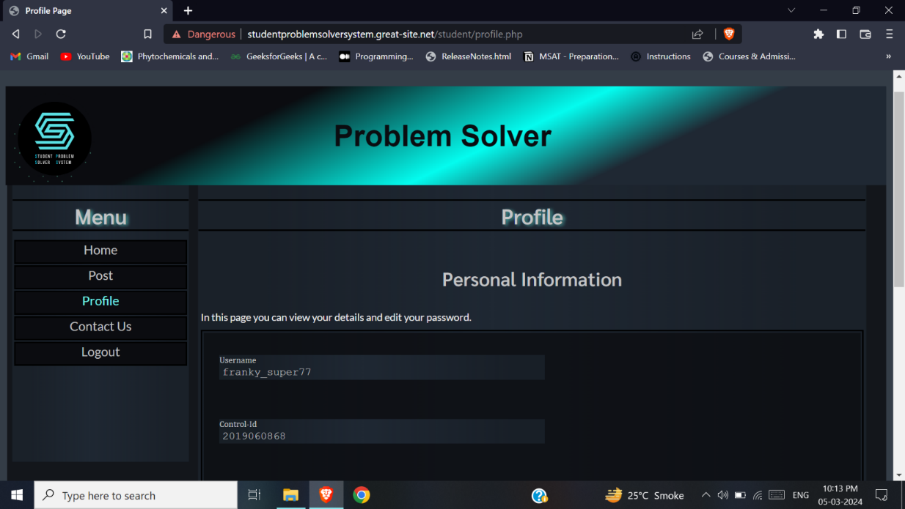

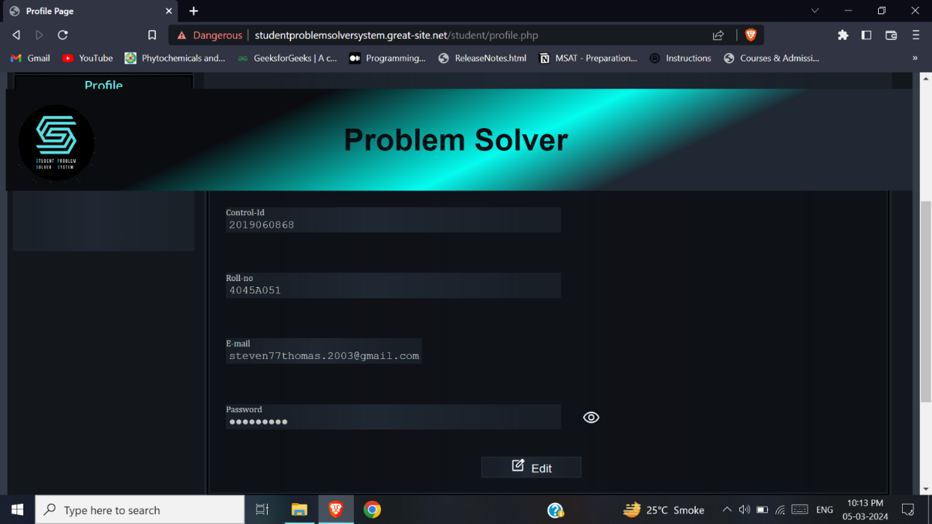

Figure 4.12.6: Student Profile Page UI

**Contact us page:**

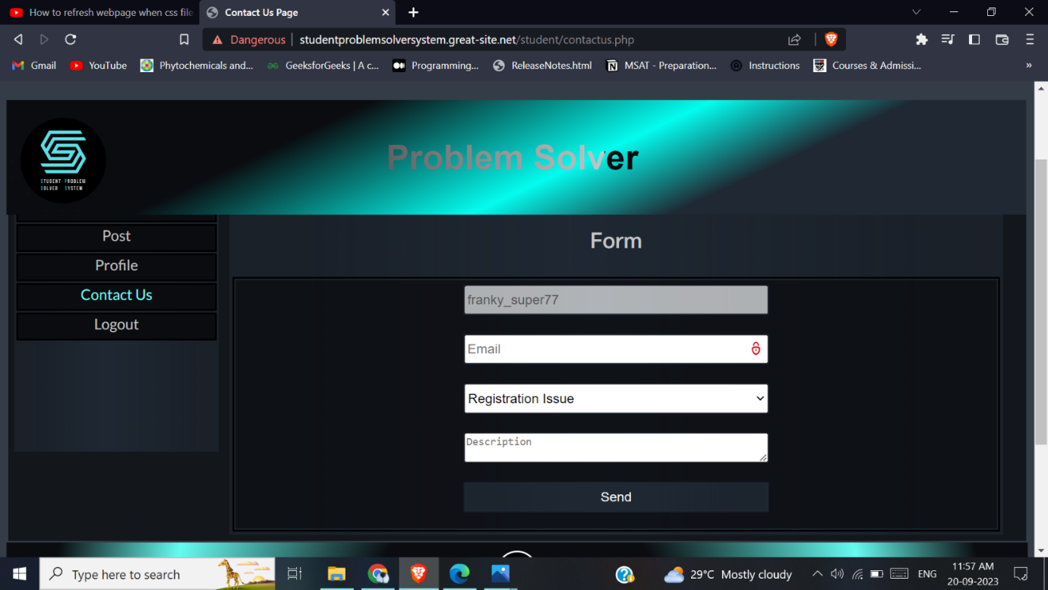

Figure 4.12.7: Student Contact Us Page UI

**View Post [Most voted Post]:**

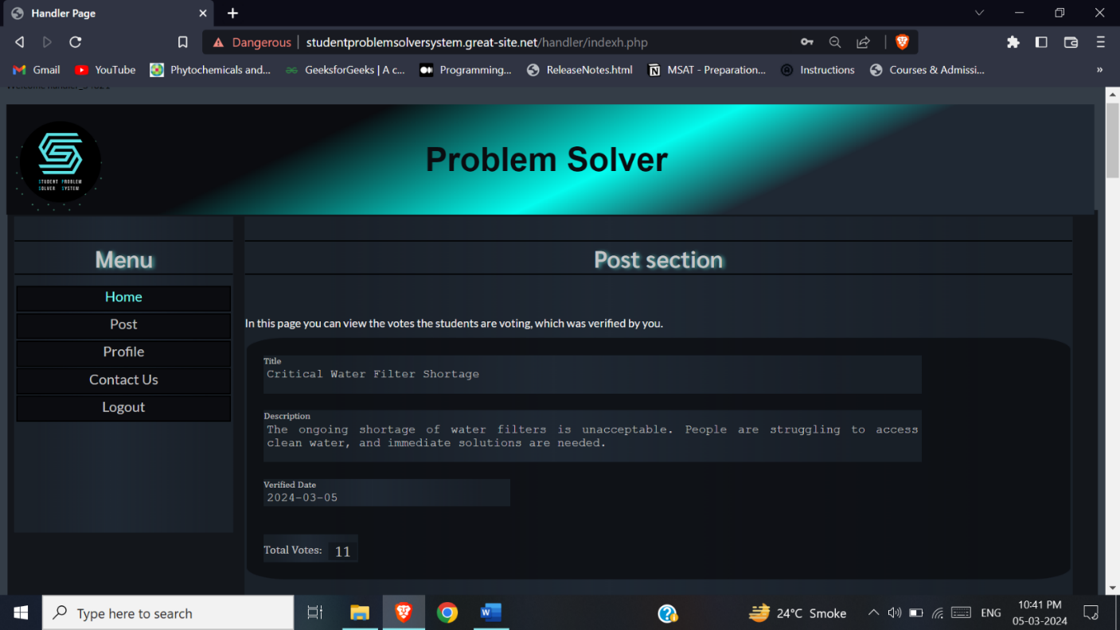

Figure 4.12.8: Handler Home Page UI

**Verify and Remove Post:**

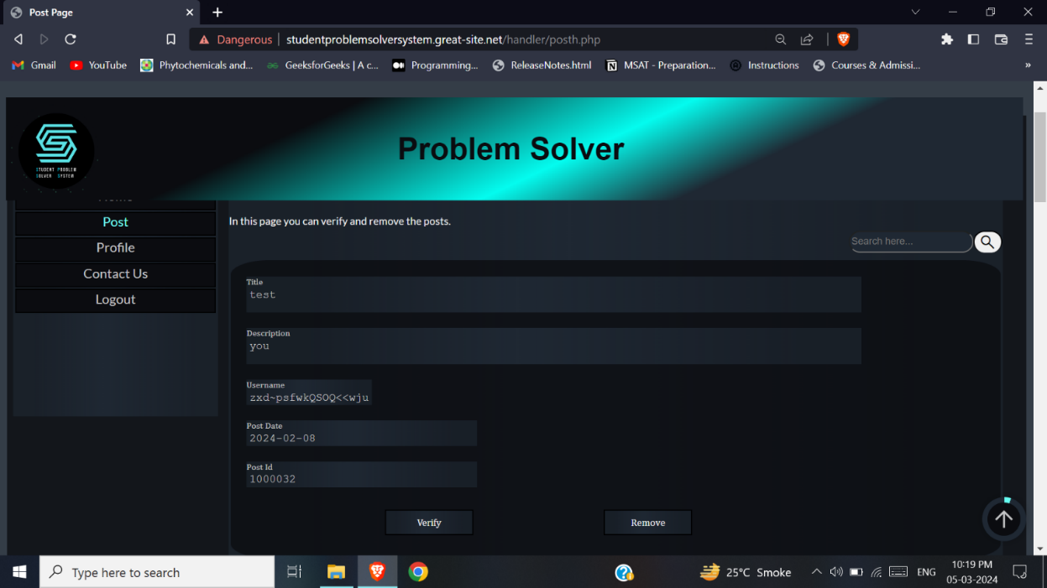

Figure 4.12.9: Handler Post Page UI

**View and Edit Profile:**

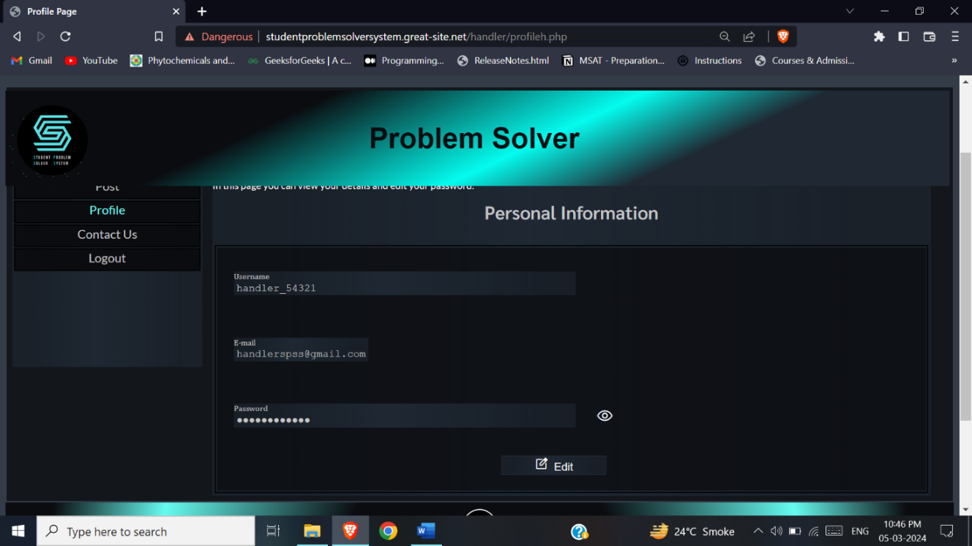

Figure 4.12.10: Handler Profile Page UI

**View and Remove Post:**

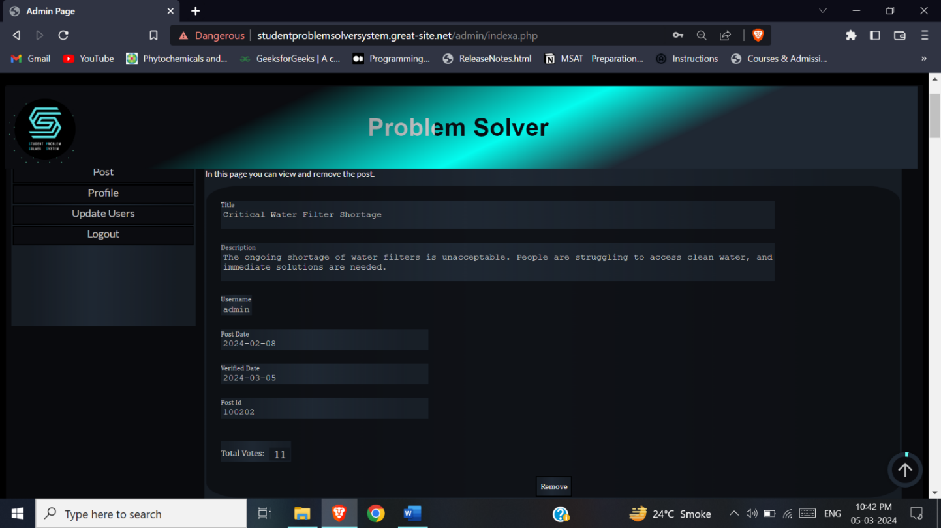

Figure 4.12.11: Admin Home Page UI

**Remove Post:**

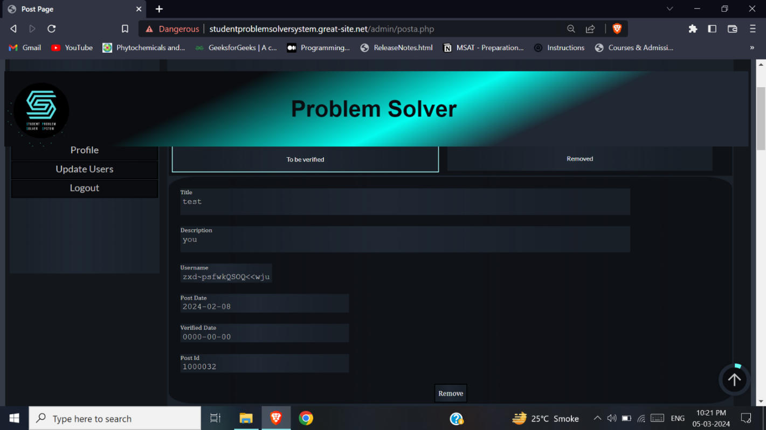

Figure 4.12.12.1: Admin Post Page 1 UI

**Verify and Delete Post:**

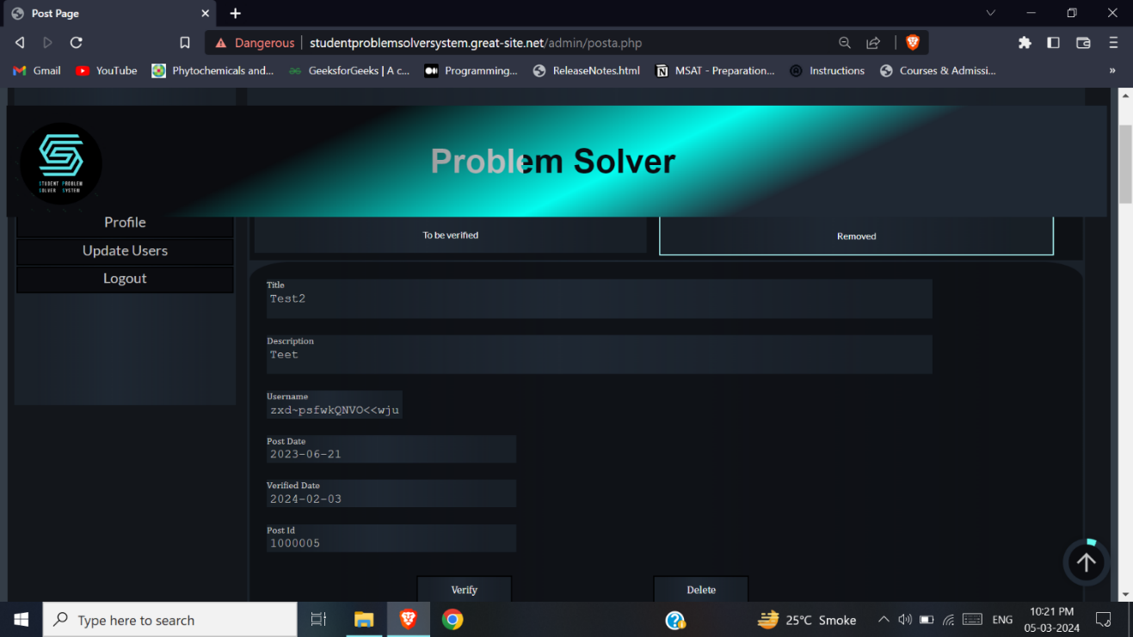

Figure 4.12.12.2: Admin Post Page 2 UI

**Manage users Page:**

**View student accounts:**

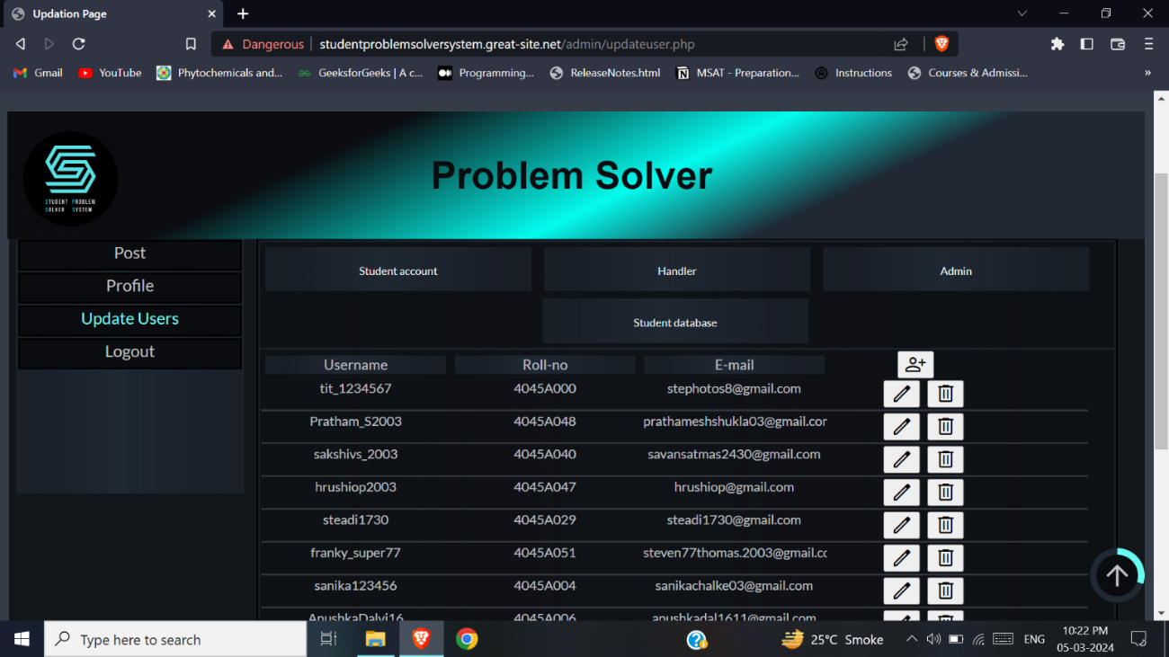

Figure 4.12.13.1: Admin Update Users Page 1 UI

**View handlers:**

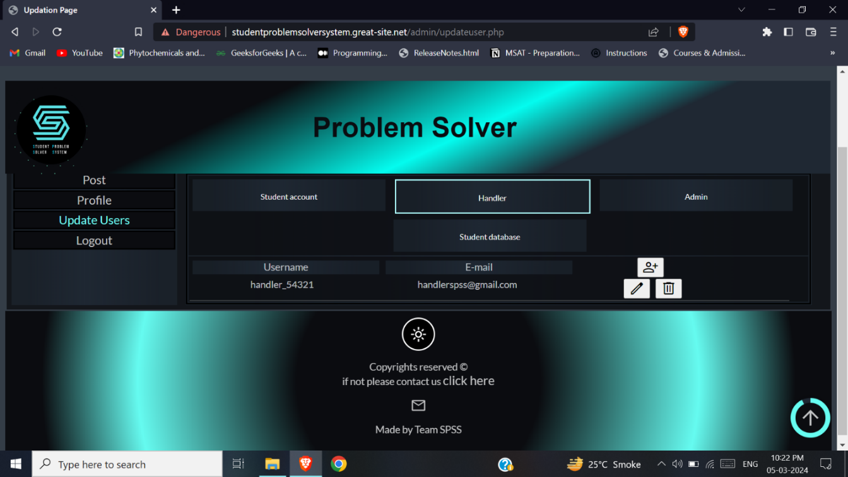

Figure 4.12.13.2: Admin Update Users Page 2 UI

**View Admin:**

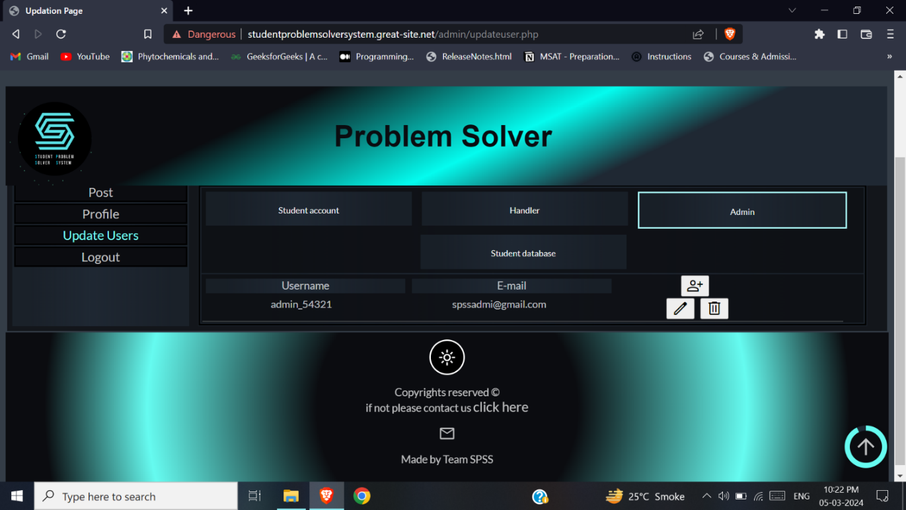

Figure 4.12.13.3: Admin Update Users Page 3 UI

**View student database:**

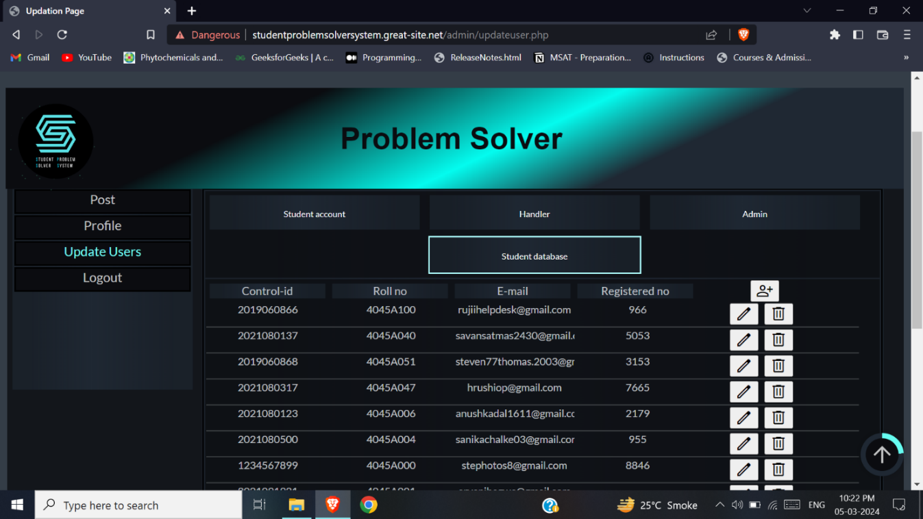

Figure 4.12.13.4: Admin Update Users Page 4 UI

**Create user for student account (admin):**

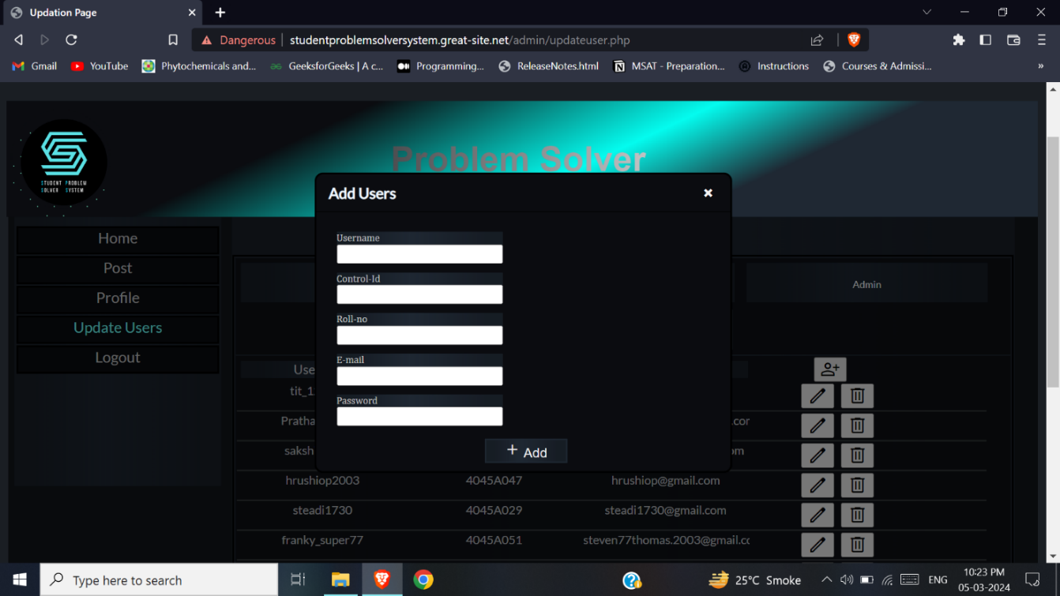

Figure 4.12.13.5: Add user model for student account UI

**Edit user for handler (admin):**

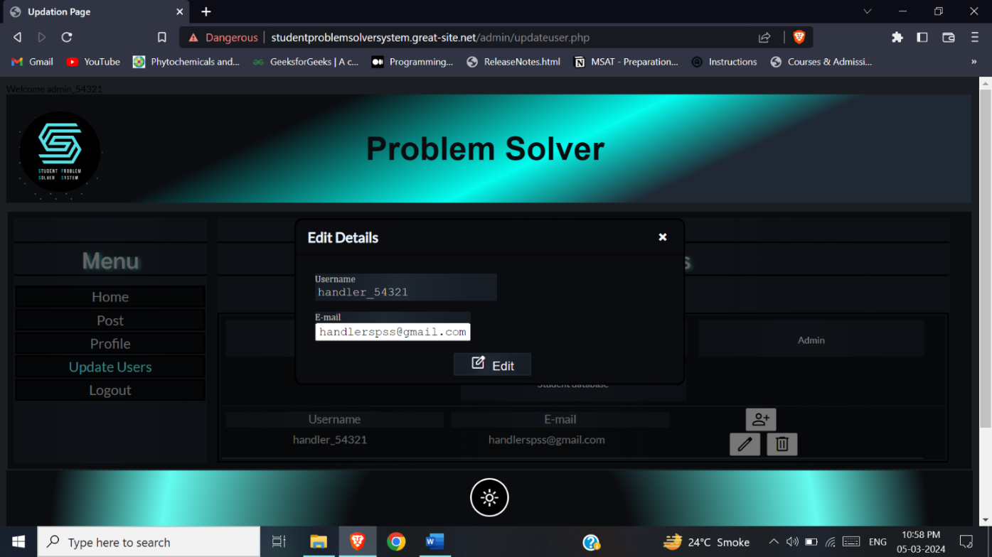

Figure 4.12.13.6: Edit user model for handler UI

**Edit user for student account (admin):**

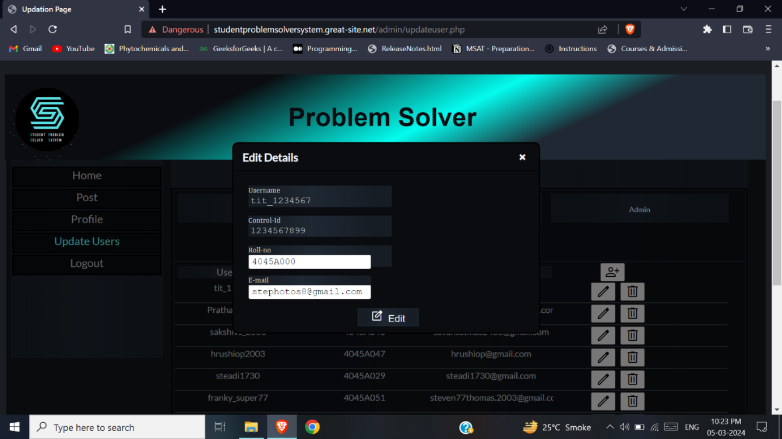

Figure 4.12.13.7: Edit user model for student database UI

## 4.13 Test Cases

**For all users:**

**Login:**

|  |  |  |  |  |
| --- | --- | --- | --- | --- |
| **Test No** | **Test Case Name** | **Expected Output** | **Actual Output** | **Remark** |
| 1 | Enter username: frankysuper77  Password: student@77 | Logged  in successfully |  |  |
| 2 | Enter username: frankysuper77  Password: stude@77 | Invalid Password |  |  |
| 3 | Enter username: frankysuper | Invalid username |  |  |
| 4 | Null values | Please enter details |  |  |

Table 4.13.1: Login Test Case

**Edit Profile:**

|  |  |  |  |  |
| --- | --- | --- | --- | --- |
| **Test No** | **Test Case Name** | **Expected Output** | **Actual Output** | **Remark** |
| 1 | New Password: bye@12345 | Details updated |  |  |
| 2 | New Password: bye@ | Enter valid password |  |  |
| 3 | Password: null | Please enter password |  |  |

Table 4.13.2: Edit Profile Test Case

**Contact Us:**

|  |  |  |  |  |
| --- | --- | --- | --- | --- |
| **Test No** | **Test Case Name** | **Expected Output** | **Actual Output** | **Remark** |
| 1 | Email: [rujiihelpdesk@gmail.com](mailto:rujiihelpdesk@gmail.com)  Select Issue: Login issue  Description: forgot password | Your mail has been sent |  |  |
| 2 | Email: rujigmail.com | Invalid email |  |  |
| 3 | Null values | Please enter details |  |  |

Table 4.13.3: Contact Us Test Case

**For Student:**

**Registration:**

|  |  |  |  |  |
| --- | --- | --- | --- | --- |
| **Test No** | **Test Case Name** | **Expected Output** | **Actual Output** | **Remark** |
| 1 | Enter control id:2019060868  Roll no: 4045A051  Email: [rujiihelpdesk@gmail.com](mailto:rujiihelpdesk@gmail.com)  Otp: 467856  username: frankysuper78  password: bye#04566 | Registered Successfully |  |  |
| 2 | control id:201906086 | Invalid Control id |  |  |
| 3 | control id:2019060866 | Already registered control id |  |  |
| 4 | Roll no: 4045A222 | Invalid Rollno |  |  |
| 5 | Email: new | Invalid email |  |  |
| 6. | Email: test@gmail.com | Already used mail |  |  |
| 7. | Otp:43 | Invalid otp |  |  |
| 8 | Enter username: frankysuper*77 | Invalid username should not consist special characters and length should be between 10 and 20 |  |  |
| 9 | Enter username: frankysuper77 | Already registered Username |  |  |
| 10 | Password: student@ | Password should consist a letter, a digit and special character, and length should be between 8 and 30 |  |  |
| 11 | Null values | Please enter details |  |  |

Table 4.13.4: Registration Test Case

**Send Post:**

|  |  |  |  |  |
| --- | --- | --- | --- | --- |
| **Test No** | **Test Case Name** | **Expected Output** | **Actual Output** | **Remark** |
| 1 | Enter Title: Filter non-availability  Enter Description: Filter is not available in every floor of the college. It should be made available. So please vote for this post. | Post sent successfully, will be posted after verified. |  |  |
| 2 | Enter Title: This is title of 4th post  Enter Description: This is description of 4th post. | Cannot post more than 3 post per week |  |  |
| 3 | Null values | Please enter details |  |  |

Table 4.13.5: Send Post Test Case

**Vote Post:**

|  |  |  |  |  |
| --- | --- | --- | --- | --- |
| **Test No** | **Test Case Name** | **Expected Output** | **Actual Output** | **Remark** |
| 1 | Vote post | Voted |  |  |
| 2 | Vote same post again | You have already voted |  |  |
| 3 | Null values | Please enter details |  |  |

Table 4.13.6: Vote Post Test Case

**For handler and admin**

**Verify Post:**

|  |  |  |  |  |
| --- | --- | --- | --- | --- |
| **Test No** | **Test Case Name** | **Expected Output** | **Actual Output** | **Remark** |
| 1 | Verify post | Verified |  |  |

*Table 4.13.7: Verify Post Test Case*

**Remove Post:**

|  |  |  |  |  |
| --- | --- | --- | --- | --- |
| **Test No** | **Test Case Name** | **Expected Output** | **Actual Output** | **Remark** |
| 1 | Remove post | Post removed |  |  |

Table 4.13.8: Remove Post Test Case

**Delete Post:**

|  |  |  |  |  |
| --- | --- | --- | --- | --- |
| **Test No** | **Test Case Name** | **Expected Output** | **Actual Output** | **Remark** |
| 1 | Delete post | Post deleted |  |  |

Table 4.13.9: Delete Post Test Case

**For Admin:**

**Add student account:**

|  |  |  |  |  |
| --- | --- | --- | --- | --- |
| **Test No** | **Test Case Name** | **Expected Output** | **Actual Output** | **Remark** |
| 1 | Enter control id:2019060869  Roll no: 4045A055  Email: [rujiihelpdesk2@gmail.com](mailto:rujiihelpdesk2@gmail.com)  username: frankysuper79  password: bye#04569 | User added |  |  |
| 2 | control id:201906086 | Invalid Control id |  |  |
| 3 | control id:2019060866 | Registered control id |  |  |
| 4 | Roll no: 4045A222 | Invalid Rollno |  |  |
| 5 | Email: new | Invalid email |  |  |
| 6. | Email: test@gmail.com | Already used mail |  |  |
| 7 | Enter username: frankysuper*77 | Invalid username, should not consist special characters and length should be between 10 and 20 |  |  |
| 8 | Enter username: frankysuper77 | Registered Username |  |  |
| 9 | Password: student@ | Password should consist a letter, a digit and special character, and length should be between 8 and 30 |  |  |
| 10 | Null values | Please enter details |  |  |

Table 4.13.10: Add student account Test Case

**Edit student account:**

|  |  |  |  |  |
| --- | --- | --- | --- | --- |
| **Test No** | **Test Case Name** | **Expected Output** | **Actual Output** | **Remark** |
| 1 | Roll no: 4045A045  Email: [rujiihelpdesk3@gmail.com](mailto:rujiihelpdesk3@gmail.com)  username: frankysuper80  password: bye#04570 | User data updated |  |  |
| 2 | Roll no: 4045A222 | Invalid Rollno |  |  |
| 3 | Email: new | Invalid email |  |  |
| 4 | Email: test@gmail.com | Already used mail |  |  |
| 5 | Enter username: frankysuper*77 | Invalid username, should not consist special characters and length should be between 10 and 20 |  |  |
| 6 | Enter username: frankysuper77 | Registered Username |  |  |
| 7 | Password: student@ | Password should consist a letter, a digit and special character, and length should be between 8 and 30 |  |  |
| 8 | Null values | Please enter details |  |  |

Table 4.13.11: Edit student account Test Case

**Add handler:**

|  |  |  |  |  |
| --- | --- | --- | --- | --- |
| **Test No** | **Test Case Name** | **Expected Output** | **Actual Output** | **Remark** |
| 1 | Enter username: hand_1234  Password: hand@hand12 | User added |  |  |
| 2 | Enter username: hand*1234 | Invalid username, should not consist special characters and length should be between 10 and 20 |  |  |
| 3 | Password: hand12 | Password should consist a letter, a digit and special character, and length should be between 8 and 30 |  |  |
| 4 | Null values | Please enter details |  |  |

Table 4.13.12: Add handler Test Case

**Add Admin:**

|  |  |  |  |  |
| --- | --- | --- | --- | --- |
| **Test No** | **Test Case Name** | **Expected Output** | **Actual Output** | **Remark** |
| 1 | Enter username: admi_1234  Password: admin@admi12 | User added |  |  |
| 2 | Enter username: admi*1234 | Invalid username, should not consist special characters and length should be between 10 and 20 |  |  |
| 3 | Password: admi12 | Password should consist a letter, a digit and special character, and length should be between 8 and 30 |  |  |
| 4 | Null values | Please enter details |  |  |

Table 4.13.13: Add Admin Test Case

**Edit handler:**

|  |  |  |  |  |
| --- | --- | --- | --- | --- |
| **Test No** | **Test Case Name** | **Expected Output** | **Actual Output** | **Remark** |
| 1 | Enter username: hand_1235  Password: hand@hand13 | User data updated |  |  |
| 2 | Enter username: hand*1235 | Invalid username, should not consist special characters and length should be between 10 and 20 |  |  |
| 3 | Password: hand13 | Password should consist a letter, a digit and special character, and length should be between 8 and 30 |  |  |
| 4 | Null values | Please enter details |  |  |

*Table 4.13.14: Edit handler Test Case*

**Edit Admin:**

|  |  |  |  |  |
| --- | --- | --- | --- | --- |
| **Test No** | **Test Case Name** | **Expected Output** | **Actual Output** | **Remark** |
| 1 | Enter username: admi_1235  Password: admi@admi13 | User data updated |  |  |
| 2 | Enter username: admi*1235 | Invalid username, should not consist special characters and length should be between 10 and 20 |  |  |
| 3 | Password: admi13 | Password should consist a letter, a digit and special character, and length should be between 8 and 30 |  |  |
| 4 | Null values | Please enter details |  |  |

Table 4.13.15: Edit admin Test Case

**Delete user:**

|  |  |  |  |  |
| --- | --- | --- | --- | --- |
| **Test No** | **Test Case Name** | **Expected Output** | **Actual Output** | **Remark** |
| 1 | Delete user | User deleted |  |  |

Table 4.13.16: Delete user Test Case

# Chapter 5

# Coding and Implementation

## 5.1 Implementation approaches

This project was implemented using the Incremental model. In incremental methodology, the model is designed, implemented, and tested incrementally. If in case there is a change in the requirements of the user then that part can be redesigned, re-implemented, and tested again iteratively. This model allows us to update the system at each increment and we can add new functionalities as well.

The interfaces are designed and created using HTML CSS and JavaScript. After the user interfaces were created, database connectivity was performed by using PHP. I have used MySQL as my database and hosted the site at the free web hosting site “infinityfree.com “. The coding part of my project is done in JavaScript and PHP language. The project was divided into modules. These modules were created one by one and after completion of each module, unit testing was performed on that module. When the module fulfils its requirements, it was integrated into the main project. After integration, each functionality was checked which can also be said to be as integration testing.

After adding all the modules to my main project, finally system testing was performed to check whether the system is working accordingly or not.

I have used validations wherever it was required. The system is made by considering all the problems into the view and the final project should be fulfilling all the requirements.

## 5.2 Coding and Efficiency

### 5.2.1 Coding:

**JavaScript code of Registration:**

Student filled details are retrieved and validated.

**register.php**

under the script tag

let rotp="";

var validate1=true;

var validate2=false;

//auto fill the other input elements witht the control id input on onchange()

function autofill()

{

$c_id = $('#rrcid').val();

if($c_id=="")

{

alert("Enter control id");

}

else{

$.ajax({

type: 'POST',

url: 'student/check_cid_fetch.php',

data: {control_id:$c_id},

success: function(data) {

data=JSON.parse(data);

if(data=="NC")

{

console.log("No data");

$('#rrrno').val("");

$('#rrmai').val("");

}

else{

console.log("data present");

$('#rrrno').val(data.roll_no);

$('#rrmai').val(data.email);

}

} })}}

//function for vlaidation of the controlid, roll no and email and to go the next container of otp

$('#next1').on('click',function(e){

$control_id = $('#rrcid').val();//covert id to php variable

$roll_no = $('#rrrno').val();

$e_mail = $('#rrmai').val();

let valid=false;

valid=true;

if(valid){

if($control_id!=="")

{

if($roll_no!=="")

{

if($e_mail!=="")

{

$.ajax({

type: 'POST',

url: 'student/check_cid.php',

data: {control_id:$control_id,roll_no:$roll_no,e_mail:$e_mail},

success: function(data) {

console.log(data);

if(data=="EU")

{

$('.verify-cont').show();

$('.verify-fake').show();

$('.sign-up-cont').hide();

$('.sign-up-fake').hide();

console.log("OTP is send to the given email");

console.log("otp sent successfully");

let rmsg="";let rto="";let rsub="";let n=[];

rotp=Math.floor((Math.random()*1000000)+1);

rmsg='This is your OTP '+rotp;

rto=$e_mail;

rsub="OTP Verification";

Email.send({

SecureToken : "6b9d686d-28ab-44b7-9793-ba592582e2a1",

To : rto,

From : "studentproblemsolver05@gmail.com",

Subject : rsub,

Body : rmsg

}).then(

alert('otp sent to mail. Please check spam.')

);

}

else if(data=="EUEU"){

alert("Already registered");

}

else if(data=="EUNR")

{

alert("roll no does not match with control id");

}

else if(data=="EUNE")

{

alert("email does not match with control id");

}

else if(data=="NU")

{

alert("control id does not exist");

}

else{

alert("something went wrong");

}

},

error: function() {

console.log(response.status);

},

})

}

else{

alert("fill email");

}

}

else{

alert("fill roll no");

}

}

else{

alert("fill control id");

}

}

e.preventDefault();

})

//function to verify the otp and to go to the next container of username and password

function verifyotp(){

$otp=$('#rrotp').val();

if($otp!=="")

{

if($otp==rotp){

alert("Correct otp");

$('.verify-cont').hide();

$('.verify-fake').hide();

$('.user-cont').show();

$('.user-fake').show();

}

else{

alert("Please enter valid otp");

}

}

else

{

alert("Enter otp");

}

}

//validation for the username and password

function createacc(){

$use=$('#rruse').val();

$pas=$('#rrpas').val();

if($use.length>20)

{

alert("Username length must not exceed 20 characters");

validate1=false;

}

else if($use.length<10)

{

alert("Username length must not be less than 10 characters");

validate1=false;

}

else{

let s=$use;let counta=0;let countn=0;

let countc=0;let invalid=0;validate1=true;

for(let i=0;i<$use.length;i++)

{

let str=s.charAt(i);

if((/[a-zA-Z]/).test(str))

{

counta+=1;

}

else if(str=='_')

{

countc+=1;

}

else if(str=='0' ||str=='1' ||str=='2' ||str=='3' ||str=='4' ||str=='5' ||str=='6' ||str=='7' ||str=='8' ||str=='9')

{

countn+=1;

}

else{

invalid=1;

break;

}

}

if(invalid==1)

{

alert("In username, No space or special character allowed, except underscore(_)");

validate1=false;

}

else if(counta==0)

{

alert("In username, Minimum one alphabet required");

validate1=false;

}

else if(countn==0)

{

alert("In username, Minimum one number required");

validate1=false;

}

}

if($pas.length<8)

{

alert("Password should not be less than 8 characters");

}

else{

let s=$pas;let counta=0;let countn=0;

let countc=0;let invalid2=0;validate2=false;

for(let i=0;i<$pas.length;i++)

{

let str=s.charAt(i);

if((/[a-zA-Z]/).test(str))

{

counta+=1;

}

else if(str==' ')

{

invalid2=1;

}

else if(str=='0' ||str=='1' ||str=='2' ||str=='3' ||str=='4' ||str=='5' ||str=='6' ||str=='7' ||str=='8' ||str=='9')

{

countn+=1;

}

else{

countc+=1;

}

}

if(invalid2==1){

alert("In password, No space character allowed");

}

else if(counta==0)

{

alert("In password, Minimum one alpahbet required");

}

else if(countn==0)

{

alert("In password, Minimum one number required");

}

else if(countc==0)

{

alert("In password, Minimum one special character required");

}

else{

validate2=true;

}

}

if(validate1==true && validate2==true)

{

if($use!=="")

{

if($pas!==""){

$.ajax({

type:'POST',

url:'student/check_usepass.php',

data:{control_id:$control_id,roll_no:$roll_no,e_mail:$e_mail,use:$use,pas:$pas},

success: function(data){

console.log(data);

if(data=='NU'){

alert("Correct credentials");

window.location='../student/index.php';

}

else if(data=='EU')

{

alert("Username already exists.Please change.");

}

else{

alert("Some issue");

}

}

})

}

else{

alert("Please enter password");

}

}

else

{

alert("Please enter username");

}

} }

let valid=false;

**Backend code of Registration:**

On entering controlid the other details are fetched and filled. The student details are inserted to the student_account table after successful creation of an account.

**check_cid.php**

<?php

$con = mysqli_connect('sql112.infinityfree.com','if0_34419009','dCXhuPfmbSMj','if0_34419009_spss_db');

if(mysqli_connect_errno())

{

die("Not connected");

}

if(!empty($_POST['control_id']) && !empty($_POST['roll_no']) && !empty($_POST['e_mail']))

{

$control_id = mysqli_real_escape_string($con,$_POST['control_id']);

$roll_no = mysqli_real_escape_string($con,$_POST['roll_no']);

$e_mail = mysqli_real_escape_string($con,$_POST['e_mail']);

$checking_existing_user = "SELECT roll_no FROM student WHERE control_id = '$control_id'";

$result_of_existing_user = mysqli_query($con,$checking_existing_user);

$checking_mail = "SELECT email FROM student WHERE control_id = '$control_id'";

$result_of_mail=mysqli_query($con,$checking_mail);

$check_regno="SELECT registered_no FROM student WHERE control_id = '$control_id'";

$result_of_regno=mysqli_query($con,$check_regno);

if(mysqli_num_rows($result_of_existing_user)>0)

{

$result_of_existing_userstr= implode("",(mysqli_fetch_row($result_of_existing_user)));

$result_of_mailstr= implode("",(mysqli_fetch_row($result_of_mail)));

$result_of_regnostr= implode("",(mysqli_fetch_row($result_of_regno)));

if($result_of_regnostr!=""){//already registered error

echo("EUEU");

}

else if($result_of_existing_userstr != $roll_no)

{

echo("EUNR");

}

else if($result_of_mailstr != $e_mail){

echo("EUNE");

}

else{

echo ("EU") ;//EXISTING USER

}

}

else{

echo("NU");//not user

}

}

?>

**check_usepass.php**

<?php

session_start();

$con = mysqli_connect('sql112.infinityfree.com','if0_34419009','dCXhuPfmbSMj','if0_34419009_spss_db');

$cid=$_POST['control_id'];

$rno=$_POST['roll_no'];

$email=$_POST['e_mail'];

$use=$_POST['use'];

$_SESSION['USERNAME']=$use;

$pas=$_POST['pas'];

$head = mt_rand(1, 10000);

$headstr = strval($head);

$sarr = str_split($headstr);

for ($i = 0; $i < strlen($headstr); $i++) {

$sarr[$i] = chr(ord($headstr[$i]) + 30);

}

$str = implode('', array_reverse($sarr));

$sarr = str_split($use);

for ($i = 0; $i < strlen($use); $i++) {

$sarr[$i] = chr(ord($use[$i]) + 5);

}

$str = $str . implode('', array_reverse($sarr));

$str1 = substr($str, 0, strlen($str) / 2);

$str2 = substr($str, strlen($str) / 2);

$str = $str2 . $str1;

$puse=$str;

$res=mysqli_query($con,"SELECT * FROM stud_account WHERE stu_username='$use'");

$count=mysqli_num_rows($res);

if($count>0){

echo "EU";//existing username

}

else{

$simple_string = "$pas";

// Store the cipher method

$ciphering = "AES-128-CTR";

// Use OpenSSl Encryption method

$iv_length = openssl_cipher_iv_length($ciphering);

$options = 0;

// Non-NULL Initialization Vector for encryption

$encryption_iv = '1234567891011121';

// Store the encryption key

$encryption_key = "$puse";

// Use openssl_encrypt() function to encrypt the data

$encryption = openssl_encrypt($simple_string, $ciphering,

$encryption_key, $options, $encryption_iv);

mysqli_query($con,"INSERT INTO `stud_account`(`stu_username`, `stu_email`, `stu_password`, `public_username`, `stu_controlid`, `stu_rollno`) VALUES ('$use','$email','$encryption','$puse','$cid','$rno')");

mysqli_query($con,"UPDATE `student` SET `registered_no`='$head' WHERE control_id='$cid'");

// mysqli_query($con,"INSERT INTO `session_tb`(`sess_username`, `sess_userstatus`) VALUES ('$use','active')");

$_SESSION['IS_LOGIN']=$email;

echo "NU";

}

?>

**JavaScript code of index page(student):**

Post component is created according to the data fetched and sorted in an ascending order of votes in and displayed in the page.

**index.php**

inside the script tag

function load_toPost(){

let tempp="";let n=[];

var sess_use="<?php echo $_SESSION['USERNAME']?>";

let iu=document.querySelector('#indexusername');

iu.innerText=sess_use;

$.ajax({

type: 'POST',

url: '../handler/indexh_fetch.php',

data: {use:sess_use},

success:function(data){

if(data=="zero"){

let y = document.getElementById("no-post");

y.style.display = "block";

}

else if(data=="NF"){

alert("Could not update posts");

}

else{

let y = document.getElementById("no-post");

y.style.display = "none";

let dataa=JSON.parse(data);

dataa=dataa.sort((a,b)=>{

return parseInt(b.post_votes) - parseInt(a.post_votes);

})

for(let ii=0;ii<dataa.length;ii++) {

addpost();

}

let ppid=0;

for(let ii=0;ii<dataa.length;ii++) {

ppid=ppid+1;

let s='#posttt'+ppid.toString();

let ppo=document.querySelector(s);

ppo.childNodes[0].lastChild.innerText=dataa[ii].post_title;

ppo.childNodes[1].lastChild.innerText=dataa[ii].post_desc;

ppo.childNodes[2].lastChild.innerText=dataa[ii].verified_date;

ppo.childNodes[3].lastChild.innerText=dataa[ii].post_id;

ppo.childNodes[4].lastChild.innerText=dataa[ii].post_votes;

}

}

}

})

}

var bodyp,divp;var post_new;

function addtitle()

{

const posttitle = document.createElement("div");

posttitle.innerText ="Title";

posttitle.setAttribute('id','post-title');

posttitle.classList.add('post-con-itm');

divp.appendChild(posttitle);

let para = document.createElement("p");

para.setAttribute('id','contentHoldertit');

posttitle.appendChild(para);

}

function adddesc(){

const postdesc = document.createElement("div");

postdesc.innerText ="Description";

postdesc.setAttribute('id','post-desc');

postdesc.classList.add('post-con-itm');

divp.appendChild(postdesc);

para = document.createElement("p");

para.setAttribute('id','contentHolderdes');

postdesc.appendChild(para);

}

function adduse(){

const postuse = document.createElement("div");

postuse.innerText ="Username";

postuse.setAttribute('id','post-usenamee');

postuse.classList.add('post-con-itm');

postuse.style.width='fit-content';

divp.appendChild(postuse);

para = document.createElement("p");

para.setAttribute('id','contentHolderuse');

postuse.appendChild(para);

}

function addpostdate()

{

const postdate = document.createElement("div");

postdate.innerText ="Post Date";

postdate.setAttribute('id','post-date');

postdate.classList.add('post-con-itm');

divp.appendChild(postdate);

para = document.createElement("p");

para.setAttribute('id','contentHolderpstd');

postdate.appendChild(para);

}

function addposteddate(){

const posteddate = document.createElement("div");

posteddate.innerText ="Verified Date";

posteddate.setAttribute('id','posted-date');

posteddate.classList.add('post-con-itm');

divp.appendChild(posteddate);

para = document.createElement("p");

para.setAttribute('id','contentHolderpstdd');

posteddate.appendChild(para);

}

function addpostid(){

const postid = document.createElement("div");

postid.innerText ="Post Id";

postid.setAttribute('id','post-id');

postid.classList.add('post-con-itm');

divp.appendChild(postid);

para = document.createElement("p");

para.setAttribute('id','contentHolderpsid');

postid.appendChild(para);

}

function addposttvote(){

let postvote = document.createElement("button");

postvote.innerText ="Vote";

postvote.setAttribute('id','post-vote');

postvote.classList.add('post-con-itm','submi');

divp.appendChild(postvote);

let count = document.createElement("div");

count.setAttribute('id','post-count');

count.classList.add('post-con-itm');

postvote.appendChild(count);

postvote.addEventListener("click",e =>{

countincphp(e);

});

}

function countincphp(e){

let votee =e.target.parentNode.childNodes[4].lastChild.innerText;

let iuu=document.querySelector('#indexusername');

console.log(iuu.innerText);

jQuery.ajax({

type: 'POST',

url: 'index_voteupdate.php',

data: {use:iuu.innerText,pid:e.target.parentNode.childNodes[3].lastChild.innerText},

success:function(data){

console.log(data);

if(data=='NV'){

alert("vote not updated");

}

else if(data=='AV'){

alert("already voted");

}

else if(Number.isInteger(parseInt(data))){

alert("vote added");

e.target.parentNode.childNodes[4].lastChild.innerText=data;

window.location.reload();

e.target.parentNode.childNodes[4].disabled=true;

}

else{

alert("some issue");

}

}

});

}

**Backend code of index page(student):**

Post table data is fetched. Vote data is updated in post table and post_vote table.

**indexh_fetch.php**

<?php

session_start();

$con = mysqli_connect('sql112.infinityfree.com','if0_34419009','dCXhuPfmbSMj','if0_34419009_spss_db');

$use=$_POST['use'];

$sql=mysqli_query($con,"UPDATE post SET post_status='removed' WHERE DATEDIFF(CURDATE(), verified_date)>3 and verified_date IS NOT null");

$res=mysqli_query($con,"SELECT * FROM post WHERE post_status='verified'");

$count=mysqli_num_rows($res);

if($count>0){

$data=array();

while($mypost= mysqli_fetch_assoc($res)){

array_push($data,$mypost);

}

echo json_encode($data);

}

else if($count==0){

echo "zero";

}

else{

echo "NF";

}

?>

**index_voteupdate.php**

<?php

session_start();

$con = mysqli_connect('sql112.infinityfree.com','if0_34419009','dCXhuPfmbSMj','if0_34419009_spss_db');

$use=$_POST['use'];

$pid=$_POST['pid'];

$res=mysqli_query($con,"SELECT * FROM post WHERE post_status='verified'");

$count=mysqli_num_rows($res);

if($count>0)

{

//if already voted the info will be in the table post_vote_tb username and pv_id

$ress=mysqli_query($con,"SELECT * FROM `post_vote_tb` WHERE `username`='$use' AND `pv_id`='$pid';");

$countt=mysqli_num_rows($ress);

if($countt>0)

{

echo "AV";

}

else{

$sql=mysqli_query($con,"SELECT post_votes FROM post WHERE post_id='$pid'");

$pvote=implode('',mysqli_fetch_row($sql));

$pvoten=(int)$pvote+1;

$pvote=strval($pvoten);

mysqli_query($con,"UPDATE `post` SET `post_votes`='$pvote' WHERE post_id='$pid'");

// mysqli_query($con,"UPDATE `post` SET `verified_date`=CURRENT_TIMESTAMP WHERE post_pusername='$puse' and post_id='$pid'");

mysqli_query($con,"INSERT INTO `post_vote_tb`(`username`, `pv_id`) VALUES ('$use','$pid')");

echo $pvote;

}

}

else{

echo "NV";

}

?>

**JavaScript code of Post page(student):**

Post filled details are retrieved and validated.

**post.php**

Inside script

var sess_use = "<?php echo $_SESSION['USERNAME']?>";

function PostValidate(){

console.log("Validation reached");

let ptitle= document.getElementById("titp").value;

let pdes= document.getElementById("desp").value;

if(ptitle==""){

alert("Please enter the title");

}

if(pdes==""){

alert("Please enter the description");

}

else{

let intent1 = processNLP(ptitle);

let intent2 = processNLP(pdes);

if(intent1 && intent2)

{

if(confirm("Are you sure you want to post"))

{

$.ajax({

type: 'POST',

url: 'stu_postingg.php',

data: {tit:ptitle,des:pdes,use:sess_use},

success: function(data) {

// console.log(data);

if(data=="A")

{

alert("This will be posted after it gets verified");

document.getElementById("titp").value="";

document.getElementById("desp").value="";

}

else if(data=="Alr"){

alert("Similar post available already.")

}

else if(data=="NAP")

{

alert("Too many posts. Only three most allowed per week to a user.");

}

else if(data=="explicit"){

alert("You are posting post against our guidelines. Please use right language and valid content");

}

else{

alert("Some issue");

}

}

});

}

}

else{

alert("You are posting post against our guidelines. Please use right language and valid content");

}

}

}

function processNLP(input) {

// Basic keyword-based intent detection

let keywords = ['abuse', 'attack', 'hate', 'harassment', 'threat', 'violence',

'spam', 'scam', 'fraud', 'phishing', 'malware', 'virus','shit','*',

'illegal', 'contraband', 'explicit', 'porn', 'nudity', 'sexual',

'racist', 'sexist', 'discrimination', 'bullying', 'intimidation',

'drugs', 'weapons', 'terrorism', 'extremism', 'radicalization',

'antisemitism', 'Islamophobia', 'discriminate', 'intolerance', 'hostility',

'violence', 'violent', 'assault', 'attack', 'aggression', 'combat',

'warning', 'alert', 'caution', 'advisory', 'danger', 'attention', 'note', 'hazard', 'forewarn', 'forealert', 'alarm', 'threat', 'imminent'];

for (let keyword of keywords) {

if (input.toLowerCase().includes(keyword.toLowerCase())) { // Convert keyword to lowercase for case-insensitive comparison

// Handle the presence of an abusive word (e.g., reject the input)

console.log('Content contains abusive language. Please revise your input.');

return false;

}

}

return true;

}

**Backend code of Post page(student):**

Post data is sent to the Post table.

**stu_posting.php**

<?php

session_start();

$con = mysqli_connect('sql112.infinityfree.com','if0_34419009','dCXhuPfmbSMj','if0_34419009_spss_db');

$tit=strtolower($_POST['tit']);

$des=strtolower($_POST['des']);

$use=$_POST['use'];

$ptit='%'.$tit.'%';

$votes=0;

// Process input through basic NLP

$intent1 = processNLP($tit);

$intent2 = processNLP($des);

$status="to be verified";

//$pd=CURRENT_TIMESTAMP;

$pdd=null;

$vd=null;

$res=mysqli_query($con,"SELECT * FROM post WHERE post_username='$use' and post_status!='removed'");

$count=mysqli_num_rows($res);

$res2=mysqli_query($con,"SELECT * FROM post WHERE post_status='verified' and post_title LIKE '$ptit'");

$count2=mysqli_num_rows($res2);

if($intent1 && $intent2)

{

if($count2>0)

{

echo("Alr");

}

else if($count>=0){

if($count<3)

{

$sql=mysqli_query($con,"SELECT public_username FROM stud_account WHERE stu_username='$use'");

$puse= implode("",(mysqli_fetch_row($sql)));

// mysqli_query($con,"INSERT INTO `post`(`post_votes`, `post_status`, `post_title`, `post_desc`, `post_date`, `posted_date`, `verified_date`, `post_username`,`post_pusername`) VALUES ('$votes','$status','$tit','$des',CURRENT_TIMESTAMP,'$pdd','$vd','$use','$puse')");

mysqli_query($con,"INSERT INTO `post`(`post_votes`, `post_status`, `post_title`, `post_desc`, `post_date`, `verified_date`, `post_username`,`post_pusername`) VALUES ('$votes','$status','$tit','$des',CURRENT_TIMESTAMP,'$vd','$use','$puse')");

echo("A");

}

else{

echo("NAP");

}

}

else{

echo "NA";

}

}

else{

echo "explicit";

}

function processNLP($input) {

// Basic keyword-based intent detection

$keywords = array(

'abuse', 'attack', 'hate', 'harassment', 'threat', 'violence',

'spam', 'scam', 'fraud', 'phishing', 'malware', 'virus','shit','*',

'idiot', 'moron', 'stupid', 'fool', 'dummy', 'dumb', 'ignorant',

'hate', 'hateful', 'bigotry', 'prejudice', 'xenophobia', 'homophobia',

'antisemitism', 'Islamophobia', 'discriminate', 'intolerance', 'hostility',

'violence', 'violent', 'assault', 'attack', 'aggression', 'combat',

'warfare', 'harm', 'injury', 'kill', 'murder', 'bloodshed', 'gun', 'knife',

'warning', 'alert', 'caution', 'advisory', 'danger', 'attention', 'note', 'hazard', 'forewarn', 'forealert', 'alarm', 'threat', 'imminent'

);

foreach ($keywords as $keyword) {

if (stripos($input, $keyword) !== false) {

return false;

}

}

// Default to the entire input if no keyword is found

return $input;

}

?>

**JavaScript code of Post page(handler):**

Post component is created according to the data fetched and displayed in the page. The post can be verified or removed. The required post can be searched in a search bar.

**posth.php**

inside the script tag

let pppid2=0;

function remove_post()

{

let pts = document.querySelectorAll(".post");

for (let i = 0; i < pts.length; i++) {

pts[i].remove();

console.log("removed",i);

}

}

let pts = document.querySelectorAll(".post");

for (let i = 0; i < pts.length; i++) {

pts[i].remove();

console.log("removed",i);

}

function search_post(){

let text=document.querySelector("#searcht").value;

console.log(text);

if(text!=""){

//alert("searching..");

let tempp="";let n=[]; // var sess_use =

var sess_use = "<?php echo $_SESSION['USERNAME']?>";

$.ajax({

type: 'POST',

url: 'posth_searchfetch.php',

data: {use:sess_use,st:text},

success:function(data){

if(data=="zero"){

remove_post();

let y = document.getElementById("no-post");

y.innerText="no post's available on the current search";

y.style.display = "block";

}

else if(data=="NF"){

alert("Could not update posts");

}

else{

console.log("post alert");

let y = document.getElementById("no-post");

y.style.display = "none";

//can try by get element by classs name

remove_post();

let dataa=JSON.parse(data);

// console.log(dataa[0].post_id);

//console.log(dataa);

// let pts=document.querySelectorAll(".post");

// pts.remove();

for(let ii=0;ii<dataa.length;ii++) {

addposthsearch();

}

//use one more loop

for(let ii=0;ii<dataa.length;ii++) {

pppid2=pppid2+1;

let s='#posttt'+pppid2.toString();

console.log(s);

let ppo=document.querySelector(s);

ppo.childNodes[0].lastChild.innerText=dataa[ii].post_title;

ppo.childNodes[1].lastChild.innerText=dataa[ii].post_desc;

ppo.childNodes[2].lastChild.innerText=dataa[ii].post_pusername;

ppo.childNodes[3].lastChild.innerText=dataa[ii].post_date;

ppo.childNodes[4].lastChild.innerText=dataa[ii].verified_date;

ppo.childNodes[5].lastChild.innerText=dataa[ii].post_id;

}

}

}

})

}

}

function load_toVerify(){

let tempp="";let n=[]; // var sess_use =

var sess_use = "<?php echo $_SESSION['USERNAME']?>";

$.ajax({

type: 'POST',

url: 'posth_fetch.php',

data: {use:sess_use},

success:function(data){

if(data=="zero"){

let y = document.getElementById("no-post");

y.innerText="Currently no post's available";

y.style.display = "block";

}

else if(data=="NF"){

alert("Could not update posts");

}

else{

console.log("post alert");

let y = document.getElementById("no-post");

y.style.display = "none";

//can try by get element by classs name

let dataa=JSON.parse(data);

// console.log(dataa[0].post_id);

//console.log(dataa);

for(let ii=0;ii<dataa.length;ii++) {

addposth();

}

let ppid=0;

for(let ii=0;ii<dataa.length;ii++) {

ppid=ppid+1;

let s='#posttt'+ppid.toString();

let ppo=document.querySelector(s);

// console.log(ppo.childNodes[4]);

ppo.childNodes[0].lastChild.innerText=dataa[ii].post_title;

ppo.childNodes[1].lastChild.innerText=dataa[ii].post_desc;

ppo.childNodes[2].lastChild.innerText=dataa[ii].post_pusername;

ppo.childNodes[3].lastChild.innerText=dataa[ii].post_date;

ppo.childNodes[4].lastChild.innerText=dataa[ii].verified_date;

ppo.childNodes[4].style.display="none";

ppo.childNodes[5].lastChild.innerText=dataa[ii].post_id;

}

}

}

})

}

**main.js**

function addposttvoteh(){

let postvote = document.createElement("p");

postvote.innerText ="Total Votes: ";

postvote.setAttribute('id','post-vote-disp');

postvote.classList.add('post-con-itm');

divp.appendChild(postvote);

let count = document.createElement("p");

count.setAttribute('id','post-count-disp');

count.classList.add('post-con-itm');

postvote.appendChild(count);

}

var box ;

function addremove()

{

divp.appendChild(box);

postremove = document.createElement("button");

postremove.innerText ="Remove";

postremove.setAttribute('id','post-rem');

postremove.classList.add('post-con-itm','submi');

box.appendChild(postremove);

postremove.addEventListener("click",e =>{

removepostphp(e);

});

}

function addpost(){

ppid=ppid+1;

let s='posttt'+ppid.toString();

bodyp= document.getElementById('post-section');

//add post

divp = document.createElement("div");

console.log("reached add post");

divp.classList.add('post');

divp.setAttribute('id',s);//indivitdual id created for the posts

bodyp.appendChild(divp);

//add title

addtitle();

//add desc

adddesc();

//add posteddate

addposteddate();

//add postid

addpostid();

//add postvote

addposttvote();

}

function addposthindexh(){

ppid=ppid+1;

let s='posttt'+ppid.toString();

bodyp= document.getElementById('post-section');

//add post

divp = document.createElement("div");

console.log("reached add post");

divp.classList.add('post');

divp.setAttribute('id',s);//indivitdual id created for the posts

bodyp.appendChild(divp);

//add title

addtitle();

//add desc

adddesc();

//add posteddate

addposteddate();

//add postvote

addposttvoteh();

}

//posth code

var postverify;var ppid=0;var ppid2=0;

function verifypost(){

box = document.createElement("div");

box.classList.add('box');

divp.appendChild(box);

postverify = document.createElement("button");

postverify.innerText ="Verify";

postverify.setAttribute('id','post-verify');

postverify.classList.add('post-con-itm','submi');

box.appendChild(postverify);

postverify.addEventListener("click",

e => {addverify(e);},true);

postverify.addEventListener("click",

e => {addverifyphp(e);},true);

}

function addverifyphp(e){

jQuery.ajax({

type: 'POST',

url: '../handler/posth_verify.php',

data: {puse:e.target.parentNode.parentNode.childNodes[2].lastChild.innerText,pid:e.target.parentNode.parentNode.childNodes[5].lastChild.innerText},

success:function(data){

if(data=='V'){

console.log("verify added");

}

else if(data=='NV'){

alert("not verified");

}

else{

alert("some issue");

}

}

});

}

function removepostphp(e){

jQuery.ajax({

type: 'POST',

url: '../handler/posth_remove.php',

data: {puse:e.target.parentNode.parentNode.childNodes[2].lastChild.innerText,pid:e.target.parentNode.parentNode.childNodes[5].lastChild.innerText},

success:function(data){

if(data=='R'){

alert("Removed post");

e.target.parentNode.parentNode.remove();

}

else if(data=='NR'){

alert("not removed");

}

else{

alert("some issue");

}

}

});

}

function addverify(e){

e.target.innerText ="Verified";

e.target.style.pointerEvents="none";

}

function addposth(){

ppid=ppid+1;

let s='posttt'+ppid.toString();

bodyp= document.getElementById('post-section');

//add post

divp = document.createElement("div");

console.log("reached add post");

divp.classList.add('post');

divp.setAttribute('id',s);//indivitdual id created for the posts

bodyp.appendChild(divp);

//add title

addtitle();

//add desc

adddesc();

//add username

adduse();

//add postdate

addpostdate();

//add posteddate

addposteddate();

//add postid

addpostid();

//verify post

verifypost();

//add remove

addremove();

}

function addposthsearch(){

ppid2=ppid2+1;

let s='posttt'+ppid2.toString();

bodyp= document.getElementById('post-section');

//add post

divp = document.createElement("div");

console.log("reached add post");

divp.classList.add('post');

divp.setAttribute('id',s);//indivitdual id created for the posts

bodyp.appendChild(divp);

//add title

addtitle();

//add desc

adddesc();

//add username

adduse();

//add postdate

addpostdate();

//add posteddate

addposteddate();

//add postid

addpostid();

//verify post

verifypost();

//add remove

addremove();

}

**Backend code of Post page(handler):**

Post data is updated to the Post table. The required post in the search is retrieved.

**posth_fetch.php**

<?php

session_start();

$con = mysqli_connect('sql112.infinityfree.com','if0_34419009','dCXhuPfmbSMj','if0_34419009_spss_db');

$use=$_POST['use'];

$res=mysqli_query($con,"SELECT * FROM post WHERE post_status='to be verified'");

$count=mysqli_num_rows($res);

if($count>0){

$data=array();

while($mypost= mysqli_fetch_assoc($res)){

array_push($data,$mypost);

}

echo json_encode($data);

}

else if($count==0){

echo "zero";

}

else{

echo "NF";

}

?>

**posth_remove.php**

<?php

session_start();

$con = mysqli_connect('sql112.infinityfree.com','if0_34419009','dCXhuPfmbSMj','if0_34419009_spss_db');

$puse=$_POST['puse'];

$pid=$_POST['pid'];

$res=mysqli_query($con,"SELECT * FROM post WHERE post_status='to be verified' OR post_status='verified'");

$count=mysqli_num_rows($res);

if($count>0)

{

mysqli_query($con,"UPDATE `post` SET `post_status`='removed' WHERE post_pusername='$puse' and post_id='$pid'");

echo "R";

}

else{

echo "NR";

}

?>

**posth_searchfetch.php**

<?php

session_start();

$con = mysqli_connect('sql112.infinityfree.com','if0_34419009','dCXhuPfmbSMj','if0_34419009_spss_db');

$use=$_POST['use'];

$st11="%".$_POST['st']." %";

$st22="% ".$_POST['st']." %";

$st33="% ".$_POST['st']."%";

$st44="%".$_POST['st']."s%";

// Get user input

$st1 = mysqli_real_escape_string($con, $st11);

$st2 = mysqli_real_escape_string($con, $st22);

$st3 = mysqli_real_escape_string($con, $st33);

$st4 = mysqli_real_escape_string($con, $st44);

$res=mysqli_query($con,"SELECT * FROM post WHERE post_status = 'to be verified' AND (post_title LIKE '$st1' OR post_title LIKE '$st2' OR post_title LIKE '$st3' OR post_title LIKE '$st4')");

$count=mysqli_num_rows($res);

if($count>0){

$data=array();

while($mypost= mysqli_fetch_assoc($res)){

array_push($data,$mypost);

}

echo json_encode($data);

}

else if($count==0){

echo "zero";

}

else{

echo "NF";

}?>

**posth_verify.php**

<?php

session_start();

$con = mysqli_connect('sql112.infinityfree.com','if0_34419009','dCXhuPfmbSMj','if0_34419009_spss_db');

$puse=$_POST['puse'];

$pid=$_POST['pid'];

$res=mysqli_query($con,"SELECT * FROM post WHERE post_status='to be verified' OR post_status='removed'");

$count=mysqli_num_rows($res);

if($count>0)

{

mysqli_query($con,"UPDATE `post` SET `post_status`='verified' WHERE post_pusername='$puse' and post_id='$pid'");

mysqli_query($con,"UPDATE `post` SET `verified_date`=CURRENT_TIMESTAMP WHERE post_pusername='$puse' and post_id='$pid'");

echo "V";

}

else{

echo "NV";

}

?>

**JavaScript code of Post page(admin):**

Post component is created according to the data fetched and displayed in the page. The post can be removed.

The removed post can be deleted.

**posta.php**

var t=0;

let btn1=document.querySelector('#tab1');

let btn2=document.querySelector('#tab2');

btn1.addEventListener('click', function(){

btn1.style.border="2px solid rgb(176, 254, 254)";

btn2.style.border="none";

let pconta1=document.querySelector('#pconta1');

pconta1.style.display="block";

let pconta2=document.querySelector('#pconta2');

pconta2.style.display="none";

});

btn2.addEventListener('click', function(){

btn2.style.border="2px solid rgb(176, 254, 254)";

btn1.style.border="none";

let pconta1=document.querySelector('#pconta1');

pconta1.style.display="none";

let pconta2=document.querySelector('#pconta2');

pconta2.style.display="block";

});

function load_toVerify(){

let tempp="";let n=[]; var sess_use = "<?php echo $_SESSION['USERNAME']?>";

$.ajax({

type: 'POST',

url: '../handler/posth_fetch.php',

data: {use:sess_use},

success:function(data){

if(data=="zero"){

let y = document.getElementById("no-post2");

y.style.display = "block";

}

else if(data=="NF"){

alert("Could not update posts");

}

else{

console.log("post alert");

let y = document.getElementById("no-post");

y.style.display = "none";

//can try by get element by classs name

let dataa=JSON.parse(data);

// console.log(dataa[0].post_id);

//console.log(dataa);

for(let ii=0;ii<dataa.length;ii++) {

addposta();

}

//use one more loop

let ppid=0;

for(let ii=0;ii<dataa.length;ii++) {

ppid=ppid+1;

let s='#posttt'+ppid.toString();

let ppo=document.querySelector(s);

// console.log(ppo.childNodes[0].lastChild);

ppo.childNodes[0].lastChild.innerText=dataa[ii].post_title;

ppo.childNodes[1].lastChild.innerText=dataa[ii].post_desc;

ppo.childNodes[2].lastChild.innerText=dataa[ii].post_pusername;

ppo.childNodes[3].lastChild.innerText=dataa[ii].post_date;

ppo.childNodes[4].lastChild.innerText=dataa[ii].verified_date;

ppo.childNodes[5].lastChild.innerText=dataa[ii].post_id;

}

t=ppid;

}

}

})

}

function load_toRemove(){

let tempp="";let n=[]; var sess_use = "<?php echo $_SESSION['USERNAME']?>";

console.log("recahed LR");

$.ajax({

type: 'POST',

url: 'posta_fetchr.php',

data: {use:sess_use},

success:function(data){

//console.log(data);

if(data=="zero"){

let y = document.getElementById("no-post2");

y.style.display = "block";

}

else if(data=="NF"){

alert("Could not update posts");

}

else{

console.log("post alert");

let y = document.getElementById("no-post2");

y.style.display = "none";

//can try by get element by classs name

let dataa=JSON.parse(data);

// console.log(dataa[0].post_id);

//console.log(dataa);

for(let ii=0;ii<dataa.length;ii++) {

addpostar();

}

//use one more loop

let ppid=t;//let j=0;

for(let ii=0;ii<dataa.length;ii++) {

ppid=ppid+1;

let ss='#postttt'+ppid.toString();

let ppo=document.querySelector(ss);

console.log("check");

//console.log(ppo);

ppo.childNodes[0].lastChild.innerText=dataa[ii].post_title;

ppo.childNodes[1].lastChild.innerText=dataa[ii].post_desc;

ppo.childNodes[2].lastChild.innerText=dataa[ii].post_pusername;

ppo.childNodes[3].lastChild.innerText=dataa[ii].post_date;

ppo.childNodes[4].lastChild.innerText=dataa[ii].verified_date;

ppo.childNodes[5].lastChild.innerText=dataa[ii].post_id;

}

}

}

})

}

**main.js**

function addposta(){//posta

ppid=ppid+1;

let s='posttt'+ppid.toString();

//body= document.getElementById('post-section');

bodyp= document.getElementById('pconta1');

//add post

divp = document.createElement("div");

console.log("reached add post");

divp.classList.add('post');

divp.setAttribute('id',s);//indivitdual id created for the posts

bodyp.appendChild(divp);

//add title

addtitle();

//add desc

adddesc();

//add username

adduse();

//add postdate

addpostdate();

//add posteddate

addposteddate();

//add postid

addpostid();

//add remove

addremovea();

}

function addpostaa(){//indexa

ppid=ppid+1;

let s='posttt'+ppid.toString();

bodyp= document.getElementById('post-section');

//add post

divp = document.createElement("div");

console.log("reached add post");

divp.classList.add('post');

divp.setAttribute('id',s);//indivitdual id created for the posts

bodyp.appendChild(divp);

//add title

addtitle();

//add desc

adddesc();

//add username

adduse();

//add postdate

addpostdate();

//add posteddate

addposteddate();

//add postid

addpostid();

//add postvote

addposttvoteh();

//add remove

addremovea();

}

function addremoveR()

{

divp.appendChild(box);

postremove = document.createElement("button");

postremove.innerText ="Delete";

postremove.setAttribute('id','post-rem');

postremove.classList.add('post-con-itm','submi');

box.appendChild(postremove);

postremove.addEventListener("click",e =>{

deletepostphp(e);

});

}

function addremovea()

{

box = document.createElement("div");

box.classList.add('box');

divp.appendChild(box);

postremove = document.createElement("button");

postremove.innerText ="Remove";

postremove.setAttribute('id','post-rem');

postremove.classList.add('post-con-itm','submi');

box.style.alignSelf ="center";

box.appendChild(postremove);

postremove.addEventListener("click",e =>{

removepostphp(e);

});

}

function deletepostphp(e){

jQuery.ajax({

type: 'POST',

url: 'posta_delete.php',

data: {puse:e.target.parentNode.parentNode.childNodes[2].lastChild.innerText,pid:e.target.parentNode.parentNode.childNodes[5].lastChild.innerText},

success:function(data){

if(data=='R'){

alert("post deleted");

e.target.parentNode.parentNode.remove();

}

else if(data=='NR'){

alert("not deleted");

}

else{

alert("some issue");

}

}

});

}

function addpostar(){

ppid=ppid+1;

let s='postttt'+ppid.toString();

bodyp= document.getElementById('pconta2');

//add post

divp = document.createElement("div");

console.log("reached add post");

divp.classList.add('post');

divp.setAttribute('id',s);//indivitdual id created for the posts

bodyp.appendChild(divp);

//add title

addtitle();

//add desc

adddesc();

//add username

adduse();

//add postdate

addpostdate();

//add posteddate

addposteddate();

//add postid

addpostid();

//verify post

verifypost();

//add remove

addremoveR();

}

function addposttvotea(){

box = document.createElement("div");

box.classList.add('box');

divp.appendChild(box);

let postvote = document.createElement("button");

postvote.innerText ="Vote";

postvote.setAttribute('id','post-verify');

postvote.classList.add('post-con-itm','submi');

box.appendChild(postvote);

let count = document.createElement("div");

count.setAttribute('id','post-count');

count.classList.add('post-con-itm');

postvote.appendChild(count);

postvote.addEventListener("click",e =>{

countincphp(e);

});

}

**Backend code of Post page(admin):**

Post data is updated to the Post table. Post data is deleted from the Post table.

**posta_fetchr.php**

<?php

session_start();

$con = mysqli_connect('sql112.infinityfree.com','if0_34419009','dCXhuPfmbSMj','if0_34419009_spss_db');

$use=$_POST['use'];

$res=mysqli_query($con,"SELECT * FROM post WHERE post_status='removed'");

$count=mysqli_num_rows($res);

if($count>0){

$data=array();

while($mypost= mysqli_fetch_assoc($res)){

array_push($data,$mypost);

}

echo json_encode($data);

}

else if($count==0){

echo "zero";

}

else{

echo "NF";

}

?>

**posta_delete.php**

<?php

session_start();

$con = mysqli_connect('sql112.infinityfree.com','if0_34419009','dCXhuPfmbSMj','if0_34419009_spss_db');

$puse=$_POST['puse'];

$pid=$_POST['pid'];

$res=mysqli_query($con,"SELECT * FROM post WHERE post_status='removed'");

$count=mysqli_num_rows($res);

if($count>0)

{

mysqli_query($con,"DELETE FROM `post` WHERE post_id='$pid'");

echo "R";

}

else{

echo "NR";

}

?>

**JavaScript code of Manage users page(admin):**

The user data can be added, edited in a module, and deleted. Validation is performed on adding and editing.

**updateusers.php**

inside script

var dataa;

function addDetailsphpa(e){

console.log("deatils added a");

// console.log(e.target.parentNode.childNodes[1].childNodes[3].value);

let use=e.target.parentNode.childNodes[1].childNodes[3].value;

let mai=e.target.parentNode.childNodes[3].childNodes[3].value;

let pas=e.target.parentNode.childNodes[5].childNodes[3].value;

// if(pas!=""){

// if(use!=""){

var regexu=/^(?=.*[A-Za-z])(?=.*\d)[A-Za-z\d_]{10,20}$/;

var regexp=/^(?=.*[0-9])(?=.*[!@#$%^&*])[a-zA-Z0-9!@#$%^&*]{6,16}$/;

if(use.length!=0 && regexu.test(use))

{

if(pas.length!=0 && regexp.test(pas))

{

if(mai!="")

{

$.ajax({

type: 'POST',

url: 'adad_add.php',

data: {use:use,e_mail:mai,pas:pas},

success: function(data) {

// console.log(data);

if(data=="NU")

{

console.log("Existing user");

alert("User created successfully");

window.location.reload();

}

else if(data=="EUEU"){

alert("Already registered");

}

else if(data=="MU")

{

alert("email already exist");

}

else{

alert("something went wrong");

}

},

error: function() {

console.log(response.status);

},

})

}

else{

alert("fill email");

}

}

else{

alert("invalid password");

}

}

else{

alert("invalid username");

}

}

function addDetailsphph(e){

console.log("deatils added h");

let use=e.target.parentNode.childNodes[1].childNodes[3].value;

let mai=e.target.parentNode.childNodes[3].childNodes[3].value;

let pas=e.target.parentNode.childNodes[5].childNodes[3].value;

// if(pas!=""){

// if(use!=""){

var regexu=/^(?=.*[A-Za-z])(?=.*\d)[A-Za-z\d_]{10,20}$/;

var regexp=/^(?=.*[0-9])(?=.*[!@#$%^&*])[a-zA-Z0-9!@#$%^&*]{6,16}$/;

if(use.length!=0 && regexu.test(use))

{

if(pas.length!=0 && regexp.test(pas))

{

if(mai!="")

{

$.ajax({

type: 'POST',

url: 'adha_add.php',

data: {use:use,e_mail:mai,pas:pas},

success: function(data) {

//console.log(data);

if(data=="NU")

{

console.log("Existing user");

alert("User created successfully");

window.location.reload();

}

else if(data=="EUEU"){

alert("Already registered");

}

else if(data=="MU")

{

alert("email already exist");

}

else{

alert("something went wrong");

//alert(data);

}

},

error: function() {

console.log(response.status);

},

})

}

else{

alert("fill email");

}

}

else{

alert("invalid password");

}

}

else{

alert("invalid username");

}

}

function addDetailsphp(e){

//console.log(e.target.parentNode.childNodes);

let use=e.target.parentNode.childNodes[1].childNodes[3].value;

let cid=e.target.parentNode.childNodes[3].childNodes[3].value;

let rno=e.target.parentNode.childNodes[5].childNodes[3].value;

let mai=e.target.parentNode.childNodes[7].childNodes[3].value;

let pas=e.target.parentNode.childNodes[9].childNodes[3].value;

//console.log(use,cid, rno,mai,pas);

var regexu=/^(?=.*[A-Za-z])(?=.*\d)[A-Za-z\d_]{10,20}$/;

var regexp=/^(?=.*[0-9])(?=.*[!@#$%^&*])[a-zA-Z0-9!@#$%^&*]{6,16}$/;

if(use.length!=0 && regexu.test(use))

{

if(pas.length!=0 && regexp.test(pas))

{

if(cid!="")

{

if(rno!="")

{

if(mai!="")

{

$.ajax({

type: 'POST',

url: 'adst_add.php',

data: {use:use,control_id:cid,roll_no:rno,e_mail:mai,pas:pas},

success: function(data) {

// console.log(data);

if(data=="NU")

{

// console.log("Existing user");

alert("User created successfully");

window.location.reload();

}

else if(data=="EUEU"){

alert("Already registered");

}

else if(data=="CU")

{

alert("control id already exist");

}

else if(data=="RU")

{

alert("roll no already exist");

}

else if(data=="MU")

{

alert("email already exist");

}

else if(data=="invalidc")

{

alert("invalid Control Id");

}

else if(data=="invalidr")

{

alert("invalid roll no");

}

else if(data=="invalide")

{

alert("invalid email");

}

else{

alert("something went wrong");

//alert(data);

}

},

error: function() {

console.log(response.status);

},

})

}

else{

alert("fill email");

}

}

else{

alert("fill roll no");

}

}

else{

alert("fill control id");

}

}

else{

alert("invalid password");

}

}

else{

alert("invalid username");

}

}

///chnages to be done

function addDetailssphp(e){

let cid=e.target.parentNode.childNodes[1].childNodes[3].value;

let mai=e.target.parentNode.childNodes[3].childNodes[3].value;

let rno=e.target.parentNode.childNodes[5].childNodes[3].value;//here 5th is password but at client side in roll no

if(cid!=="")

{

if(mai!=="")

{

if(rno!=="")

{

$.ajax({

type: 'POST',

url: 'adsts_add.php',

data: {control_id:cid,roll_no:rno,e_mail:mai},

success: function(data) {

// console.log(data);

if(data=="NU")

{

// console.log("Existing user");

alert("User created successfully");

window.location.reload();

}

else if(data=="EUEU"){

alert("Already registered");

}

else if(data=="CU")

{

alert("control id already exist");

}

else if(data=="RU")

{

alert("roll no already exist");

}

else if(data=="MU")

{

alert("email already exist");

}

else{

alert("something went wrong");

alert(data);

}

},

error: function() {

console.log(response.status);

},

})

}

else{

alert("fill roll no");

}

}

else{

alert("fill email");

}

}

else{

alert("fill control id");

}

}

function addDetailsa(){

console.log("modal for admin created");

const openModalButtons = document.querySelector('.data-open-modal4');

const closeModalButtons = document.querySelector('#data-close-modal4');

const overlay= document.getElementById('overlay');

openModalButtons.addEventListener('click',()=>{

const modal = document.querySelector('.modal4');

openModall4(modal);

});

overlay.addEventListener('click',()=>{

const modal = document.querySelector('.modal4.active4');

closeModall4(modal);

});

closeModalButtons.addEventListener('click',()=>{

const modal = document.querySelector('.modal4');

closeModall4(modal);

});

let addf=document.querySelector('#addfa');

if(addf!=null)

addf.addEventListener('click',e=>{

addDetailsphpa(e);

});

function openModall4(modal){

if(modal==null) return

modal.classList.add('active4');

overlay.classList.add('active4');

}

function closeModall4(modal){

if(modal==null) return

modal.classList.remove('active4');

overlay.classList.remove('active4');

}

}

function addDetailsh(){

console.log("modal for handler created");

const openModalButtons = document.querySelector('.data-open-modal3');

const closeModalButtons = document.querySelector('#data-close-modal3');

const overlay= document.getElementById('overlay');

openModalButtons.addEventListener('click',()=>{

const modal = document.querySelector('.modal3');

openModall3(modal);

});

overlay.addEventListener('click',()=>{

const modal = document.querySelector('.modal3.active3');

closeModall3(modal);

});

closeModalButtons.addEventListener('click',()=>{

const modal = document.querySelector('.modal3');

closeModall3(modal);

});

let addf=document.querySelector('#addfh');

if(addf!=null)

addf.addEventListener('click',e=>{

addDetailsphph(e);

});

function openModall3(modal){

if(modal==null) return

modal.classList.add('active3');

overlay.classList.add('active3');

}

function closeModall3(modal){

if(modal==null) return

modal.classList.remove('active3');

overlay.classList.remove('active3');

}

}

function addDetails(){

const openModalButtons = document.querySelector('.data-open-modal2');

const closeModalButtons = document.querySelector('#data-close-modal2');

const overlay= document.getElementById('overlay');

openModalButtons.addEventListener('click',()=>{

const modal = document.querySelector('.modal2');

openModall(modal);

});

overlay.addEventListener('click',()=>{

const modal = document.querySelector('.modal2.active2');

closeModall(modal);

});

closeModalButtons.addEventListener('click',()=>{

const modal = document.querySelector('.modal2');

closeModall(modal);

});

let addf=document.querySelector('#addf');

if(addf!=null){

addf.addEventListener('click',e=>{

addDetailsphp(e);

});

}

function openModall(modal){

if(modal==null) return

modal.classList.add('active2');

overlay.classList.add('active2');

}

function closeModall(modal){

if(modal==null) return

modal.classList.remove('active2');

overlay.classList.remove('active2');

}

}

function addDetailss(){

const openModalButtons = document.querySelector('.data-open-modal5');

const closeModalButtons = document.querySelector('#data-close-modal5');

const overlay= document.getElementById('overlay');

openModalButtons.addEventListener('click',()=>{

const modal = document.querySelector('.modal5');

openModalls(modal);

});

// openModalButtons.addEventListener('click',()=>cosole.log("clcikedd"));

overlay.addEventListener('click',()=>{

const modal = document.querySelector('.modal5.active5');

closeModalls(modal);

});

closeModalButtons.addEventListener('click',()=>{

const modal = document.querySelector('.modal5');

closeModalls(modal);

});

let addf=document.querySelector('#addfs');

if(addf!=null){

addf.addEventListener('click',e=>{

addDetailssphp(e);

});

}

function openModalls(modal){

if(modal==null) return

modal.classList.add('active5');

overlay.classList.add('active5');

}

function closeModalls(modal){

if(modal==null) return

modal.classList.remove('active5');

overlay.classList.remove('active5');

}

}

function changedDetailsa(){

console.log("changeda");

let mail = document.querySelector('#aemcontentHoldermai');

let user = document.querySelector('#aemcontentHolderusee');

// let password = document.querySelector('#aemcontentHolderpas');

var regexu=/^(?=.*[A-Za-z])(?=.*\d)[A-Za-z\d_]{10,20}$/;

var regexp=/^(?=.*[0-9])(?=.*[!@#$%^&*])[a-zA-Z0-9!@#$%^&*]{6,16}$/;

if(user.innerText.length!=0 && regexu.test(user.innerText))

{

// if(password.value.length!=0 && regexp.test(password.value))

// {

$.ajax({

type: 'POST',

url: 'adad_change.php',

data: {use:user.innerText,mai:mail.value},

success:function(data){

// console.log(data);

if(data=="P"){

alert("Details have been updated. Please close and refresh once.");

window.location.reload();

}

else if(data=="NF"){

alert("Could not update details");

}

else{

alert("Some issue");

}

}

})

// }

// else{

// alert("invalid password");

// }

}

else{

alert("invalid username");

}

}

function changedDetailsh(){

console.log("changedh");

let mail = document.querySelector('#hemcontentHoldermai');

let user = document.querySelector('#hemcontentHolderusee');

// let password = document.querySelector('#hemcontentHolderpas');

var regexu=/^(?=.*[A-Za-z])(?=.*\d)[A-Za-z\d_]{10,20}$/;

var regexp=/^(?=.*[0-9])(?=.*[!@#$%^&*])[a-zA-Z0-9!@#$%^&*]{6,16}$/;

if(user.innerText.length!=0 && regexu.test(user.innerText))

{

// if(password.value.length!=0 && regexp.test(password.value))

// {

$.ajax({

type: 'POST',

url: 'adha_change.php',

data: {use:user.innerText,mai:mail.value},

success:function(data){

// console.log(data);

if(data=="P"){

alert("Details have been updated. Please close and refresh once.");

window.location.reload();

}

else if(data=="NF"){

alert("Could not update details");

}

else{

alert("Some issue");

}

}

})

// }

// else{

// alert("invalid password");

// }

}

else{

alert("invalid username");

}

}

function changedDetails(){

let cid = document.querySelector('#semcontentHoldercid');

let maill = document.querySelector('#semcontentHoldermai');

let rno = document.querySelector('#semcontentHolderrno');

let user = document.querySelector('#semcontentHolderusee');

// let password = document.querySelector('#semcontentHolderpas');

var regexu=/^(?=.*[A-Za-z])(?=.*\d)[A-Za-z\d_]{10,20}$/;

//var regexp=/^(?=.*[0-9])(?=.*[!@#$%^&*])[a-zA-Z0-9!@#$%^&*]{6,16}$/;

if(user.innerText.length!=0 && regexu.test(user.innerText))

{

// if(password.value.length!=0 && regexp.test(password.value))

// {

// if(pas!=""){

// if(use!=""){

if(rno.value!="")

{

if(maill.value!="")

{

$.ajax({

type: 'POST',

url: 'adst_change.php',

data: {cid:cid.innerText,use:user.innerText,pas:password.value,mai:maill.value,rno:rno.value},

success:function(data){

console.log(data);

if(data=="P"){

alert("Details have been updated. Please close and refresh once.");

window.location.reload();

}

// else if(data=="EUEU"){

// alert("Already registered");

// }

// else if(data=="RU")

// {

// alert("roll no already exist");

// }

// else if(data=="MU")

// {

// alert("email already exist");

// }

else if(data=="invalidr")

{

alert("invalid roll no");

}

else if(data=="invalide")

{

alert("invalid email");

}

else{

alert("something went wrong");

//alert(data);

}

}})

}

else{

alert("fill email");

}

}

else{

alert("fill roll no");

}

}

else{

alert("invalid username");

}

}

function changedDetailss(){

let mail = document.querySelector('#ssemcontentHoldermai');

let rno = document.querySelector('#ssemcontentHolderrno');

let cid = document.querySelector('#ssemcontentHoldercid');

let regno = document.querySelector('#ssemcontentHolderreg');

$.ajax({

type: 'POST',

url: 'adsts_change.php',

data: {cid:cid.innerText,reg:regno.value,mai:mail.value,rno:rno.value},

success:function(data){

if(data=="P"){

alert("Details have been updated. Please close and refresh once.");

window.location.reload();

}

else if(data=="NF"){

alert("Could not update details");

}

else{

alert("Some issue");

}

}

})

}

function deleteDetailsa(e){

console.log('deleteDetailsa');

let user=e.target.parentNode.parentNode.parentNode.childNodes[0].innerText;

if(confirm('Are you sure you want to delete')){

$.ajax({

type: 'POST',

url: 'adad_delete.php',

data: {use:user},

success:function(data){

// console.log(data);

if(data=="P"){

alert("Details have been deleted. Please close and refresh once if changes not visisble.");

window.location.reload();

}

else if(data=="NF"){

alert("Could not delete details");

}

else{

alert("Some issue");

}

}

})

}

}

function deleteDetailsh(e){

console.log('deleteDetailsh');

let user=e.target.parentNode.parentNode.parentNode.childNodes[0].innerText;

if(confirm('Are you sure you want to delete')){

$.ajax({

type: 'POST',

url: 'adha_delete.php',

data: {use:user},

success:function(data){

//console.log(data);

if(data=="P"){

alert("Details have been deleted. Please close and refresh once if changes not visisble.");

window.location.reload();

}

else if(data=="NF"){

alert("Could not delete details");

}

else{

alert("Some issue");

}

}

})

}

}

function deleteDetails(e){

console.log('deleteDetails');

let user=e.target.parentNode.parentNode.parentNode.childNodes[0].innerText;

if(confirm('Are you sure you want to delete')){

$.ajax({

type: 'POST',

url: 'adst_delete.php',

data: {use:user},

success:function(data){

//console.log(data);

if(data=="P"){

alert("Details have been deleted. Please close and refresh once if changes not visisble.");

window.location.reload();

}

else if(data=="NF"){

alert("Could not delete details");

}

else{

alert("Some issue");

}

}

})

}

}

function deleteDetailss(e){

let cid=e.target.parentNode.parentNode.parentNode.childNodes[0].innerText;

//console.log('deleteDetails',cid);

if(confirm('Are you sure you want to delete')){

$.ajax({

type: 'POST',

url: 'adsts_delete.php',

data: {cid:cid},

success:function(data){

//console.log(data);

if(data=="P"){

alert("Details have been deleted. Please close and refresh once if changes not visisble.");

window.location.reload();

}

else if(data=="NF"){

alert("Could not delete details");

}

else{

alert("Some issue");

}

}

})

}

}

function studentinfo()

{

// console.log("studentinfo");

let st=document.querySelector("#studcont");

let ha=document.querySelector("#handcont");

let ad=document.querySelector("#admicont");

let st2=document.querySelector("#studcont2");

st2.style.display="none";

st.style.display="flex";

ha.style.display="none";

ad.style.display="none";

let trr=document.querySelectorAll('.tr');

if(trr.length!=0){

let tdcon=document.querySelector('.tdcont');

tdcon.remove();

}

let tempp="";let n=[]; var sess_use = "<?php echo $_SESSION['USERNAME']?>";

$.ajax({

type: 'POST',

url: 'adst_fetch.php',

data: {use:sess_use},

success:function(data){

if(data=="zero"){

alert('No student data available');

let y = document.getElementById("no-post");

y.style.display = "block";

}

else if(data=="NF"){

alert("some issue");

}

else{

console.log("data alert");

dataa=JSON.parse(data);

//console.log(dataa);

let ppid=0;

let tdcontt=document.createElement("div");

tdcontt.classList.add('tdcont');

for(let ii=0;ii<dataa.length;ii++) {

ppid=ppid+1;

let s='#posttt'+ppid.toString();

let tr=document.createElement("div");

tr.setAttribute("class","tr");

tr.setAttribute('id',s);

let th=document.createElement("div");

th.setAttribute("id","tds");

st.appendChild(tdcontt);

tr.appendChild(th);

th.innerText=dataa[ii].stu_username;

th=document.createElement("div");

th.setAttribute("id","tds");

tr.appendChild(th);

th.innerText=dataa[ii].stu_controlid;

th.style.display='none';

th=document.createElement("div");

th.setAttribute("id","tds");

tr.appendChild(th);

th.innerText=dataa[ii].stu_rollno;

th=document.createElement("div");

th.setAttribute("id","tds");

tr.appendChild(th);

th.innerText=dataa[ii].stu_email;

th=document.createElement("div");

th.setAttribute("id","tds");

tdcontt.appendChild(tr);

tr.appendChild(th);

let ebtn=document.createElement("button");

let edit=document.createElement("span");

edit.setAttribute("class","material-symbols-outlined");

ebtn.setAttribute("class","data-modal-targets");

ebtn.addEventListener("click",e=>{

editProfile(e);}

);

ebtn.setAttribute("id","iconss");

edit.setAttribute("id","iconsss");

edit.innerHTML="edit";

ebtn.appendChild(edit);

th.appendChild(ebtn);

ebtn.style.marginLeft="1px";

ebtn.style.marginRight="8px";

let dbtn=document.createElement("button");

let deletee=document.createElement("span");

deletee.setAttribute("class","material-symbols-outlined");

dbtn.addEventListener("click",e=>{

deleteDetails(e);}

);

deletee.setAttribute("id","iconsss");

dbtn.setAttribute("id","iconss");

deletee.innerHTML="delete";

dbtn.appendChild(deletee);

th.appendChild(dbtn);

}

}

}

})

}

//changes to be made here

function studentinfo2()

{

// console.log("studentinfo");

let st=document.querySelector("#studcont");

let ha=document.querySelector("#handcont");

let ad=document.querySelector("#admicont");

let st2=document.querySelector("#studcont2");

st2.style.display="flex";

st.style.display="none";

ha.style.display="none";

ad.style.display="none";

let trr=document.querySelectorAll('.tr');

if(trr.length!=0){

let tdcon=document.querySelector('.tdcont');

tdcon.remove();

}

let tempp="";let n=[]; var sess_use = "<?php echo $_SESSION['USERNAME']?>";

$.ajax({

type: 'POST',

url: 'adsts_fetch.php',

data: {use:sess_use},

success:function(data){

if(data=="zero"){

alert('No student data available');

let y = document.getElementById("no-post");

y.style.display = "block";

}

else if(data=="NF"){

alert("some issue");

}

else{

console.log("data alert");

dataa=JSON.parse(data);

//console.log(dataa);

let ppid=0;

let tdcontt=document.createElement("div");

tdcontt.classList.add('tdcont');

for(let ii=0;ii<dataa.length;ii++) {

ppid=ppid+1;

let s='#posttt'+ppid.toString();

let tr=document.createElement("div");

tr.setAttribute("class","tr");

tr.setAttribute('id',s);

let th=document.createElement("div");

th.setAttribute("id","tdss");

st2.appendChild(tdcontt);

tr.appendChild(th);

th.innerText=dataa[ii].control_id;

th=document.createElement("div");

th.setAttribute("id","tdss");

tr.appendChild(th);

th.innerText=dataa[ii].roll_no;

// th.style.display='none';

th=document.createElement("div");

th.setAttribute("id","tdss");

tr.appendChild(th);

th.innerText=dataa[ii].email;

th=document.createElement("div");

th.setAttribute("id","tdss");

tr.appendChild(th);

th.innerText=dataa[ii].registered_no;

th=document.createElement("div");

th.setAttribute("id","tdss");

tdcontt.appendChild(tr);

tr.appendChild(th);

let ebtn=document.createElement("button");

let edit=document.createElement("span");

edit.setAttribute("class","material-symbols-outlined");

ebtn.setAttribute("class","data-modal-targetss");

ebtn.addEventListener("click",e=>{

editProfiles(e);}

);

ebtn.setAttribute("id","iconss");

edit.setAttribute("id","iconsss");

edit.innerHTML="edit";

ebtn.appendChild(edit);

th.appendChild(ebtn);

ebtn.style.marginLeft="1px";

ebtn.style.marginRight="8px";

let dbtn=document.createElement("button");

let deletee=document.createElement("span");

deletee.setAttribute("class","material-symbols-outlined");

dbtn.addEventListener("click",e=>{

deleteDetailss(e);}

);

deletee.setAttribute("id","iconsss");

dbtn.setAttribute("id","iconss");

deletee.innerHTML="delete";

dbtn.appendChild(deletee);

th.appendChild(dbtn);

}

}

}

})

}

function handlerinfo()

{

console.log("handlerinfo");

let st=document.querySelector("#studcont");

let ha=document.querySelector("#handcont");

let ad=document.querySelector("#admicont");

let st2=document.querySelector("#studcont2");

st2.style.display="none";

st.style.display="none";

ha.style.display="flex";

ad.style.display="none";

let trr=document.querySelectorAll('.trh');

if(trr.length!=0){

let tdcon=document.querySelector('.tdconth');

tdcon.remove();

}

let tempp="";let n=[]; var sess_use = "<?php echo $_SESSION['USERNAME']?>";

$.ajax({

type: 'POST',

url: 'adha_fetch.php',

data: {use:sess_use},

success:function(data){

if(data=="zero"){

alert('No handler data available');

let y = document.getElementById("no-post");

y.style.display = "block";

}

else if(data=="NF"){

alert("some issue");

}

else{

dataa=JSON.parse(data);

//console.log(dataa);

let ppid=0;

let tdcontt=document.createElement("div");

tdcontt.classList.add('tdconth');

for(let ii=0;ii<dataa.length;ii++) {

ppid=ppid+1;

let s='#posttt'+ppid.toString();

let tr=document.createElement("div");

tr.setAttribute("class","trh");

tr.setAttribute('id',s);

let th=document.createElement("div");

th.setAttribute("id","tdh");

ha.appendChild(tdcontt);

tr.appendChild(th);

th.innerText=dataa[ii].hand_username;

th=document.createElement("div");

th.setAttribute("id","tdh");

tr.appendChild(th);

th.innerText=dataa[ii].hand_email;

th=document.createElement("div");

th.setAttribute("id","tdh");

tdcontt.appendChild(tr);

tr.appendChild(th);

let ebtn=document.createElement("button");

let edit=document.createElement("span");

edit.setAttribute("class","material-symbols-outlined");

ebtn.setAttribute("class","data-open-targeth");

ebtn.addEventListener("click",e=>{

editProfileh(e);}

);

ebtn.setAttribute("id","iconss");

edit.setAttribute("id","iconsss");

edit.innerHTML="edit";

ebtn.appendChild(edit);

th.appendChild(ebtn);

ebtn.style.marginLeft="1px";

ebtn.style.marginRight="8px";

let dbtn=document.createElement("button");

let deletee=document.createElement("span");

deletee.setAttribute("class","material-symbols-outlined");

dbtn.addEventListener("click",e=>{

deleteDetailsh(e);}

);

deletee.setAttribute("id","iconsss");

dbtn.setAttribute("id","iconss");

deletee.innerHTML="delete";

dbtn.appendChild(deletee);

th.appendChild(dbtn);

}

}

}

})

}

function admininfo()

{

//console.log("admininfo");

let st=document.querySelector("#studcont");

let ha=document.querySelector("#handcont");

let ad=document.querySelector("#admicont");

let st2=document.querySelector("#studcont2");

st2.style.display="none";

st.style.display="none";

ha.style.display="none";

ad.style.display="flex";

let trr=document.querySelectorAll('.tra');

if(trr.length!=0){

let tdcon=document.querySelector('.tdconta');

tdcon.remove();

}

let tempp="";let n=[]; var sess_use = "<?php echo $_SESSION['USERNAME']?>";

$.ajax({

type: 'POST',

url: 'adad_fetch.php',

data: {use:sess_use},

success:function(data){

if(data=="zero"){

alert('No admin data available');

let y = document.getElementById("no-post");

y.style.display = "block";

}

else if(data=="NF"){

alert("some issue");

}

else{

console.log("data alert");

dataa=JSON.parse(data);

//console.log(dataa);

let ppid=0;

let tdcontt=document.createElement("div");

tdcontt.classList.add('tdconta');

for(let ii=0;ii<dataa.length;ii++) {

ppid=ppid+1;

let s='#posttt'+ppid.toString();

let tr=document.createElement("div");

tr.setAttribute("class","tra");

tr.setAttribute('id',s);

let th=document.createElement("div");

th.setAttribute("id","tda");

ad.appendChild(tdcontt);

tr.appendChild(th);

th.innerText=dataa[ii].admin_username;

th=document.createElement("div");

th.setAttribute("id","tda");

tr.appendChild(th);

th.innerText=dataa[ii].admin_email;

th=document.createElement("div");

th.setAttribute("id","tda");

tdcontt.appendChild(tr);

tr.appendChild(th);

let ebtn=document.createElement("button");

let edit=document.createElement("span");

edit.setAttribute("class","material-symbols-outlined");

ebtn.setAttribute("class","data-open-targeta");

ebtn.addEventListener("click",e=>{

editProfilea(e);}

);

ebtn.setAttribute("id","iconss");

edit.setAttribute("id","iconsss");

edit.innerHTML="edit";

ebtn.appendChild(edit);

th.appendChild(ebtn);

ebtn.style.marginLeft="1px";

ebtn.style.marginRight="8px";

let dbtn=document.createElement("button");

let deletee=document.createElement("span");

deletee.setAttribute("class","material-symbols-outlined");

dbtn.addEventListener("click",e=>{

deleteDetailsa(e);}

);

deletee.setAttribute("id","iconsss");

dbtn.setAttribute("id","iconss");

deletee.innerHTML="delete";

dbtn.appendChild(deletee);

th.appendChild(dbtn);

}

}

}

})

}

function editProfilea(e){

console.log("editprofilea");

// console.log(e.target.parentNode.parentNode.parentNode.childNodes[0].innerText);

const openModalButtons = document.querySelectorAll('.data-open-targeta');

const closeModalButtons = document.querySelectorAll('#data-close-buttona');

const overlay= document.getElementById('overlay');

openModalButtons.forEach(button =>

button.addEventListener('click',()=>{

const modala = document.querySelectorAll('.modala');

openModala(modala);

}))

overlay.addEventListener('click',()=>{

const modalsa = document.querySelectorAll('.modala.activea');

modals.forEach(modala => {

closeModala(modalsa)

})

})

closeModalButtons.forEach(button =>

button.addEventListener('click',()=>{

const modala = button.closest('.modala');

closeModala(modala)

}))

function openModala(){

if(modala==null) return

modala.classList.add('activea');

overlay.classList.add('activea');

}

function closeModala(){

if(modala==null) return

modala.classList.remove('activea');

overlay.classList.remove('activea');

}

//putting details in modal

let username = document.querySelector('#aemcontentHolderusee');

username.innerText = e.target.parentNode.parentNode.parentNode.childNodes[0].innerText ;

let email = document.querySelector('#aemcontentHoldermai');

email.value = e.target.parentNode.parentNode.parentNode.childNodes[1].innerText;

// let password = document.querySelector('#aemcontentHolderpas');

// password.value =e.target.parentNode.parentNode.parentNode.childNodes[2].innerText;

}

function editProfileh(e){

const openModalButtons = document.querySelectorAll('.data-open-targeth');

const closeModalButtons = document.querySelectorAll('#data-close-buttonh');

const overlay= document.getElementById('overlay');

openModalButtons.forEach(button =>

button.addEventListener('click',()=>{

const modalh = document.querySelectorAll('.modalh');

openModalh(modalh);

}))

overlay.addEventListener('click',()=>{

const modalsh = document.querySelectorAll('.modalh.activeh');

modals.forEach(modalh => {

closeModalh(modalsh)

})

})

closeModalButtons.forEach(button =>

button.addEventListener('click',()=>{

const modalh = button.closest('.modalh');

closeModalh(modalh)

}))

function openModalh(){

if(modalh==null) return

modalh.classList.add('activeh');

overlay.classList.add('activeh');

}

function closeModalh(){

if(modalh==null) return

modalh.classList.remove('activeh');

overlay.classList.remove('activeh');

}

//putting details in modal

let username = document.querySelector('#hemcontentHolderusee');

username.innerText = e.target.parentNode.parentNode.parentNode.childNodes[0].innerText ;

let email = document.querySelector('#hemcontentHoldermai');

email.value = e.target.parentNode.parentNode.parentNode.childNodes[1].innerText;

// let password = document.querySelector('#hemcontentHolderpas');

// password.value =e.target.parentNode.parentNode.parentNode.childNodes[2].innerText;

}

function editProfile(e){

//console.log(e.target.parentNode.parentNode.parentNode.childNodes[0].innerText);

const openModalButtons = document.querySelectorAll('.data-modal-targets');

const closeModalButtons = document.querySelectorAll('#data-close-buttons');

const overlay= document.getElementById('overlay');

openModalButtons.forEach(button =>

button.addEventListener('click',()=>{

const modal = document.querySelectorAll('.modal');

openModal(modal);

}))

overlay.addEventListener('click',()=>{

const modals = document.querySelectorAll('.modal.active');

modals.forEach(modal => {

closeModal(modal)

})

})

closeModalButtons.forEach(button =>

button.addEventListener('click',()=>{

const modal = button.closest('.modal');

closeModal(modal)

}))

function openModal(){

if(modal==null) return

modal.classList.add('active');

overlay.classList.add('active');

}

function closeModal(){

if(modal==null) return

modal.classList.remove('active');

overlay.classList.remove('active');

}

//putting details in modal

let username = document.querySelector('#semcontentHolderusee');

username.innerText = e.target.parentNode.parentNode.parentNode.childNodes[0].innerText;

let controlid = document.querySelector('#semcontentHoldercid');

controlid.innerText = e.target.parentNode.parentNode.parentNode.childNodes[1].innerText;

let rno = document.querySelector('#semcontentHolderrno');

rno.value = e.target.parentNode.parentNode.parentNode.childNodes[2].innerText;

let email = document.querySelector('#semcontentHoldermai');

email.value = e.target.parentNode.parentNode.parentNode.childNodes[3].innerText;

}

function editProfiles(e){

//let modal;

//console.log(e.target.parentNode.parentNode.parentNode.childNodes[0].innerText,"reached");

const openModalButtonss = document.querySelectorAll('.data-modal-targetss');

//console.log(openModalButtonss);

const closeModalButtonss = document.querySelectorAll('#data-close-buttonss');

const overlay= document.getElementById('overlay');

openModalButtonss.forEach(button =>

button.addEventListener('click',()=>{

const modals = document.querySelectorAll('.modals');

openModalss(modals);

}))

//openModalButtonss.addEventListener('click',()=>console.log("beforeclose"));

overlay.addEventListener('click',()=>{

const modalss = document.querySelectorAll('.modals.actives');

modalss.forEach(modals => {

closeModalss(modals)

})

})

closeModalButtonss.forEach(button =>

button.addEventListener('click',()=>{

const modal = button.closest('.modals');

closeModalss(modals)

}))

function openModalss(){

if(modals==null) return

modals.classList.add('actives');

//console.log("open");

overlay.classList.add('actives');

}

function closeModalss(){

if(modals==null) return

modals.classList.remove('actives');

//console.log("close");

overlay.classList.remove('actives');

}

//putting details in modal

let controlid = document.querySelector('#ssemcontentHoldercid');

controlid.innerText = e.target.parentNode.parentNode.parentNode.childNodes[0].innerText;

let rno = document.querySelector('#ssemcontentHolderrno');

rno.value = e.target.parentNode.parentNode.parentNode.childNodes[1].innerText;

let email = document.querySelector('#ssemcontentHoldermai');

email.value = e.target.parentNode.parentNode.parentNode.childNodes[2].innerText;

let password = document.querySelector('#ssemcontentHolderreg');

password.value =e.target.parentNode.parentNode.parentNode.childNodes[3].innerText;

}

**Backend code of Manage users page(admin):**

The added, edited, and deleted data of user(student) is updated to the respective table.

**adst_add.php**

<?php

session_start();

$con = mysqli_connect('sql112.infinityfree.com','if0_34419009','dCXhuPfmbSMj','if0_34419009_spss_db');

$cid=$_POST['control_id'];

$rno=$_POST['roll_no'];

$email=$_POST['e_mail'];

$use=$_POST['use'];

$pas=$_POST['pas'];

$head = mt_rand(1, 10000);

$headstr = strval($head);

$sarr = str_split($headstr);

for ($i = 0; $i < strlen($headstr); $i++) {

$sarr[$i] = chr(ord($headstr[$i]) + 30);

}

$str = implode('', array_reverse($sarr));

$sarr = str_split($use);

for ($i = 0; $i < strlen($use); $i++) {

$sarr[$i] = chr(ord($use[$i]) + 5);

}

$str = $str . implode('', array_reverse($sarr));

$str1 = substr($str, 0, strlen($str) / 2);

$str2 = substr($str, strlen($str) / 2);

$str = $str2 . $str1;

$puse=$str;

$res=mysqli_query($con,"SELECT * FROM stud_account WHERE stu_username='$use'");

$count=mysqli_num_rows($res);

if($count>0){

echo "EUEU";//existing username

}

else{

$ress1=mysqli_query($con,"SELECT * FROM stud_account WHERE stu_controlid='$cid'");

$countt1=mysqli_num_rows($ress1);

$ress2=mysqli_query($con,"SELECT * FROM stud_account WHERE stu_rollno='$rno'");

$countt2=mysqli_num_rows($ress2);

$ress3=mysqli_query($con,"SELECT * FROM stud_account WHERE stu_email='$email'");

$countt3=mysqli_num_rows($ress3);

$ress4=mysqli_query($con,"SELECT * FROM student WHERE control_id='$cid'");

$countt4=mysqli_num_rows($ress4);

$ress5=mysqli_query($con,"SELECT * FROM student WHERE roll_no='$rno'");

$countt5=mysqli_num_rows($ress5);

$ress6=mysqli_query($con,"SELECT * FROM student WHERE email='$email'");

$countt6=mysqli_num_rows($ress6);

if($countt1>0){

echo "CU";

}

else if($countt2>0){

echo "RU";

}

else if($countt3>0){

echo "MU";

}

else if($countt4==0){

echo "invalidc";

}

else if($countt5==0){

echo "invalidr";

}

else if($countt6==0){

echo "invalide"; }

else{

$simple_string = "$pas";

//echo "Original String: " . $simple_string;

// Store the cipher method

$ciphering = "AES-128-CTR";

// Use OpenSSl Encryption method

$iv_length = openssl_cipher_iv_length($ciphering);

$options = 0;

// Non-NULL Initialization Vector for encryption

$encryption_iv = '1234567891011121';

// Store the encryption key

$encryption_key = "$puse";

// Use openssl_encrypt() function to encrypt the data

$encryption = openssl_encrypt($simple_string, $ciphering,

$encryption_key, $options, $encryption_iv);

mysqli_query($con,"INSERT INTO `stud_account`(`stu_username`, `stu_email`, `stu_password`, `public_username`, `stu_controlid`, `stu_rollno`) VALUES ('$use','$email','$encryption','$puse','$cid','$rno')");

mysqli_query($con,"UPDATE `student` SET `registered_no`='$head' WHERE control_id='$cid'");

echo "NU";

}

}

?>

**adst_change.php**

<?php

session_start();

//$con = mysqli_connect('sql112.infinityfree.com','if0_34419009','dCXhuPfmbSMj','if0_34419009_spss_db');

$con = mysqli_connect('sql112.infinityfree.com','if0_34419009','dCXhuPfmbSMj','if0_34419009_spss_db');

$cid=$_POST['cid'];

$use=$_POST['use'];

$rno=$_POST['rno'];

$pas=$_POST['pas'];

$email=$_POST['mai'];

//$reg=$_POST['reg'];

$res=mysqli_query($con,"SELECT * FROM stud_account WHERE stu_controlid='$cid'");

$count=mysqli_num_rows($res);

if($count>0){

$ress5=mysqli_query($con,"SELECT * FROM student WHERE roll_no='$rno'");

$countt5=mysqli_num_rows($ress5);

$ress6=mysqli_query($con,"SELECT * FROM student WHERE email='$email'");

$countt6=mysqli_num_rows($ress6);

if($countt5==0){

echo "invalidr";

}

else if($countt6==0){

echo "invalide";

}

else{

mysqli_query($con,"UPDATE `student` SET `roll_no`='$rno' WHERE control_id='$cid'");

mysqli_query($con,"UPDATE `student` SET `email`='$email' WHERE roll_no='$rno'");

mysqli_query($con,"UPDATE `stud_account` SET `stu_rollno`='$rno' WHERE stu_controlid='$cid'");

mysqli_query($con,"UPDATE `stud_account` SET `stu_email`='$email' WHERE stu_controlid='$cid'");

mysqli_query($con,"UPDATE `stud_account` SET `stu_password`='$pas' WHERE stu_controlid='$cid'");

echo "P";

}

}

else{

echo "NF";

}

?>

**adst_fetch.php**

<?php

session_start();

$con = mysqli_connect('sql112.infinityfree.com','if0_34419009','dCXhuPfmbSMj','if0_34419009_spss_db');

$use=$_POST['use'];

$res=mysqli_query($con,"SELECT * FROM stud_account");

$count=mysqli_num_rows($res);

if($count>0){

$data=array();

while($mypost= mysqli_fetch_assoc($res)){

array_push($data,$mypost);

}

echo json_encode($data);

}

else if($count==0){

echo "zero";

}

else{

echo "NF";

}

?>

**adst_delete.php**

<?php

session_start();

$con = mysqli_connect('sql112.infinityfree.com','if0_34419009','dCXhuPfmbSMj','if0_34419009_spss_db');

$cid=$_POST['cid'];

$res=mysqli_query($con,"SELECT * FROM `student` WHERE control_id='$cid'");

$count=mysqli_num_rows($res);

if($count>0){

mysqli_query($con,"DELETE FROM `student` WHERE control_id='$cid'");

echo("P");//existing username

}

else{

echo "NF";}

?>

### 5.2.2 Coding Efficiency

I have tried to keep the codes as short as possible but functionalities and reliability are not compromised. Efficiency is an important aspect of the system as the usability by reducing the complexity. Wherever there was repetition of code, I used functions. Login page is common for both user and admin. So, the functions were the called instead of writing the whole code again and again.

## 5.3 Testing Approaches

The approach of testing used are functional testing and user-acceptance testing. The focus of functional testing is to verify that the software functions correctly according to the documented requirements Unlike functional testing, and user-acceptance testing which focuses on verifying technical requirements, evaluates the software's usability, accessibility, and overall user experience.

## 5.4 Unit Testing

**For all users:**

**Login:**

|  |  |  |  |  |
| --- | --- | --- | --- | --- |
| **Test No** | **Test Case Name** | **Expected Output** | **Actual Output** | **Remark** |
| 1 | Enter username: franky_super77  Password: hi@123456 | Logged  in successfully | Correct credentials-student | Passed |
| 2 | Enter username: franky_super77  Password: stude@77 | Invalid Password | Incorrect Password | Passed |
| 3 | Enter username: frankysuper7 | Invalid username | Username does not exist | Passed |
| 4 | Enter username: null  Password: hi@123456 | Please enter details | Please enter username | Passed |
| 5 | Enter username: franky_super77  Password: null | Please enter details | Please enter password | Passed |

Table 5.4.1: Login Test Case

**Edit Profile:**

|  |  |  |  |  |
| --- | --- | --- | --- | --- |
| **Test No** | **Test Case Name** | **Expected Output** | **Actual Output** | **Remark** |
| 1 | New Password: bye@12345 | Details updated | Details have been updated | Passed |
| 2 | New Password: bye@ | Enter valid password | Invalid password | Passed |
| 3 | Password: null | Please enter password | Invalid password | Passed |

Table 5.4.2: Edit Profile Test Case

**Contact Us:**

|  |  |  |  |  |
| --- | --- | --- | --- | --- |
| **Test No** | **Test Case Name** | **Expected Output** | **Actual Output** | **Remark** |
| 1 | Email: [rujiihelpdesk@gmail.com](mailto:rujiihelpdesk@gmail.com)  Select Issue: Login issue  Description: forgot password | Your mail has been sent | The form was submitted successfully | Passed |
| 2 | Email: rujigmail.com | Invalid email | Please include ‘@’ in the email address | Passed |
| 3 | Email: null | Please enter details | Please fill out this field | Passed |

*Table 5.4.3: Contact Us Test Case*

**Forgot Password:**

|  |  |  |  |  |
| --- | --- | --- | --- | --- |
| **Test No** | **Test Case Name** | **Expected Output** | **Actual Output** | **Remark** |
| 1 | Enter username: franky_super77  Enter email: null | Password sent to mail. Please check spam. | Password sent to mail. Please check spam. | Passed |
| 2 | Enter username: null  Enter_email: steven77thomas.2003@gmail.com | Password sent to mail. Please check spam. | Password sent to mail. Please check spam. | Passed |
| 3 | Enter username: franky_super77  Enter_email: [steven77thomas.2003@gmail.com](mailto:steven77thomas.2003@gmail.com) | Password sent to mail. Please check spam. | Password sent to mail. Please check spam. | Passed |
| 4 | Enter username: null  Enter email: null | Please enter details | Please enter username | Passed |

Table 5.4.4: Forgot Password Test Case

**For Student:**

**Registration:**

|  |  |  |  |  |
| --- | --- | --- | --- | --- |
| **Test No** | **Test Case Name** | **Expected Output** | **Actual Output** | **Remark** |
| 1 | Enter control id:2019060866  Roll no: 4045A100  Email: [rujiihelpdesk@gmail.com](mailto:rujiihelpdesk@gmail.com)  Otp: 467856  username: frankysuper78  password: bye#04566 | Registered Successfully | Correct credentials | Passed |
| 2 | control id:201906086 | Invalid Control id | control id does not exist | Passed |
| 3 | control id:2019060868 | Already registered control id | Already registered | Passed |
| 4 | Roll no: 4045A222 | Invalid Rollno | roll no does not match with control id | Passed |
| 5 | Email: new | Invalid email | Please include ‘@’ in the email address | Passed |
| 6. | Email: test@gmail.com | Already used mail | email does not match with control id | Passed |
| 7. | Otp:43 | Invalid otp | Incorrect otp | Passed |
| 8 | Enter username: frankysuper*77 | Invalid username should not consist special characters, except underscore() and length should be between 10 and 20 | In username, No space or special character allowed, except underscore(_) | Passed |
| 9 | Enter username: franky_super77 | Already registered Username | Already registered Username | Passed |
| 10 | Password: student@ | Password should consist a letter, a digit and special character, and length should be between 8 and 30 | In password, Minimum one number required | Passed |
| 11 | Enter control id: null  Roll no: 4045A100  Email: [rujiihelpdesk@gmail.com](mailto:rujiihelpdesk@gmail.com) | Please enter details | fill control id | Passed |
| 12 | Enter control id: 2019060866  Roll no: null  Email: [rujiihelpdesk@gmail.com](mailto:rujiihelpdesk@gmail.com) | Please enter details | fill roll no | Passed |
| 13 | Enter control id: 2019060866  Roll no: 4045A100  Email: null | Please enter details | fill email | Passed |
| 14 | Otp:null | Enter otp | Enter otp | Passed |
| 15 | username: null  password: bye#04566 | Username length must not be less than 10 characters | Username length must not be less than 10 characters | Passed |
| 16 | username: frankysuper78  password: null | Password should not be less than 8 characters | Correct credentials | Failed |

Table 5.4.5: Registration Test Case

**Send Post:**

|  |  |  |  |  |
| --- | --- | --- | --- | --- |
| **Test No** | **Test Case Name** | **Expected Output** | **Actual Output** | **Remark** |
| 1 | Enter Title: Filter non-availability  Enter Description: Filter is not available in every floor of the college. It should be made available. So please vote for this post. | Post sent successfully, will be posted after verified. | This will be posted after it gets verified | Passed |
| 2 | Enter Title: This is title of 4th post  Enter Description: This is description of 4th post. | Cannot post more than 3 post per week | Too many posts. Only three most allowed per week to a user. | Passed |
| 3 | Enter Title: dummy  Enter Description: Filter is not available in every floor of the college. It should be made available. So please vote for this post. | You are posting post against our guidelines. Please use right language and valid content | You are posting post against our guidelines. Please use right language and valid content | Passed |
| 4 | Enter Title: null  Enter Description: Filter is not available in every floor of the college. It should be made available. So please vote for this post. | Please enter details | Please enter title | Passed |
| 5 | Enter Title: Filter non-availability  Enter Description: null | Please enter details | Please enter password | Passed |

Table 5.4.6: Send Post Test Case

**Home(Vote Post):**

|  |  |  |  |  |
| --- | --- | --- | --- | --- |
| **Test No** | **Test Case Name** | **Expected Output** | **Actual Output** | **Remark** |
| 1 | Vote post | Voted | vote added | Passed |
| 2 | Vote same post again | You have already voted | already voted | Passed |

Table 5.4.7: Vote Post Test Case

**For handler and admin**

**Verify Post:**

|  |  |  |  |  |
| --- | --- | --- | --- | --- |
| **Test No** | **Test Case Name** | **Expected Output** | **Actual Output** | **Remark** |
| 1 | Verify post | Verified | Verified | Passed |

Table 5.4.8: Verify Post Test Case

**Search Post:**

|  |  |  |  |  |
| --- | --- | --- | --- | --- |
| **Test No** | **Test Case Name** | **Expected Output** | **Actual Output** | **Remark** |
| 1 | washroom | Posts to be displayed which contains word ‘washroom’ | Same as expected output | Passed |
| 2 | null | no post's available on the current search | no post's available on the current search | Passed |

Table 5.4.9: Search Post Test Case

**Remove Post:**

|  |  |  |  |  |
| --- | --- | --- | --- | --- |
| **Test No** | **Test Case Name** | **Expected Output** | **Actual Output** | **Remark** |
| 1 | Remove post | Post removed | Removed post | Passed |

Table 5.4.10: Remove Post Test Case

**Delete Post:**

|  |  |  |  |  |
| --- | --- | --- | --- | --- |
| **Test No** | **Test Case Name** | **Expected Output** | **Actual Output** | **Remark** |
| 1 | Delete post | Post deleted | Post deleted | Passed |

Table 5.4.11: Delete Post Test Case

**For Admin:**

**Add student account:**

|  |  |  |  |  |
| --- | --- | --- | --- | --- |
| **Test No** | **Test Case Name** | **Expected Output** | **Actual Output** | **Remark** |
| 1 | Enter control id:2021060111  Roll no: 4045A111  Email: [studentproblemsolversystem05@gmail.com](mailto:studentproblemsolversystem05@gmail.com)  username: student_1111  password: student@1111 | User added | User created successfully | Passed |
| 2 | control id:201906086 | Invalid Control id | Invalid Control id | Passed |
| 3 | control id:2019060866 | Registered control id | control id already exist | Passed |
| 4 | Roll no: 4045A222 | Invalid Rollno | invalid roll no | Passed |
| 5 | Email: new | Invalid email | invalid email | Passed |
| 6. | Email: stephotos8@gmail.com | Already used mail | email already exist | Passed |
| 7 | Enter username: frankysuper*77 | Invalid username, should not consist special characters and length should be between 10 and 20 | Invalid username | Passed |
| 8 | Enter username: franky_super77 | Registered Username | Already Registered | Passed |
| 9 | Password: student@ | Password should consist a letter, a digit and special character, and length should be between 8 and 30 | Invalid password | Passed |
| 10 | Enter control id:null  Roll no: 4045A111  Email: [studentproblemsolversystem05@gmail.com](mailto:studentproblemsolversystem05@gmail.com)  username: student_1111  password: student@1111 | fill control id | User created successfully | Failed |
| 11 | Enter control id: 2021060111  Roll no: null  Email: [studentproblemsolversystem05@gmail.com](mailto:studentproblemsolversystem05@gmail.com)  username: student_1111  password: student@1111 | fill roll no | fill roll no | Passed |
| 12 | Enter control id:2021060111  Roll no: 4045A111  Email: null  username: student_1111  password: student@1111 | fill email | fill email | Passed |
| 13 | Enter control id:2021060111  Roll no: 4045A111  Email: [studentproblemsolversystem05@gmail.com](mailto:studentproblemsolversystem05@gmail.com)  username: null  password: student@1111 | invalid username | invalid username | Passed |
| 14 | Enter control id:2021060111  Roll no: 4045A111  Email: [studentproblemsolversystem05@gmail.com](mailto:studentproblemsolversystem05@gmail.com)  username: student_1111  password: null | invalid password | invalid password | Passed |

Table 5.4.12: Add student account Test Case

**Edit student account:**

|  |  |  |  |  |
| --- | --- | --- | --- | --- |
| **Test No** | **Test Case Name** | **Expected Output** | **Actual Output** | **Remark** |
| 1 | Roll no: 4045A045  Email: [rujiihelpdesk3@gmail.com](mailto:rujiihelpdesk3@gmail.com) | User data updated | Details have been updated. | Passed |
| 2 | Roll no: 4045A222 | Invalid Rollno | Invalid Rollno | Passed |
| 3 | Email: new | Invalid email | Invalid email | Passed |
| 4 | Roll no: null  Email: null | Please enter details | invalid email | Passed |

*Table 5.4.13: Edit student account Test Case*

**Add handler:**

|  |  |  |  |  |
| --- | --- | --- | --- | --- |
| **Test No** | **Test Case Name** | **Expected Output** | **Actual Output** | **Remark** |
| 1 | Enter username: hand_123456  Email:handlerrr@gmail.com  Password: hand@hand12 | User added | User created successfully | Passed |
| 2 | Enter username: hand_ | Invalid username, should not consist special characters and length should be between 10 and 20 | Invalid username | Passed |
| 3 | Password: hand12 | Password should consist a letter, a digit and special character, and length should be between 8 and 30 | Invalid password | Passed |
| 4 | Enter username: null  Email: null  Password: null | Please enter details | Invalid username | Passed |

Table 5.4.14: Add handler Test Case

**Add Admin:**

|  |  |  |  |  |
| --- | --- | --- | --- | --- |
| **Test No** | **Test Case Name** | **Expected Output** | **Actual Output** | **Remark** |
| 1 | Enter username: admi_123456  Email: adminnn@gmail.com  Password: admin@admi12 | User added | User created successfully | Passed |
| 2 | Enter username: admi_ | Invalid username, should not consist special characters and length should be between 10 and 20 | Invalid username | Passed |
| 3 | Password: admi12 | Password should consist a letter, a digit and special character, and length should be between 8 and 30 | Invalid password | Passed |
| 4 | Enter username: null  Email: null  Password: null | Please enter details | Invalid username | Passed |

Table 5.4.15: Add Admin Test Case

**Edit handler:**

|  |  |  |  |  |
| --- | --- | --- | --- | --- |
| **Test No** | **Test Case Name** | **Expected Output** | **Actual Output** | **Remark** |
| 1 | Enter mail: handdd@gmail.com  Password: hand@hand13 | User data updated | Details have been updated. | Passed |
| 2 | Password: hand13 | Password should consist a letter, a digit and special character, and length should be between 8 and 30 | Invalid password | Passed |
| 3 | Enter mail: null  Password: null | Please enter details | Invalid username | Passed |

Table 5.4.16: Edit handler Test Case

**Edit Admin:**

|  |  |  |  |  |
| --- | --- | --- | --- | --- |
| **Test No** | **Test Case Name** | **Expected Output** | **Actual Output** | **Remark** |
| 1 | Enter mail: adminnn@gmail.com  Password: admi@admi13 | User data updated | Details have been updated. | Passed |
| 2 | Password: admi13 | Password should consist a letter, a digit and special character, and length should be between 8 and 30 | Invalid password | Passed |
| 3 | Enter mail: null  Password: null | Please enter details | Invalid username | Passed |

Table 5.4.17: Edit admin Test Case

**Delete user:**

|  |  |  |  |  |
| --- | --- | --- | --- | --- |
| **Test No** | **Test Case Name** | **Expected Output** | **Actual Output** | **Remark** |
| 1 | Delete user | User deleted | Details have been deleted. | Passed |

Table 5.4.18: Delete user Test Case

## 5.5 Integration Testing

**Integrating testing of Registration, Profile and Manage Users:**

|  |  |  |  |  |
| --- | --- | --- | --- | --- |
| **Test No** | **Test Case Name** | **Expected Output** | **Actual Output** | **Remark** |
| 1 | Registered action | User data updated in Profile of Student and Manage Users Module of Admin | Same as expected Output | Passed |
| 2 | New password Edit action | User password updated in Manage Users Module of Admin | Same as expected Output | Passed |

Table 5.5.1: Registration and Profile Integrated Test Case

**Integrating testing of Send Post and Post Module of Handler:**

|  |  |  |  |  |
| --- | --- | --- | --- | --- |
| **Test No** | **Test Case Name** | **Expected Output** | **Actual Output** | **Remark** |
| 1 | Send Post action | Post available on Post Module of Handler | Same as expected output | Passed |

Table 5.5.2: Send Post Integrated Test Case

**Integrating testing of Home(student) and Home (other users):**

|  |  |  |  |  |
| --- | --- | --- | --- | --- |
| **Test No** | **Test Case Name** | **Expected Output** | **Actual Output** | **Remark** |
| 1 | Vote action | Vote count of post is updated in Home tabs of All users | Same as expected output | Passed |

Table 5.5.3: Home(student)Integrated Test Case

**Integrating testing of Post (Handler) and Home (other users):**

|  |  |  |  |  |
| --- | --- | --- | --- | --- |
| **Test No** | **Test Case Name** | **Expected Output** | **Actual Output** | **Remark** |
| 1 | Verify action | The post is added to the Home tabs of All users | Same as expected output | Passed |
| 2 | Remove action | The post is added to the Post tab under ‘removed post’ section of Admin  and removed from Home Page tab of All users | Same as expected output | Passed |

Table 5.5.4: Verify and Remove Post Integrated Test Case

**Integrating testing of Manage users, login, and Profile of student:**

|  |  |  |  |  |
| --- | --- | --- | --- | --- |
| **Test No** | **Test Case Name** | **Expected Output** | **Actual Output** | **Remark** |
| 1 | Add action | The added student is to be able to login and view details in profile | Same as expected output | Passed |
| 2 | Edit action | The student data is updated in the profile | Same as expected output | Passed |
| 3 | Delete action | The student will not be able to login | Same as expected output | Passed |

Table 5.5.5: Add, Edit and Delete student account Integrated Test Case

**Integrating testing of Manage users, login, and Profile of Handler:**

|  |  |  |  |  |
| --- | --- | --- | --- | --- |
| **Test No** | **Test Case Name** | **Expected Output** | **Actual Output** | **Remark** |
| 1 | Add action | The added handler is to be able to login and view details in profile | Same as expected output | Passed |
| 2 | Edit action | The handler data is updated in the profile | Same as expected output | Passed |
| 3 | Delete action | The handler will not be able to login | Same as expected output | Passed |

Table 5.5.6: Add, Edit and Delete Handler Integrated Test Case

**Integrating testing of Manage users, login, and Profile of Admin:**

|  |  |  |  |  |
| --- | --- | --- | --- | --- |
| **Test No** | **Test Case Name** | **Expected Output** | **Actual Output** | **Remark** |
| 1 | Add action | The added admin is to be able to login and view details in profile | Same as expected output | Passed |
| 2 | Edit action | The admin data is updated in the profile | Same as expected output | Passed |
| 3 | Delete action | The admin will not be able to login | Same as expected output | Passed |

Table 5.5.7: Add, Edit and Delete Admin account Integrated Test Case

## 5.6 Modification and Implementation

Registration and Add admin modification were done.

Modification:

|  |  |  |
| --- | --- | --- |
| **Test No** | **Test Case Name** | **Change in Code** |
| 1 | Checking the null value validation of password field in registration | if(pass!=null)//extra nested outside block was created in javascript before sending data in ajax  {  //rest of the code  } |
| 2 | Checking the null value validation of control id field in add admin section in manage users page. | if(cid!=null)//extra nested outside block was created in javascript before sending data in ajax  {  //rest of the code  } |

Table 5.6.1: Modification Table for registration(student) and add student of manage users(admin)

Retesting:

**For Student:**

**Registration:**

|  |  |  |  |  |
| --- | --- | --- | --- | --- |
| **Test No** | **Test Case Name** | **Expected Output** | **Actual Output** | **Remark** |
| 1 | Enter control id:2019060866  Roll no: 4045A100  Email: [rujiihelpdesk@gmail.com](mailto:rujiihelpdesk@gmail.com)  Otp: 467856  username: frankysuper78  password: bye#04566 | Registered Successfully | Correct credentials | Passed |
| 2 | control id:201906086 | Invalid Control id | control id does not exist | Passed |
| 3 | control id:2019060868 | Already registered control id | Already registered | Passed |
| 4 | Roll no: 4045A222 | Invalid Rollno | roll no does not match with control id | Passed |
| 5 | Email: new | Invalid email | Please include ‘@’ in the email address | Passed |
| 6. | Email: test@gmail.com | Already used mail | email does not match with control id | Passed |
| 7. | Otp:43 | Invalid otp | Incorrect otp | Passed |
| 8 | Enter username: frankysuper*77 | Invalid username should not consist special characters, except underscore() and length should be between 10 and 20 | In username, No space or special character allowed, except underscore(_) | Passed |
| 9 | Enter username: franky_super77 | Already registered Username | Already registered Username | Passed |
| 10 | Password: student@ | Password should consist a letter, a digit and special character, and length should be between 8 and 30 | In password, Minimum one number required | Passed |
| 11 | Enter control id: null  Roll no: 4045A100  Email: [rujiihelpdesk@gmail.com](mailto:rujiihelpdesk@gmail.com) | Please enter details | fill control id | Passed |
| 12 | Enter control id: 2019060866  Roll no: null  Email: [rujiihelpdesk@gmail.com](mailto:rujiihelpdesk@gmail.com) | Please enter details | fill roll no | Passed |
| 13 | Enter control id: 2019060866  Roll no: 4045A100  Email: null | Please enter details | fill email | Passed |
| 14 | Otp:null | Enter otp | Enter otp | Passed |
| 15 | username: null  password: bye#04566 | Username length must not be less than 10 characters | Username length must not be less than 10 characters | Passed |
| 16 | username: frankysuper78  password: null | Password should not be less than 8 characters | Password should not be less than 8 characters | Passed |

Table 5.6.2: Registration Test Case

**Integrating testing of Registration, Profile and Manage Users:**

|  |  |  |  |  |
| --- | --- | --- | --- | --- |
| **Test No** | **Test Case Name** | **Expected Output** | **Actual Output** | **Remark** |
| 1 | Registered action | User data updated in Profile of Student and Manage Users Module of Admin | Same as expected Output | Passed |
| 2 | New password Edit action | User password updated in Manage Users Module of Admin | Same as expected Output | Passed |

Table 5.6.3: Registration and Profile Integrated Test Case

**For Admin:**

**Add student account:**

|  |  |  |  |  |
| --- | --- | --- | --- | --- |
| **Test No** | **Test Case Name** | **Expected Output** | **Actual Output** | **Remark** |
| 1 | Enter control id:2021060111  Roll no: 4045A111  Email: [studentproblemsolversystem05@gmail.com](mailto:studentproblemsolversystem05@gmail.com)  username: student_1111  password: student@1111 | User added | User created successfully | Passed |
| 2 | control id:201906086 | Invalid Control id | Invalid Control id | Passed |
| 3 | control id:2019060866 | Registered control id | control id already exist | Passed |
| 4 | Roll no: 4045A222 | Invalid Rollno | invalid roll no | Passed |
| 5 | Email: new | Invalid email | invalid email | Passed |
| 6. | Email: stephotos8@gmail.com | Already used mail | email already exist | Passed |
| 7 | Enter username: frankysuper*77 | Invalid username, should not consist special characters and length should be between 10 and 20 | Invalid username | Passed |
| 8 | Enter username: franky_super77 | Registered Username | Already Registered | Passed |
| 9 | Password: student@ | Password should consist a letter, a digit and special character, and length should be between 8 and 30 | Invalid password | Passed |
| 10 | Enter control id:null  Roll no: 4045A111  Email: [studentproblemsolversystem05@gmail.com](mailto:studentproblemsolversystem05@gmail.com)  username: student_1111  password: student@1111 | fill control id | fill control id | Passed |
| 11 | Enter control id: 2021060111  Roll no: null  Email: [studentproblemsolversystem05@gmail.com](mailto:studentproblemsolversystem05@gmail.com)  username: student_1111  password: student@1111 | fill roll no | fill roll no | Passed |
| 12 | Enter control id:2021060111  Roll no: 4045A111  Email: null  username: student_1111  password: student@1111 | fill email | fill email | Passed |
| 13 | Enter control id:2021060111  Roll no: 4045A111  Email: [studentproblemsolversystem05@gmail.com](mailto:studentproblemsolversystem05@gmail.com)  username: null  password: student@1111 | invalid username | invalid username | Passed |
| 14 | Enter control id:2021060111  Roll no: 4045A111  Email: [studentproblemsolversystem05@gmail.com](mailto:studentproblemsolversystem05@gmail.com)  username: student_1111  password: null | invalid password | invalid password | Passed |

Table 5.6.4: Add student account Test Case

**Integrating testing of Manage users, login, and Profile of student:**

|  |  |  |  |  |
| --- | --- | --- | --- | --- |
| **Test No** | **Test Case Name** | **Expected Output** | **Actual Output** | **Remark** |
| 1 | Add action | The added student is to be able to login and view details in profile | Same as expected output | Passed |
| 2 | Edit action | The student data is updated in the profile | Same as expected output | Passed |
| 3 | Delete action | The student will not be able to login | Same as expected output | Passed |

Table 5.6.5: Add, Edit and Delete student account Integrated Test Case

# Chapter 6

# Results and Discussions

## 6.1 Test Report

The testing part in project development is a very important phase. This phase helps to know whether all the functionalities are being performed the way that they are supposed to be executing.

The testing phase started with designing the test cases for each module as well as the designing process for integration test cases was performed. Each module was analysed and according to that test cases were formed. The test cases include input and the expected output to be seen after entering the values. After designing the test cases, the test cases were checked by entering the inputs and checking from different users if they are getting the expected output or not. If the expected outputs match the actual output, then the test cases were remarked to be successful or else, they were remarked as fail.

The input values of student while registering included controlid, rollno, email, otp, username and password, which on successfully being validated shows success message and if something incorrect, the issue is alerted to the user.

Not all values were tried and tested but the process made sure the system would be able to cope up with any values.

After performing all the test cases, there were no more errors. So, no further modifications were needed in the respective modules.

## 6.2 User Documentation

**1.** This is the first page of the website which gives, the new student option to sign up and existing user the option to sign in.

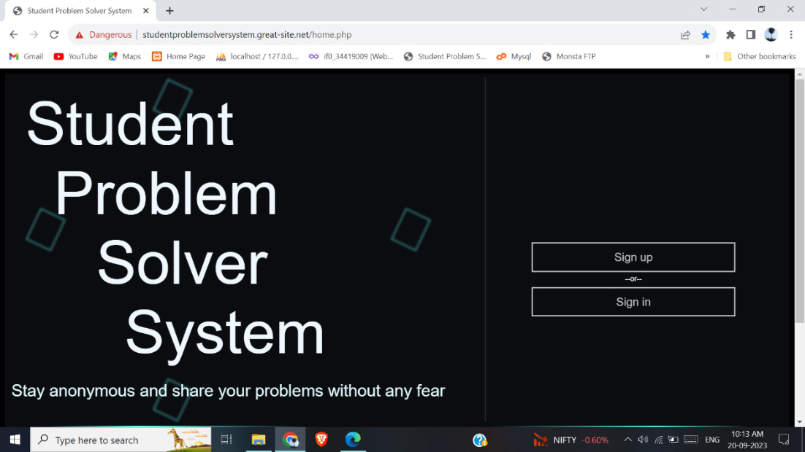

Figure 6.2.1: Home Page UI

1. The new user must register by filling their valid control id, roll no, email. An OTP would be send to the respective email. On entering correct OTP the user can enter valid username and password to create an account.

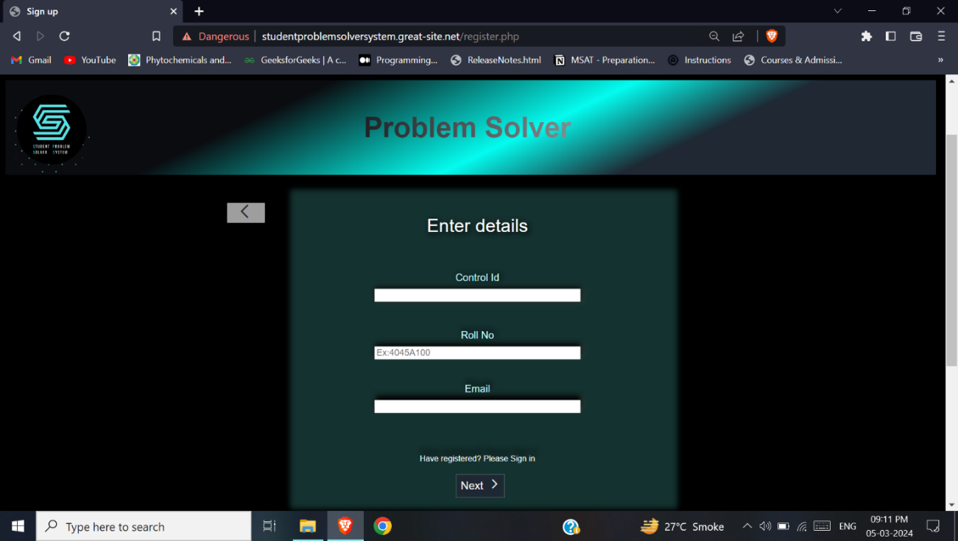

Figure 6.2.2.1: Register Page 1 UI

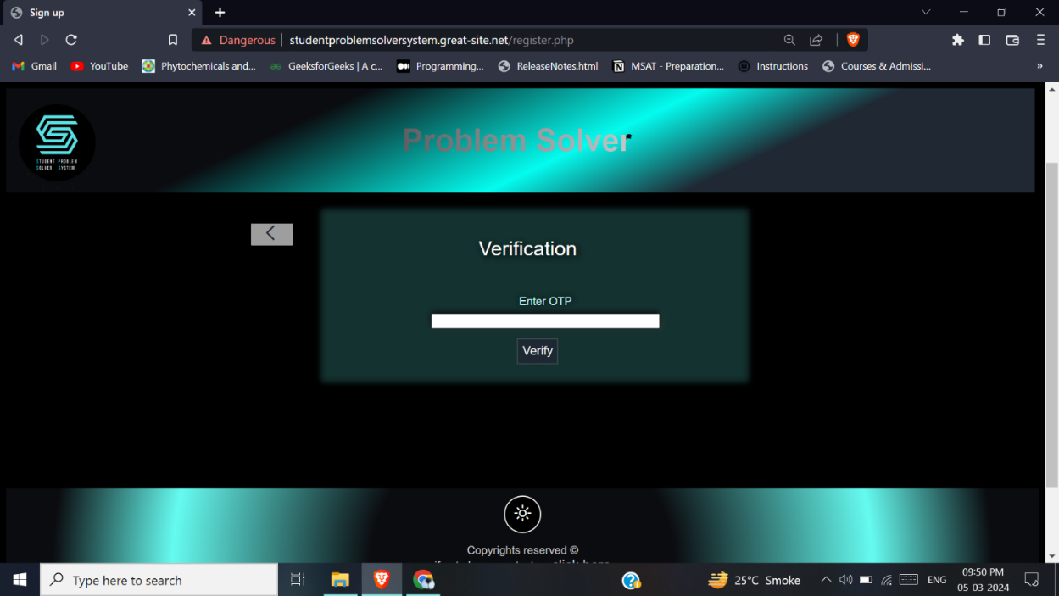

Figure 6.2.2.2: Register Page 2 UI

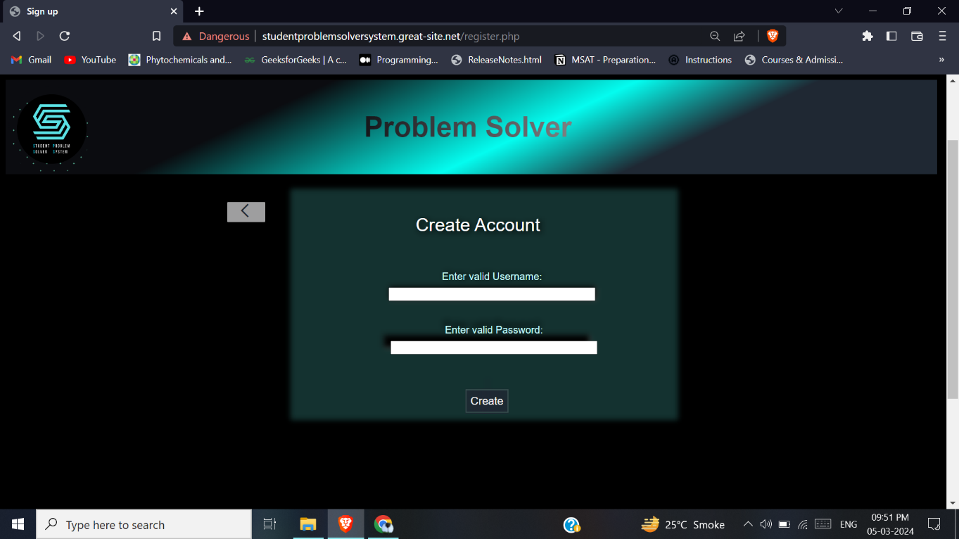

Figure 6.2.2.3: Register Page 3 UI

**3.** The registered users can login with their valid username and password.

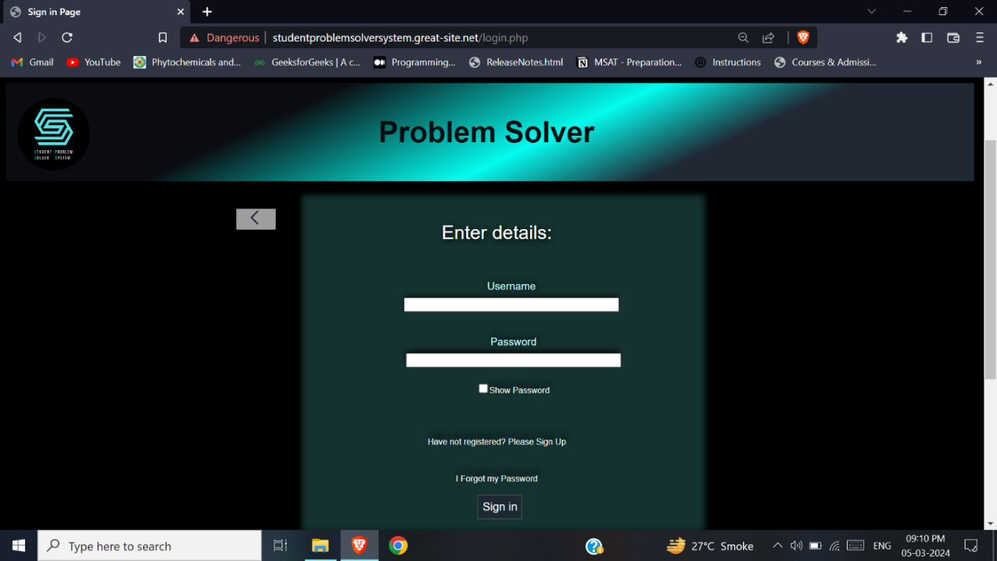

Figure 6.2.3: Login Page UI

**Student:**

**4.** If the student has logged in, this would be the first home page. Here, the student can view and vote the post according to their opinions.

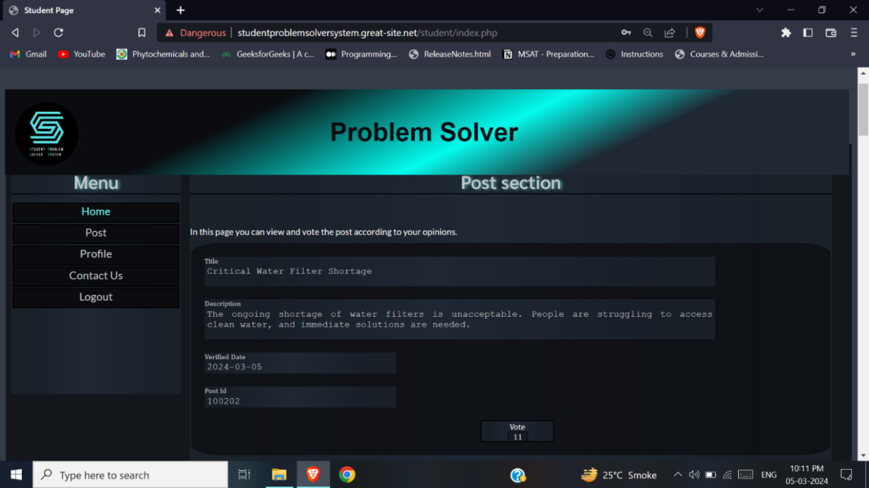

Figure 6.2.4: Student Home Page UI

**5.** On clicking the post tab, a page a will appear where student can fill the title and description of the problem they are facing and wanting to post.

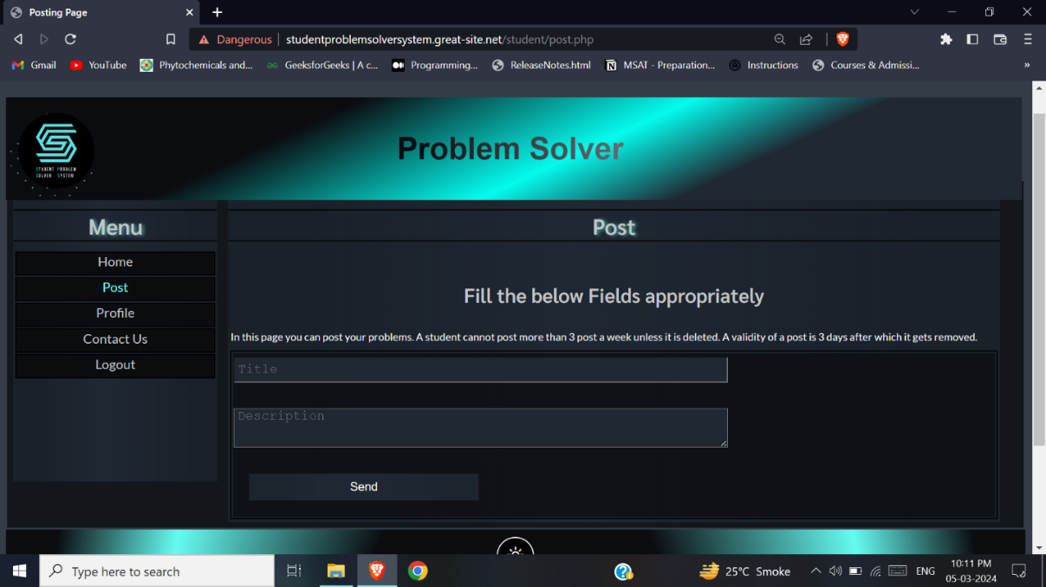

Figure 6.2.5: Student Send Post Page UI

**6.** On clicking the profile tab, a page a will appear where student can view and edit their profile. On clicking edit a modal will appear in which u can edit your password. To save the edited password click edit.

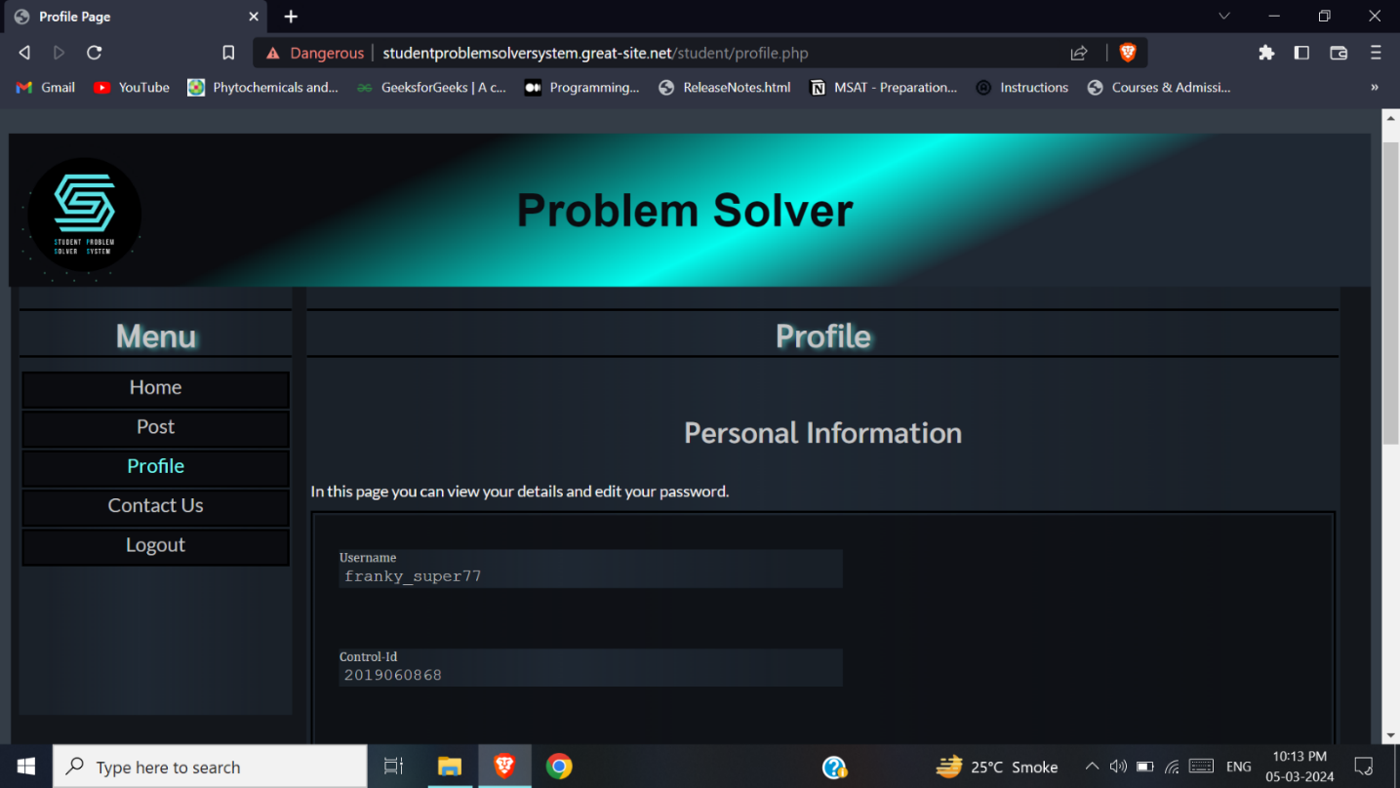

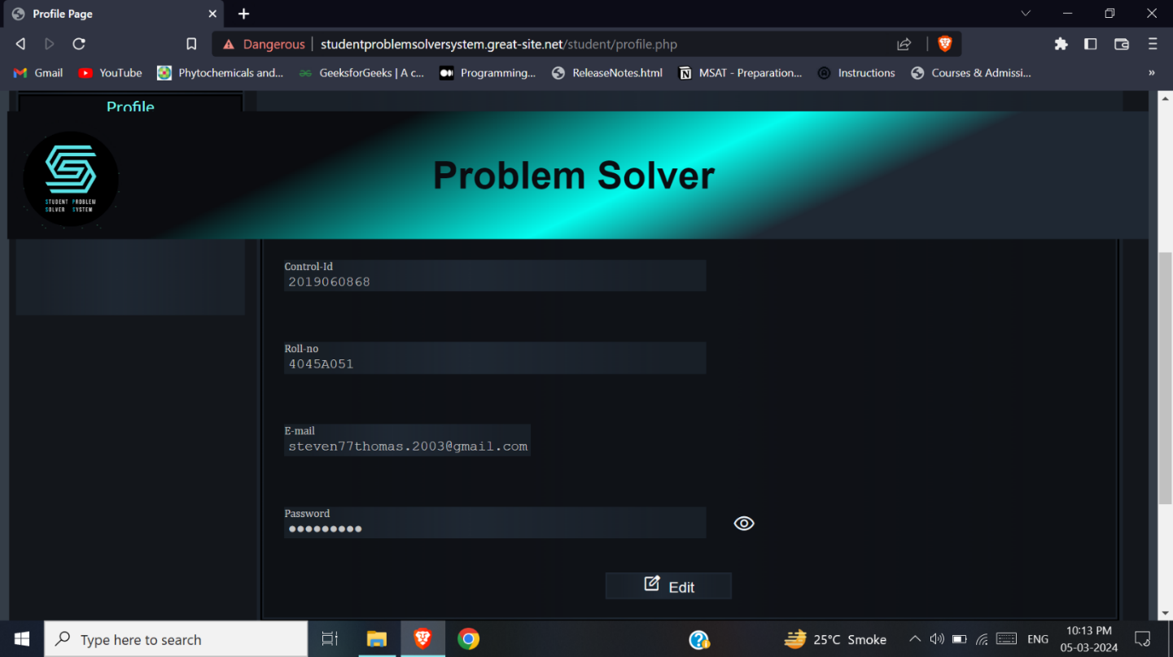

Figure 6.2.6: Student Profile Page UI

**7.** On clicking the Contact Us tab, a page a will appear where student can fill a form regarding any issues faced while using the website. The contact us of handler function’s in the same way.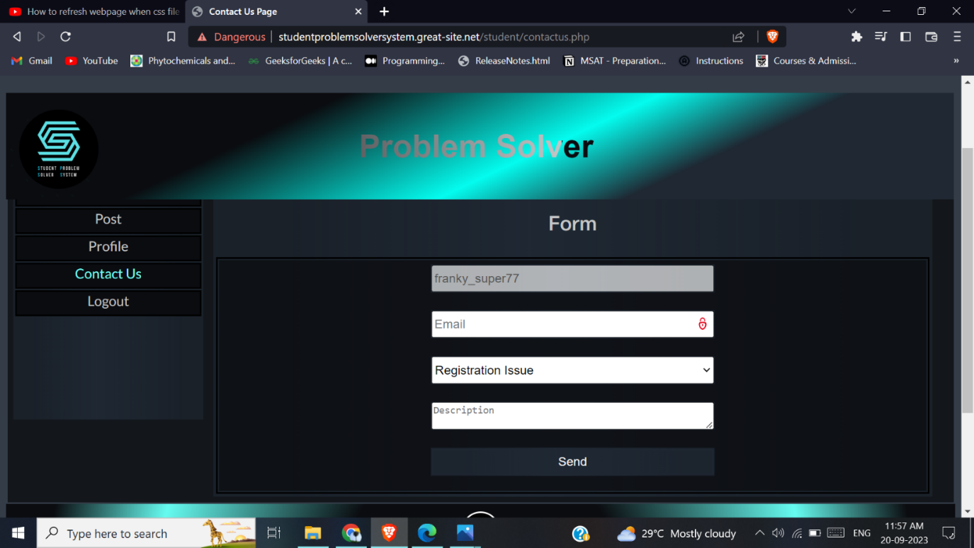

Figure 6.2.7: Student Contact Us Page UI

**Handler:**

**8.** If the handler has logged in, this would be the first home page. Here, the handler can view the most voted posts at the top.

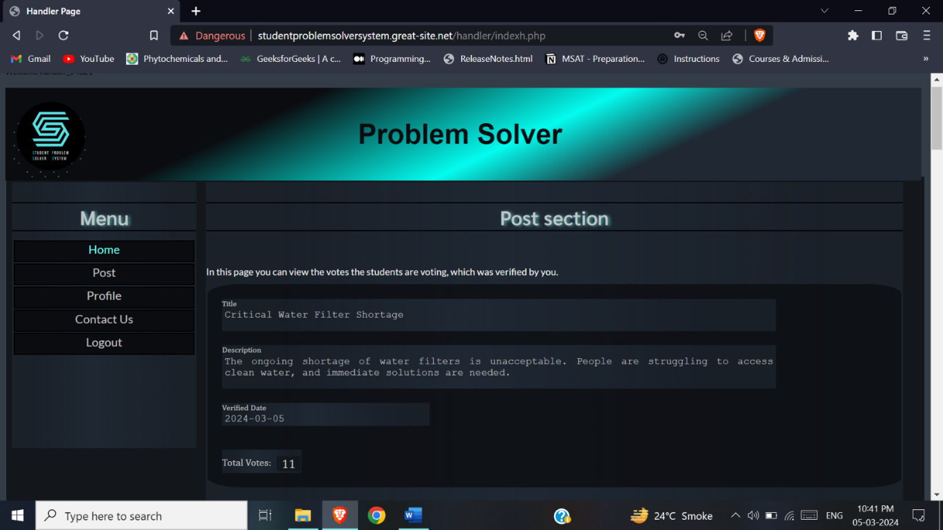

Figure 6.2.8: Handler Home Page UI

**9.** On clicking the post tab, a page will appear where the handler can view the posts which need to be either verified or removed. Here a search bar is present where u can search post by entering keyword and clicking the search button.

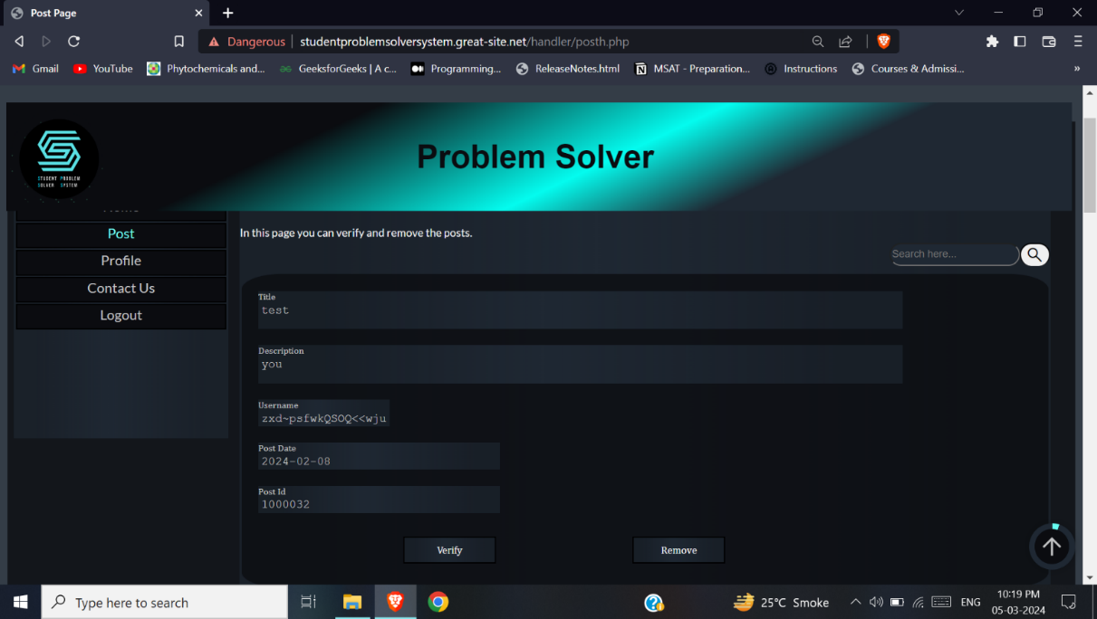

Figure 6.2.9: Handler Post Page UI

**10.** On clicking the profile tab, a page a will appear where handler can view and edit their profile. On clicking edit a modal will appear in which u can edit your password. To save the edited password click edit. The profile page of admin function’s the same way.

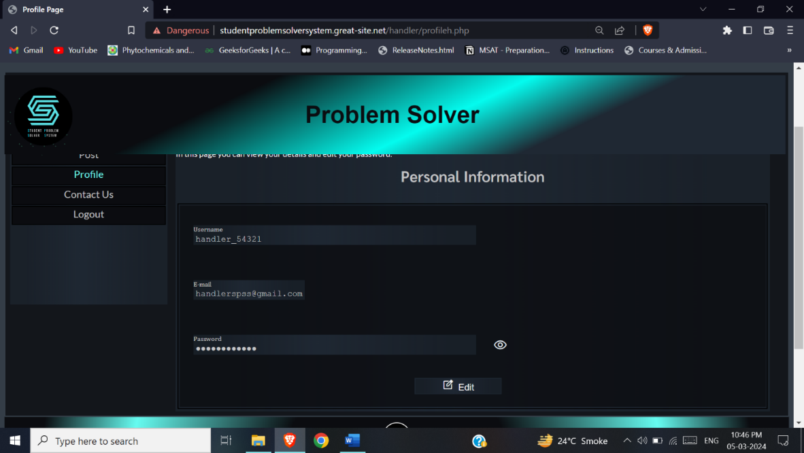

Figure 6.2.10: Handler Profile Page UI

**Admin:**

**11.** If the admin has logged in, this would be the first home page. Here, the admin can view the most voted posts at the top and remove the posted post.

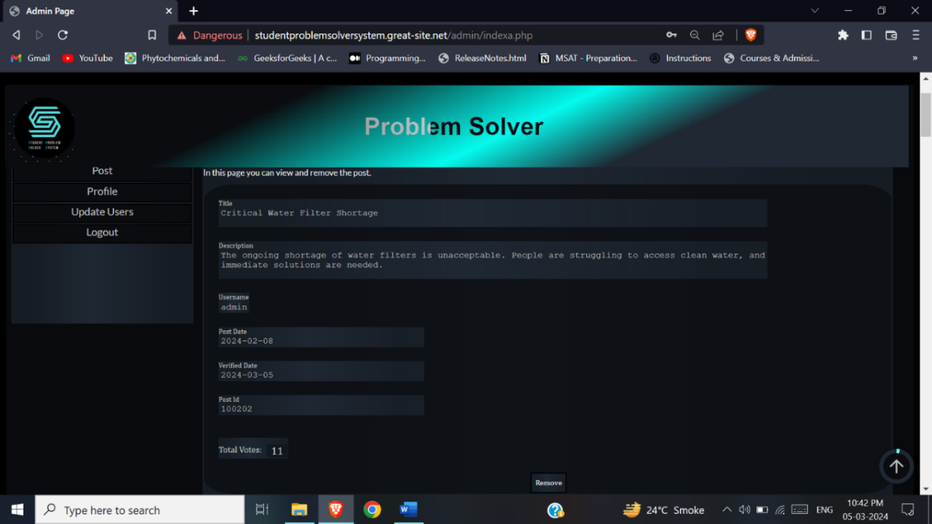

Figure 6.2.11: Admin Home Page UI

**12.** On clicking the post tab, a page will appear where the admin can view the posts which need to be verified and could be removed.

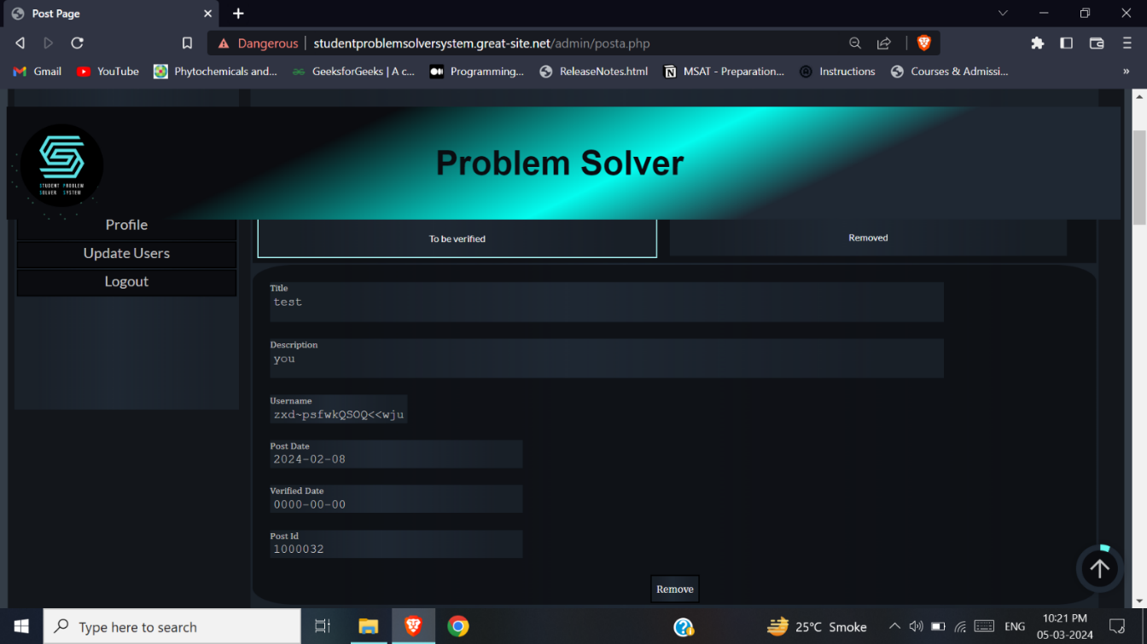

Figure 6.2.12.1: Admin Post Page 1 UI

**13.** On clicking the removed tab, admin can view all removed post which could either be deleted or verified.

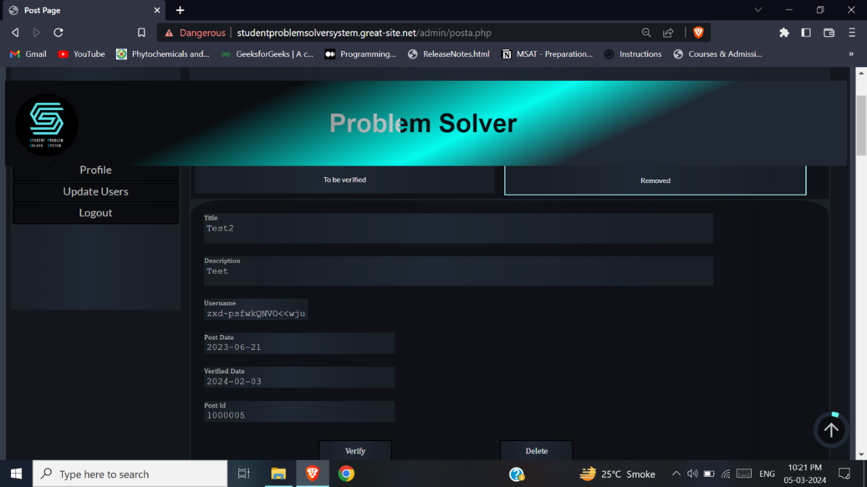

Figure 6.2.12.2: Admin Post Page 2 UI

**Manage users Page:**

**14.** On clicking the Manage users tab, admin can view all student users. On clicking the add symbol, a modal will appear where a user can be added. On clicking the edit button, a modal will appear where a user can be edited. On clicking the delete button, the user will be deleted. The modals appearing is applicable to the other user add and edit.

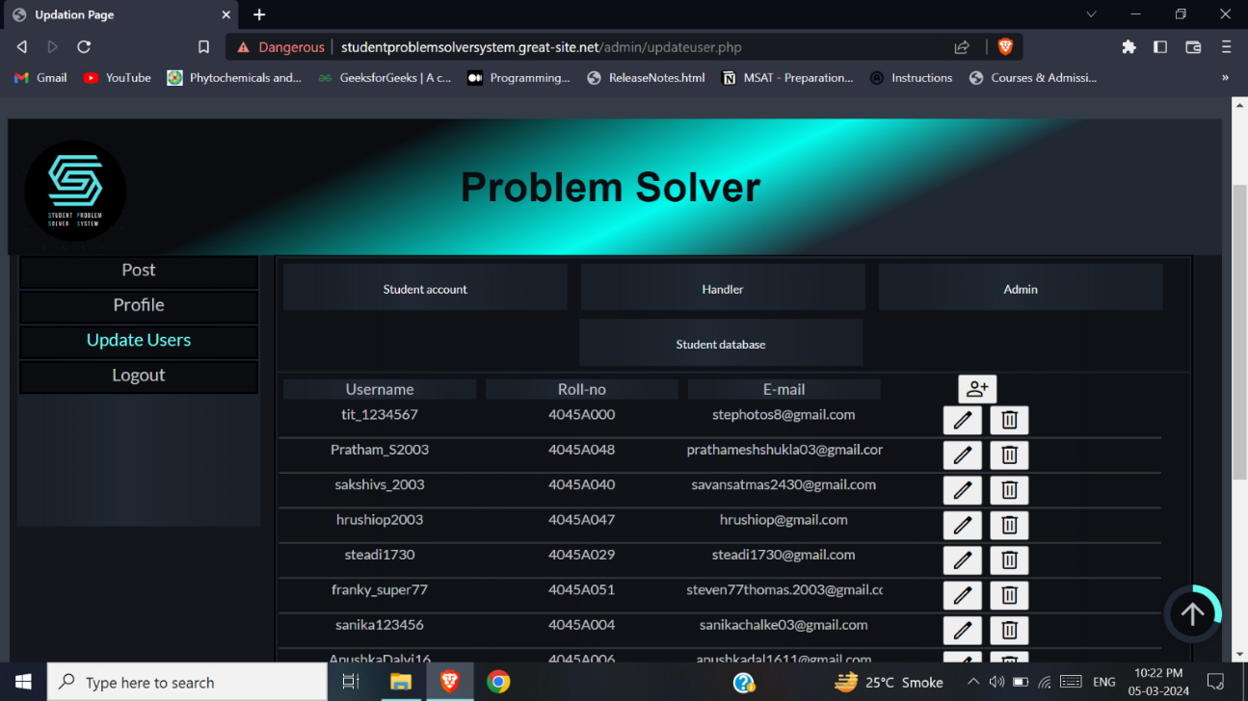

Figure 6.2.13.1: Admin Update Users Page 1 UI

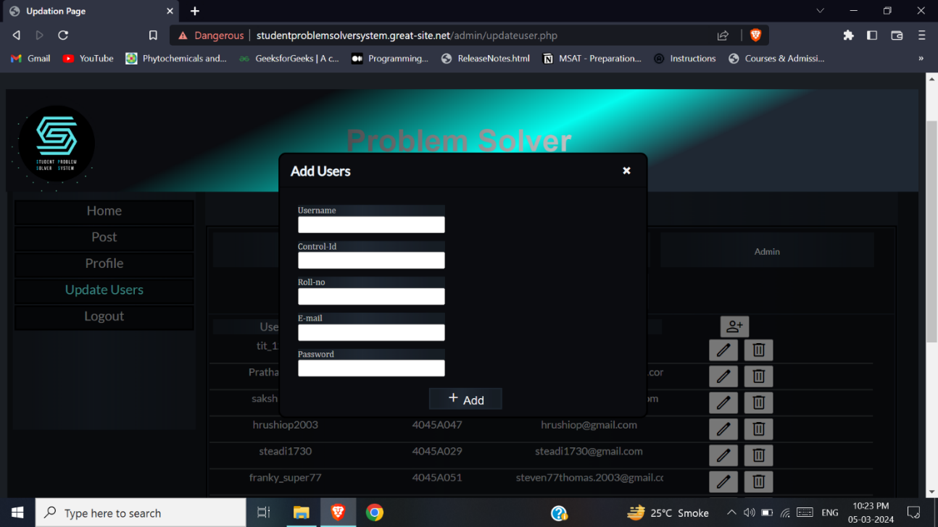

Figure 6.2.13.2: Add user model for student account UI

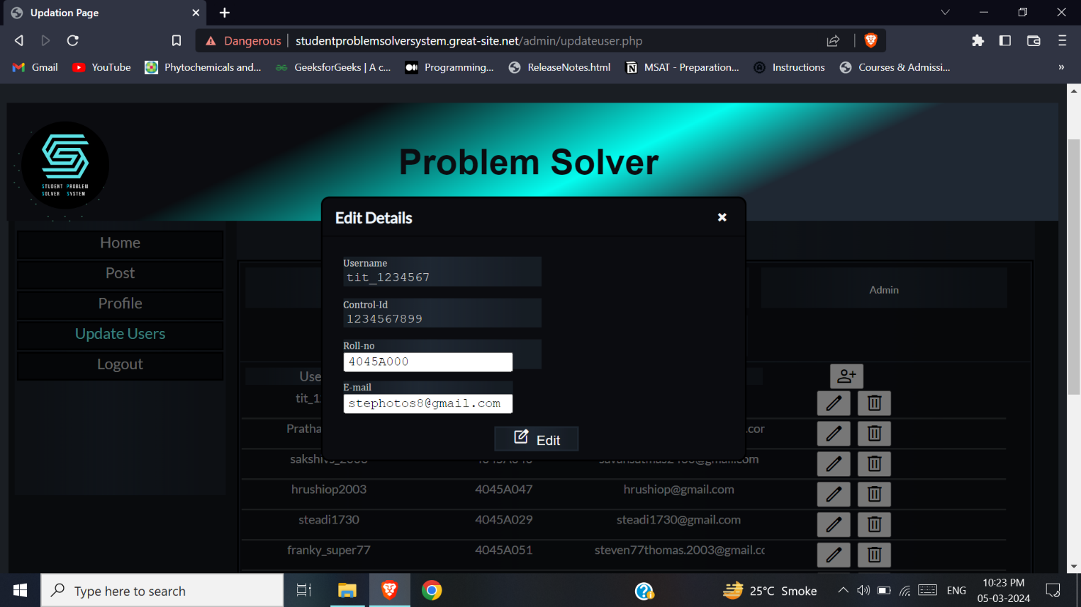

Figure 6.2.13.3: Edit user model for student database UI

**15.** On clicking the Handler tab, admin can view all handler users. On clicking the add symbol, a modal will appear where a user can be added. On clicking the edit button, a modal will appear where a user can be edited. On clicking the delete button, the user will be deleted.

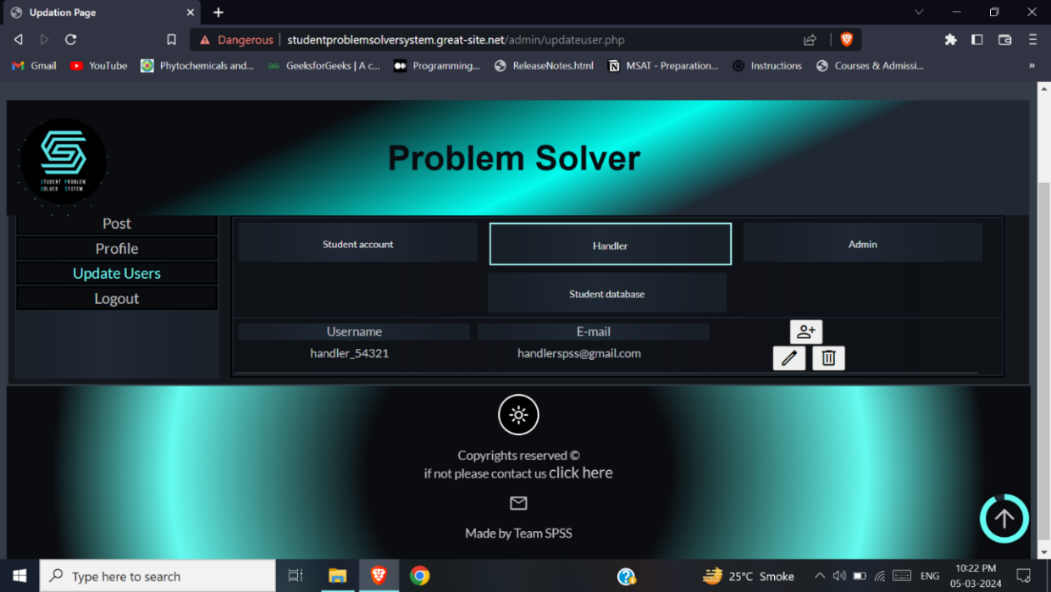

Figure 6.2.13.4: Admin Update Users Page 2 UI

**16.** On clicking the admin tab, admin can view all admin users. On clicking the add symbol, a modal will appear where a user can be added. On clicking the edit button, a modal will appear where a user can be edited. On clicking the delete button, the user will be deleted.

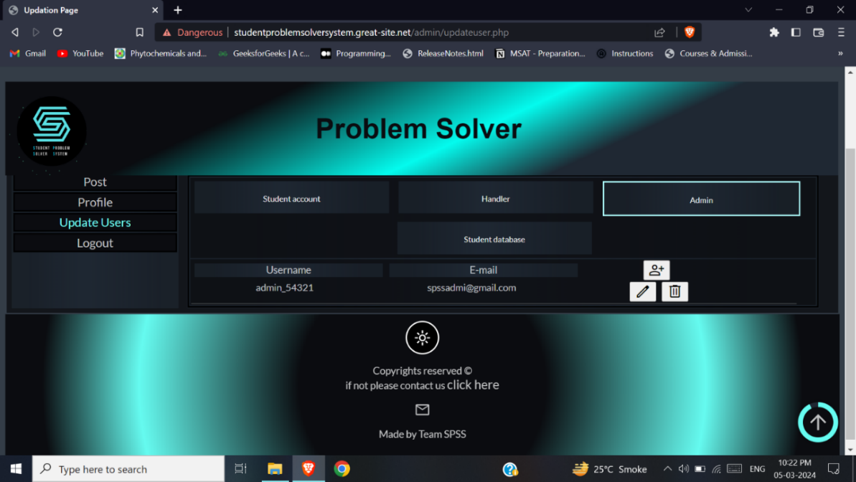

Figure 6.2.13.5: Admin Update Users Page 3 UI

**16.** On clicking the admin tab, admin can view all student information present in the college. On clicking the add symbol, a modal will appear where a user can be added. On clicking the edit button, a modal will appear where a user can be edited. On clicking the delete button, the user will be deleted.

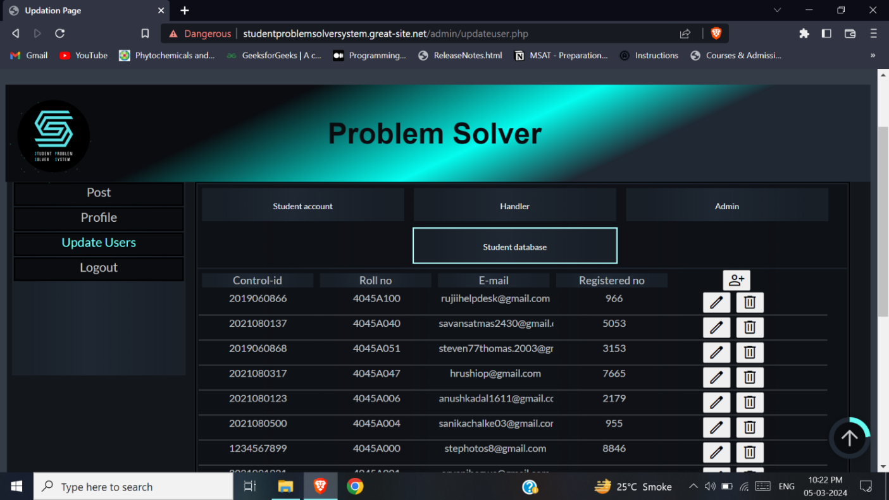

Figure 6.2.13.6: Admin Update Users Page 4 UI

**17.** After all the work has been completed the user can logout by clicking logout button.

# Chapter 7

# Conclusion and Future Work

## 7.1 Conclusion

The student problem solver system will be helpful for the students of the college, as it will help them to communicate their problems easily and anonymously through this software to the college management.

In this website the students can post their problems and vote on post which has been posted. They can view and edit their profile details. In case of any other issues faced while using the software, the student can contact the issue through the contact us page to the admin.

Handler verifies the posts before being posted to the other students or is removed if found irrelevant. Handler can view the most voted most and convey to the college management. Profile and contact us page is available here too.

Admin can add, edit, and delete users. Admin can remove, verify, and delete posts under specific conditions. Profile page is available for editing details.

## 7.2 Limitation

* Students cannot update details apart from password without contacting the admin.
* Students cannot post 3 post per week.
* Students cannot undo a vote.
* Student cannot vote multiple times to a post
* Students cannot have multiple account.
* Handler cannot remove a verified post.
* Admin cannot verify post which has not been removed or not verified.
* Admin cannot edit the controlid and username of a student.

## 7.3 Future Scope

* To every post personalised notification could be sent.
* To prevent repeated posts from being posted Natural language Processing and Machine learning could be applied.
* All solved problem of year could be displayed after a year of software use.

# References

**Books Referred:**

[1] Software Engineering”Ian Somerville”, Pearson publisher 8 edition

[2] Database System Conceptes,”Henry F Korth, Abraham Silberschatz”

[3] James Rumbaugh Object-Oriented Modelling and Design with UML Second Edition

**Website References:**

The Links referred from the date 03/04/2023 to 25/04/2023:

[1] [Student Friendly College Management System - 1000 Projects](https://1000projects.org/student-friendly-college-management-system.html)

[2] <https://www.tutorialsduniya.com/software-engineering-projects-pdf/>

[3] <https://nevonprojects.com/online-diagnostic-lab-reporting-system/>

[4] <https://www.tutorialsduniya.com/software-engineering-projects-pdf/>

[5] <https://www.youtube.com/watch?v=1Rs2ND1ryYc&t=6210s>

[6] <https://www.php.net/docs.php>

**Referred for UML diagrams:**

[1] Wondershare edrawmax software

**Referred for Gant Chart:**

[1] Microsoft Excel software